Barrel Tasting 2023 Social Media Toolkit
Hashtag #BarrelTasting2023 for the event.
Event Page URL: https://www.wineroad.com/events/barrel-tasting-weekends/ or shortened URL: https://bit.ly/BarrelTasting23
Event Ticket Page URL: https://www.eventbrite.com/e/barrel-tasting-2023-wine-road-sonoma-county-tickets-505339653507
Dropbox Link to Media Photos/Video: https://www.dropbox.com/sh/noyoeef8lvtz16s/AACtf2pUHIA3KQU4jjDlIgX5a?dl=0
Facebook Event:
You can share/add our Barrel Tasting event that is already created on Facebook: https://www.facebook.com/events/585168516567659
You can also add our event to your page by going to the event on our page, clicking on the “three dots” on the top of the event and choosing “Add to Page.”
See graphic for how to share and add below.
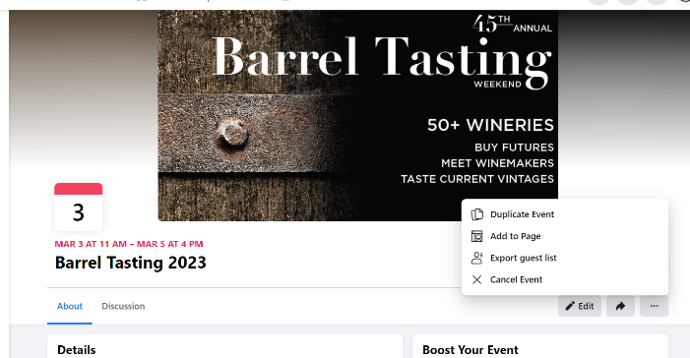
NOTE: It’s generally better to share and add the event we created on Facebook versus creating your own so that those that are interested click on our event and therefore can be retargeted with sponsored/paid posts – paid for by Wine Road - at a later date.

Hashtags to use on Instagram (plus add yours!):
#BarrelTasting2023 #wineroad #sipsonoma #sonomacountywine #californiawine #wineevents #winetasting #gowinetasting #winetourism
Share our Barrel Tasting blog post:
- Wine lovers, have you heard the news? Barrel Tasting 2023 is just around the corner and we couldn't be more excited! Here's a sneak peek at some of the top reasons why you don't want to miss out on this year's event. https://www.alongthewineroad.com/top-10-reasons-to-attend-barrel-tasting-2023/

Social Media Post Ideas:
- Barrel Tasting season is here and we're counting down the days until we get to be back in the cellar to give you a sneak peek at some of our best wines before they're even bottled. Get your tickets today and make us one of your stops.

- Wine lovers, have you heard the news? Barrel Tasting 2023 is just around the corner and we couldn't be more excited! Get your early bird tickets before the price goes up on February 1st. URL.

- Early bird tickets are now on sale for our 45th annual Barrel Tasting, the “must do” California Wine event… sample wines from the barrel, buy “futures,” talk to winemakers and explore the beautiful Alexander, Dry Creek and Russian River Valleys. The price goes up on February 1st, so don’t delay!

- Why Barrel Tasting?
- Taste wine straight from the barrel and experience the unique flavors and aromas that come from the aging process.
- Meet the winemakers and learn about the winemaking process firsthand.
- Discover new and upcoming wineries and wines.
- Take advantage of special deals and discounts on wine purchases.
- Explore the beautiful wine country and take in the stunning views.
So the question really is…why NOT Barrel Tasting? Get your tickets today! URL
- Wine Road’s Barrel Tasting Weekend is March 3-5. Get your tickets now!
- Wine Road’s Barrel Tasting Weekend is March 3 – 5 with no reservations required this year. Yes, Wine Road events are back their pre-pandemic format (happy dance)! Get your tickets today.
- 45 years and still going strong - Barrel Tasting that is! Tickets are on sale now for Wine Road’s 45th Annual Barrel Tasting, March 3 – 5. Taste and buy the future. Meet the winemakers. Compare the barrel wines to the finished wines. And most importantly, HAVE FUN! Get your tickets now because no tickets will be sold at the door.
- No matter where the (Wine) road takes you during Barrel Tasting weekend, we’re sure you’re going to love taking a sneak peek into the future of Sonoma County Wines – especially ours! Tickets are on sale now through February 27th.
- If you love wine and want to taste what the future holds for Sonoma County wine, then get your tickets to Barrel Tasting and make us of your stops!
- Taste the Future from our cellar to yours! Barrel Tasting is a great opportunity to sample wines from the barrel, talk to winemakers and explore the beautiful Alexander, Dry Creek and Russian River Valleys. Wines.
- Good friends + Good Wine + Good Times = Barrel Tasting! Tickets are still available, but don’t wait because no tickets will be sold at the door.

