Once you have the Church Life app, you are ready to save it on your desktop. Click the three little dots in the top-right corner of the screen.
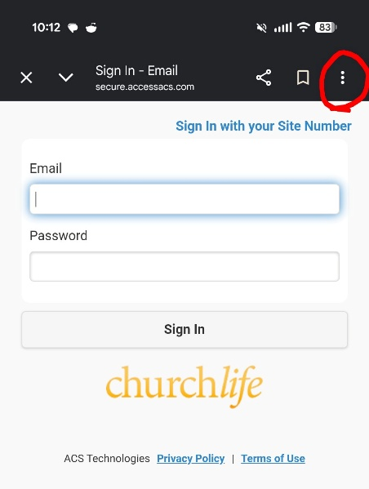
Select “Install and create a shortcut” on the pop-up menu.
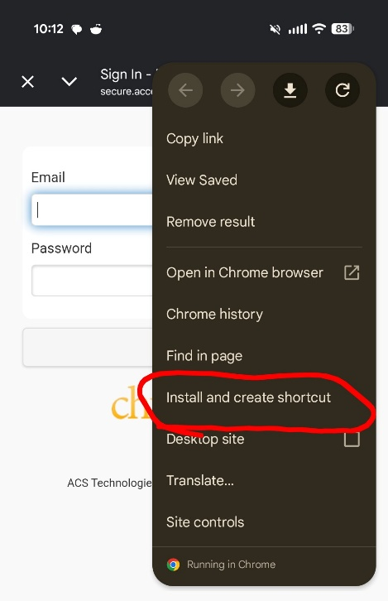

Name the shortcut whatever you would like but make it easy to remember.
