ACCESS ACS Instructions:
Click on the link below and follow the prompts:
https://secure.accessacs.com/access/memberlogin.aspx?sn=104766
Account sign up/
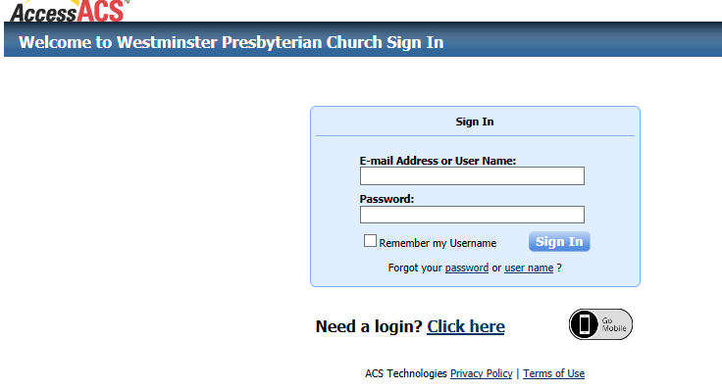
If you don’t already have a login, click need a login and follow prompts. You must use the same name and email address we have in our church database in order to be given a member login.
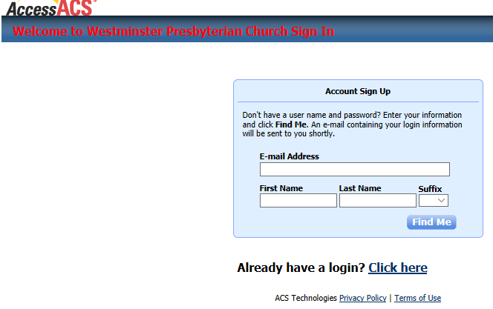
If it matches you will get a message:
Congratulations! You have successfully set up a member account. Please check your e-mail inbox (at your email address) for information about your account. See sample of the email you will get below:
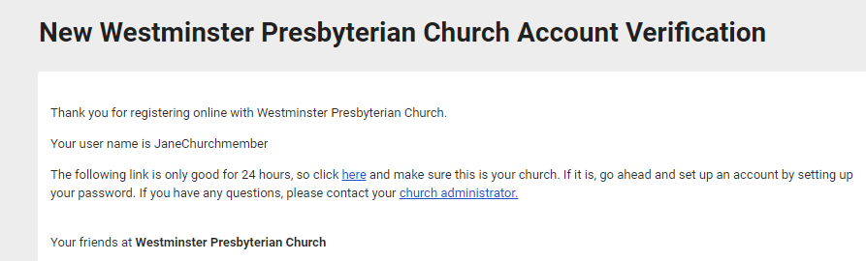

You go to your email and click the clink to finish setting up your account with your password.
- It needs to be 8-15 characters total
- No part of username or e-mail
- Two or more numbers
- None of these characters: <&>/\;%[space]
- Lower and upper case characters
(SEE BELOW)

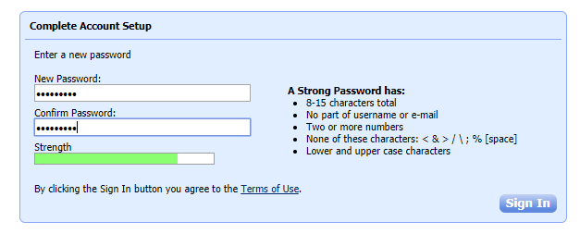

You will be able to view the church directory, view and pay your pledge and other online giving activities. Other features available at a later date.

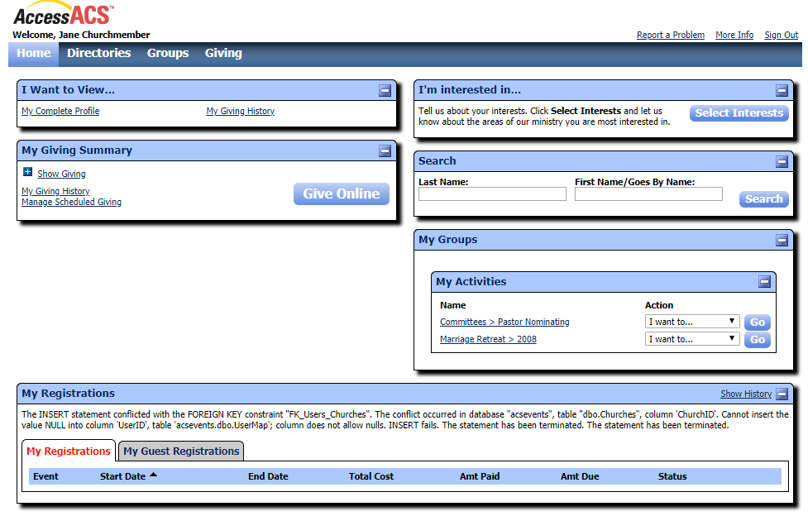

App for your cell phone or tablet:
Download the “Church Life” app for the Google or App Store

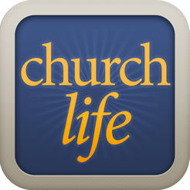
You will use the same login info that you login to the AccessACS website.
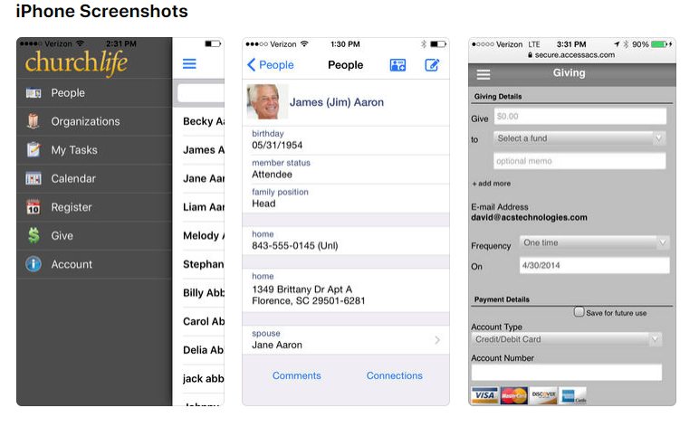
You will be able to use the directory to look up address, phone, email and pictures of church members. You will also be able to pay your pledges, memorials, and other current activities on your phone or tablet. In order to see how much, you owe on your pledge you will need to log into AccessACS.

