HCSA: HONORS COLLEGE STUDENT ASSOCIATION (cont.)

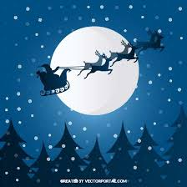
Our final event of the semester was a Christmas Movie Night. We showed Fred Claus, and had about 15 students + the board attend. We provided food and drinks to students and watched this movie on a Friday in December. Students had a lot of fun and enjoyed the movie!

HCSA had their first e-board meeting of the Winter Semester January 15th and some events we are considering putting on are: HC Crash Course, a Trivia Night, and an Egg Painting contest near Easter! Stay tuned for updates.

Welcome our 2022-2023 Eboard:
Cameron Roach (president)
Karim George (vice president)
Connor Jabro (Public relation chair)
Treasurer (TBD)
Amna Zaidi (Fundraising Chair)

