Underprivileged Children Across the U.S. Receive Dental Services Thanks to Charity Auction

America’s ToothFairy and MGE: Management Experts work together to provide oral health education and grants for restorative dental care.

Charlotte, NC, July 25, 2023 -- America’s ToothFairy, a nonprofit organization dedicated to increasing access to oral health care for children in underserved communities, knows first-hand the challenges that safety-net clinics face to provide quality dental care and preventive services for low-income families and children living in areas where services are often out of reach.

Since its founding in 2006, America’s ToothFairy has helped its program members dramatically increase access to dental services and provide oral health education for more than 13 million kids and caregivers across the country, including *Naomi, a 15-year-old from Maplewood, Minnesota. When she visited Community Dental Care (CDC), a member of the Dental Resource Program of America’s ToothFairy, the dental team immediately noticed subpar dental restorations on her four front teeth. Upon further examination they found decay on four of her molars. To make matters worse, Naomi’s existing crowns had large overhangs that were impacting the health of her gums, and recurring decay was forming. They feared she might lose her front teeth.

Believing that Naomi deserved a higher standard of care despite her family’s significant financial barriers, the team at CDC reached out to America’s ToothFairy for financial assistance to help Naomi receive the best care possible.

“Our program members have the systems in place to provide services for families that lack equitable access to dental care. What they often lack are the resources,” said Jill Malmgren, executive director of America’s ToothFairy. “Our organization was founded with the idea that dental professionals can work together to improve the oral health of children who do not get the dental services they need to be healthy and whose oral health literacy is limited.”

One organization that partners with America’s ToothFairy to help kids in need is MGE: Management Experts, an education and coaching program that aims to help dentists be more successful business owners. MGE has held a charity auction to benefit America’s ToothFairy at its annual conference every year since 2019, raising a total of more than $326,000.
Last year, the auction funding provided life-changing dental services for 12 children in need of restorative care—including Naomi—as well as superhero-themed oral health education kits that were used to teach 10,000 kids and their parents how to prevent dental disease.

Most recently, MGE members raised more than $116,000 to support the mission of America’s ToothFairy for the fifth year in a row.

“We were very pleased with the results from last year’s contribution,” said Jeffrey Blumberg, MGE’s COO. “Our members are moved by this worthwhile cause and looking forward to what we will accomplish together with America’s ToothFairy this year.”

“Prevention and education programming is one of the main pillars of our mission,” Malmgren added. “Our superhero-themed kits were so popular that we are excited to offer them again this year for our members’ back-to-school outreach in addition to supporting the provision of restorative care for patients who would otherwise fall through the cracks.”

“We are grateful to America’s ToothFairy for their continued support in providing grants for patients in need,” CDC’s Director of Development, Crystal Yang said. “Their charitable support helps our team provide oral health education and preventive services to many children who would otherwise not have received it.”

*Patient’s name has been changed to protect her privacy.

About America’s ToothFairy: National Children’s Oral Health Foundation
As a resource provider, America’s ToothFairy increases access to oral health care by supporting nonprofit clinics and community partners delivering education, prevention, and treatment services for underserved children. Since its inception in 2006, America’s ToothFairy has distributed more than $23.6 million in donated products, educational materials, and financial grants to improve oral health outcomes for children and youth in need. For more information, visit AmericasToothFairy.org.

About MGE: Management Experts, Inc.
MGE Management Experts, Inc. is a practice management training organization for dentists, dental specialists and dental office staff headquartered in St. Petersburg, Florida. MGE has trained tens of thousands on such subjects as management, case acceptance, marketing, executive skills, financial planning and leadership. For more information, visit mgeonline.com.

* * * * * * * * * *

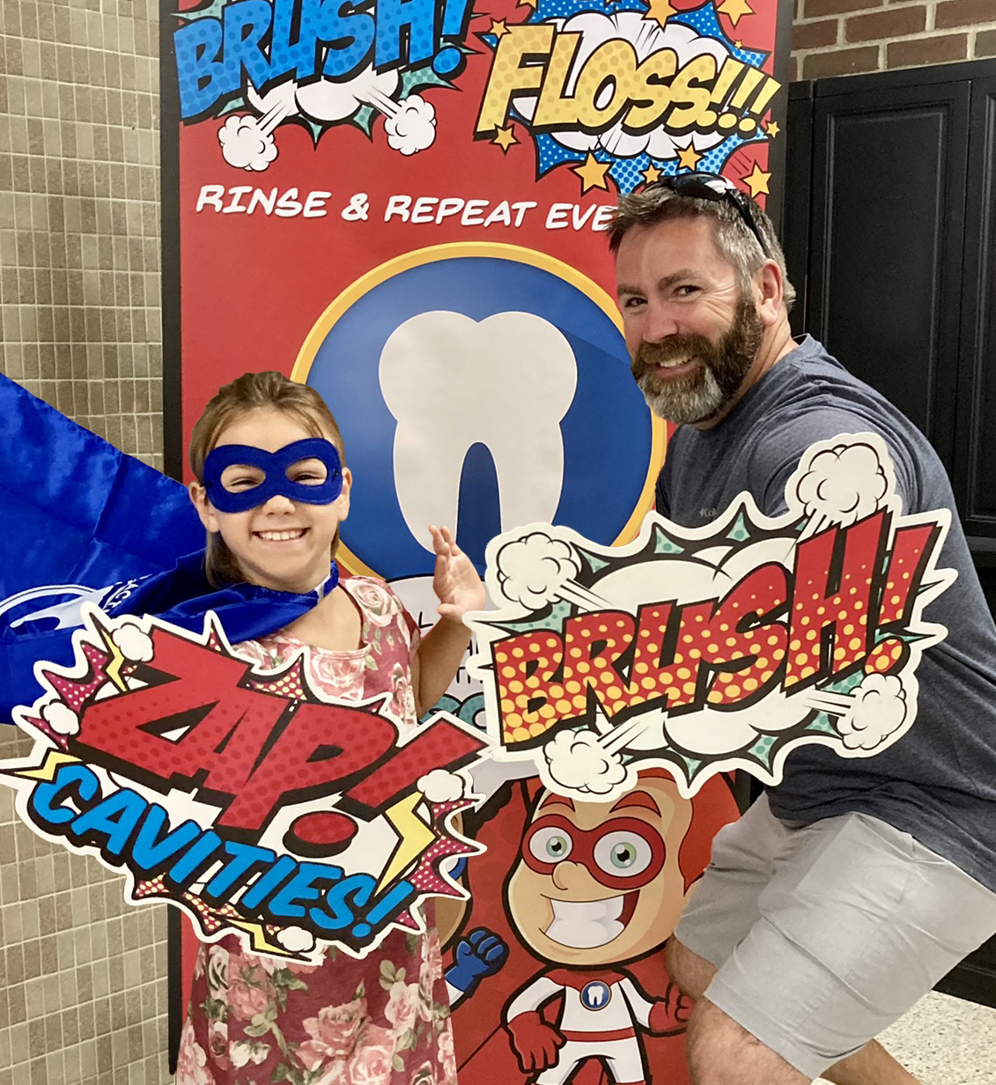

A young girl and her father participate in an oral health education event in Owatonna, MN. Superhero-themed educational materials provided by America’s ToothFairy and sponsored by MGE: Management Experts engaged 10,000 kids and their caregivers at events across the United States last year. The oral health education kits will be provided for back-to-school events again this year thanks a charity auction that raised more the $100,000 to support preventive and restorative dental services for under-resourced communities.

America’s ToothFairy Contact:
Jan Badger, Communications Manager, America's ToothFairy
communications@ncohf.org I 336-408-8023 I AmericasToothFairy.org

