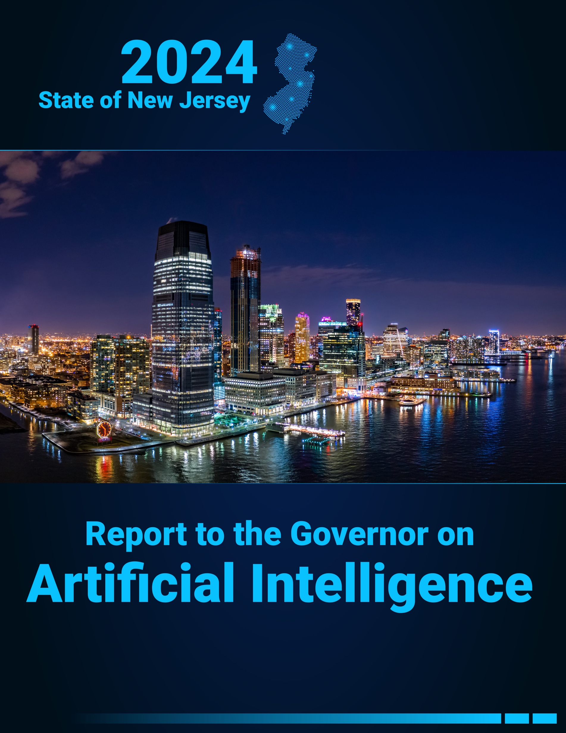

Table of Contents
Acknowledgments iii
Introduction 1
Executive Summary 2
1 Safety, Security, Technology, and Privacy for AI Use Casses 8
1.1 Introduction 8
1.2 Potential Use Cases 9
1.3 Risks and Limitations of GenAI Use 13
1.4 Emerging Landscape of Policies to Address AI Risk 18
1.5 Sustainability and Climate Change Impacts 22
1.6 Why the New Jersey Government Should Expand GenAI Adoption 23
1.7 How New Jersey State Government Should Continue Deployment of GenAI 24
1.8 Utilize Criteria for Selecting and Scaling Pilots 24
1.9 Recommendations 27
2 Workforce Training, Jobs of the Future, and Training Public Professionals 31
2.1 Introduction 31
2.2 GenAI’s Workforce Impact: A New Frontier 32
2.3 New Jersey Workers’ Perceptions of AI 33
2.4 New Jersey’s Current Efforts to Lead the Way With AI 35
2.5 Comparative Policy Response: Learnings from Other States 39
2.6 Recommendations 41
3 AI, Equity, and Literacy 45
3.1 Introduction 45
3.2 Bias and Discrimination in AI Technology 46
3.3 How Use of AI Could Enhance Equity and Digital Literacy in New Jersey 47
3.4 Potential Use Cases 48
3.5 Using AI to Enhance Information Literacy 54
3.6 Recommendations 56
3.7 Survey on New Jersey Residents’ Perspectives on AI 61
4 Making New Jersey a Hub for AI Innovation 62
4.1 Introduction 62
4.2 Strengthening AI Innovation and Economic Growth in New Jersey 62
4.3 Challenges to Establishing New Jersey’s AI Ecosystem 64
4.4 Recommendations 65
Closing 69
Appendices i
A.1. Appendix A: “AI and You” Engagement i
A.2 Appendix B: “Your Future of AI” Survey iii
A.3 Appendix C: Using AI to Conduct Policy Research iv
A.4 Appendix D: AI in Higher Education Landscape Analysis v
A.5 Appendix E: Findings from OSHE Survey vi
A.6 Appendix F: Survey on Public Perspectives of AI vii
Glossary of Terms xxi
Reference Materials, Research, Publications, and Articles Used xxvii

Acknowledgments
Contributors to the creation of this report were members of State Government, Academia, and the Private Sector.
With gratitude, these contributors included members of the task force:

Co-Chairs:
- Dr. Beth Noveck, State of New Jersey, Chief AI Strategist
- Christopher Rein, State of New Jersey, Office of Information Technology
- Tim Sullivan, Economic Development Authority

Government members:
- Dr. Brian Bridges, State of New Jersey, Office of Higher Education
- Carolyn Cannella, State of New Jersey, Governor's Office
- Dave Cole, State of New Jersey, Office of Innovation
- Doug MacDonald, State of New Jersey, Economic Development Authority
- Jayné Johnson, State of New Jersey, Governor's Office
- Jeffrey Oakman, State of New Jersey, Governor's Office
- John Harrison, State of New Jersey, Department of Community Affairs
- Dr. Jorden Schiff, State of New Jersey, Department of Education
- Lesley Hirsch, State of New Jersey, Department of Labor and Workforce Development

- Lisa Blauer, State of New Jersey, Office of Information Technology
- Matt Berns, State of New Jersey, Governor’s Office
- Matthew Platkin, State of New Jersey, Attorney General’s Office
- Melina Meneguin-Layerenza, State of New Jersey, Attorney General's Office
- Melissa Walker, State of New Jersey, Governor’s Office
- Michael Geraghty, State of New Jersey, Cybersecurity and Communications Integration Cell
- Peter Tenebruso, State of New Jersey, Department of Environmental Protection
- Poonam Soans, State of New Jersey, Office of Information Technology
- Robert Asaro-Angelo, State of New Jersey, Department of Labor and Workforce Development
- Sarah Brafman, State of New Jersey, Governor’s Office
- Stephanie Ashley, State of New Jersey, Governor’s Office
- Xavier Hughes, State of New Jersey, Office of Innovation
- Yolanda Allen, State of New Jersey, Department of Labor and Workforce Development

External Participants:
- Aaron Fichtner, New Jersey Council of County Colleges
- Aimee Sprung, Microsoft
- Amit Moran, BlueVine
- Angela Pinsky, Google
- Antonio Delgado, Miami Dade College
- Arvind Narayanan, Princeton University
- Bobby Varma, Princeton Identity
- Braxton Plummer, Verizon
- Brian Venturo, CoreWeave
- Brittany Cassin, DigiCARE Realized
- Dr. Carl Van Horn, Rutgers University
- Charles Wowkanech, AFL-CIO
- Cristian Borcea, New Jersey Institute of Technology
- Diana Pankevich, Pfizer
- Dillon Reisman, American Civil Liberties Union of New Jersey
- Dr. David Bader, New Jersey Institute of Technology
- Dr. Grace Wang, New Jersey Institute of Technology
- Edward Amoroso, TAG Infosphere
- Dr. Fay Cobb Payton, Rutgers University – Newark / Director, Institute for Data, Research and Innovation Science (IDRIS)
- Fran Ehret, CWA
- Dr. Greg Porumbescu, Rutgers University - Newark
- Jonathan Dambrot, Cranium AI
- Joseph Eng, Billtrust
- Kevin Kurdziel, GSETA
- Mark Aakhus, Rutgers University
- Mary Strain, AWS
- Mihir Kshirsagar, Princeton University
- Mike Reagan, CGI
- Natalya Johnson, Johnson & Johnson
- Oleg Dulin, ADP
- Rakhi Agarwal, Sanofi
- Rich Rosenzweig, CoreWeave
- Dr. Ronald Quincy, Rutgers University
- Sarah Henderson, Google
- Selvi Karuppaswamy, New Jersey Judiciary
- Dr. Vincent Oria, New Jersey Institute of Technology

Other Contributors:
- Hyorim Seo, School of Public Affairs and Administration, Rutgers University - Newark
- Jinah Yoo, School of Public Affairs and Administration, Rutgers University – Newark
- Vishal Trehan, School of Public Affairs and Administration, Rutgers University - Newark



Introduction
On October 10, 2023, Governor Phil Murphy signed Executive Order No. 346, which established an Artificial Intelligence (“AI”) Task Force to study emerging AI technologies, issue findings on their potential societal impacts, and offer recommendations for government actions to encourage the ethical and responsible use of AI technologies.
The Co-Chairs of the AI Task Force formed four working groups consisting of subject matter experts to undertake this charge and address how GenAI could impact New Jersey across sectors.
This “Report to the Governor on Artificial Intelligence” summarizes the working groups’ findings and provides expert insights and practical recommendations that aim to ensure that the State of New Jersey leverages AI in a responsible and ethical manner to improve government services, achieve equity, and create and maintain economic opportunities for residents. In particular, this report focuses on Generative AI (GenAI), exploring how this prominent and accessible tool may impact government operations as well as the State’s economy, workforce, and communities. In addition, because AI technologies largely have been used for “traditional” analytical (i.e., non-generative) purposes, the report evaluates potential applications of GenAI against the broader family of AI technologies available to the State.
Finally, federal and state policymakers across the country are actively considering approaches to several AI-related topics. As the AI landscape evolves rapidly, the Task Force charged with developing this report does not propose answers to every policy question raised by AI. Some of those policy questions may be better addressed at the federal level, with states addressing gaps or deficiencies in federal law. Other policy questions are still so new or so rapidly developing that the Task Force is not able to offer recommendations at this time. Instead of attempting to provide an exhaustive set of policy prescriptions, the Task Force articulates some guiding principles and recommends establishing a committee to meet on a regular basis to discuss emerging issues in AI and consider avenues for State action.

Executive Summary
AI, particularly GenAI, is poised to transform the workforce, economy, and the way government interacts with and serves constituents. The State of New Jersey should embrace this change by investing in AI research and innovation in a responsible manner that considers the interests of New Jersey residents, businesses, and visitors, promotes economic opportunity and equity, and protects data privacy and safety.
The AI Task Force Co-Chairs designated four Working Groups, each with its own chapter and recommendations summarized below:
1. Security, Safety, Technology, and Privacy Considerations for AI Use Cases
Chapter 1 provides an in-depth assessment of potential opportunities and challenges associated with the State’s use of AI and recommends strategies for the State to develop AI policy and to build and deploy AI solutions. The potential applications for GenAI are far-reaching, from enhancing internal administrative operations to improving external service delivery. The Security, Safety, Technology, and Privacy Considerations for AI Use Cases Working Group offers recommendations that balance enthusiasm for seizing valuable opportunities presented by this emerging technology with ensuring appropriate safeguards to mitigate risks inherent in AI tool development and use.
Recommendation 1: Maintain Human Oversight
The State should ensure that humans remain actively involved when GenAI tools are deployed within the government, including reviewing AI-generated outputs, making or reviewing critical decisions, and intervening when necessary to prevent or address errors or biases.
Recommendation 2: Embed Privacy and Security in AI Governance Framework
The State should embed strong privacy protections and incorporate advanced cybersecurity measures into the State’s AI governance framework. This should include clear data management policies, advanced detection technologies, and incident response frameworks as well as clearly defined leadership roles, escalation paths, rigorous testing protocols, and training for State personnel on the implications of using GenAI.
Recommendation 3: Establish Robust Quality Assurance
The State should implement quality assurance protocols to verify the accuracy and reliability of AI-generated content. These protocols should include testing for bias, monitoring system performance, and ensuring transparency by disclosing how the AI model works and was trained and by citing the sources referenced in particular AI-generated responses to enable human verification and ongoing monitoring.
Recommendation 4: Implement a Strategic, Controlled, and Scalable Pilot Approach for GenAI
When deploying GenAI, the State should adopt a “test-and-learn” approach by starting with small-scale pilots. It should prioritize projects that align with strategic goals, solve meaningful problems, and offer high potential to benefit New Jersey residents and businesses.
Recommendation 5: Continue to evaluate emerging policy needs and solutions
The AI landscape is rapidly evolving, and New Jersey’s policies and strategies must keep pace with this ongoing transformation. The working group therefore recommends the report’s guiding principles aide New Jersey’s policymakers as they continue to monitor and evaluate legislative and regulatory actions by the federal government and other States. The task force should also continue to meet on a regular basis to discuss emerging issues and consider options for State action.
2. Workforce Training, Jobs of the Future, and Training Public Professionals
Chapter 2 examines AI’s potential to shape the future of work and best strategies for the State to respond to opportunities and challenges introduced by this shift. GenAI may lead to growth in job opportunities by expanding existing high-tech industries and spurring entirely new job types and industries that either do not exist today or are not yet widespread. Many workers, however, are concerned that AI use may cause changes to their daily lives and jobs. The Workforce Training, Jobs of the Future, and Training Public Professionals Working Group offers recommendations that address worker concerns regarding AI’s impact and offer proactive strategies for how government, employers, and universities can work together to harness AI to fuel growth and drive innovation.
Recommendation 1: Expand Opportunities for All Through AI-integrated Skill Development
The New Jersey Department of Education (“NJDOE”), Office of the Secretary of Higher Education (“OSHE”), and Department of Labor and Workforce Development (“NJDOL”) should collaborate to update K-12 and technical education resources, promote AI literacy, expand AI-focused degree programs, and provide free AI learning opportunities to all demographics, including those who may lack computer and technology skills, through partnerships. Training sessions may be offered at various locations depending on partnerships, including libraries and community centers.
Recommendation 2: Enhance NJ Career Navigator to Provide AI Labor Market Monitoring and Response System
NJDOL and the Office of Innovation should enhance the NJ Career Navigator platform to include real-time labor market monitoring to enable the State to respond to emerging market needs.
AI-powered analysis of this data could make personalized recommendations for individuals as they make career and education decisions and help inform government and educational decision-makers as they decide which programs to expand.
Recommendation 3: Expand the State’s Workforce Programs that Support Job Transitions
Building on existing AI training initiatives for public sector employees, the NJDOL should create a comprehensive program combining existing transition programs (providing a financial benefit aiding with costs of career shifts such as training), tech apprenticeships, and tailored training initiatives to support workers. These programs can help create pathways to high-growth in-demand jobs and should focus on reskilling opportunities for low-income workers.
Recommendation 4: Enable Small Office/Home Office (“SOHO”) Businesses to Harness GenAI to Fuel Growth
New Jersey should fuel the expansion of SOHO businesses by supporting small businesses/freelancers in their adoption of GenAI via funding (e.g., subsidized AI platform licenses), trainings (e.g., workshops for AI literacy), and partnerships (e.g., pooling resources with larger enterprises) to promote innovation and stimulate economic growth. GenAI can unlock new capabilities for small business owners, helping to turbocharge growth, drive competition, and ultimately create new jobs.
3. AI, Equity, and Literacy
Chapter 3 addresses applications of AI in education to illustrate the potential impacts of AI technologies on equity. The AI, Equity, and Literacy Working Group offers recommendations for strategies to prevent bias resulting from the use of AI and to support diversity in AI development, and provides a roadmap for local school districts, higher education institutions, and workforce training programs to adopt AI to improve learning outcomes.
Recommendation 1: Promote Digital Literacy, Engagement, And Increased Exposure to AI Tools And Resources to Students, Parents, And Guardians Early In Education, Particularly In Resource-Challenged Communities, to Foster A Solid Foundation For Future Academic And Professional Opportunities
As highlighted in the Workforce Training, Jobs of the Future, and Training Public Professionals Working Group’s first recommendation, AI skill development and instruction on responsible AI use should be integrated into educational resources, where appropriate. To ensure equitable implementation, the State should enable school districts and educators to ensure that historically underserved communities receive equal access as their peers to digital infrastructure and AI-focused resources that foster skill development. This includes providing targeted resources and scholarships as well as engaging parents and guardians with skill-building workshops.
Recommendation 2: Support Educators to Ensure They Have The Skills, Resources, And Confidence Needed to Integrate AI in Classrooms
To support innovation in teaching and reduce administrative burdens, the State should provide resources to school districts that enable educators to receive ongoing professional development on how to responsibly leverage AI tools to streamline administrative tasks, target support, and ensure that all New Jersey students are able to access AI-informed education.
Recommendation 3: Encourage Partnerships and Collaborations among Historically Underserved Groups and Emerging Businesses to Encourage Better Integration of AI Technologies, Enabling Competitive Advantages
The State should foster diversity in AI startups by providing funding, mentorship, and incubator programs that are led by members of underrepresented groups, for example, individuals with disabilities. This would ensure that AI solutions are created by diverse teams who are most likely to understand the unique challenges faced by their respective communities.
Recommendation 4: Foster Public Trust in AI Technology by Encouraging Research and Education on Ethical AI, and Through Engagement of Stakeholders across All Segments Of Society
The State should involve historically underserved communities in its work with GenAI, including by supporting research on AI ethics and equity to identify issues related to bias and ensure that AI technologies benefit all communities fairly.
Recommendation 5: Bolster, Fund, and Intentionally Engage Minority-Serving Institutions (MSIs) in AI Initiatives
The State should foster intentional, equitable, and relational partnerships with MSIs, New Jersey’s higher education institutions, and industry organizations to drive innovation at every stage of the AI development lifecycle, from problem definition to technology development.
Recommendation 6: Prepare Guidance on Preventing Both Intentional and Unintentional AI Discrimination
The Division of Civil Rights should issue guidance that addresses both intentional bias (disparate treatment) and unintended discrimination (disparate impact) and clarifies how existing protections against discrimination extend to AI. By doing so, the State can ensure that AI systems do not disproportionately harm historically underserved communities.
4. Making New Jersey a Hub for AI Innovation
Chapter 4 outlines the State’s strategic plan for building a robust AI ecosystem to support existing AI businesses, attract new businesses, and encourage innovation within New Jersey. The Making New Jersey a Hub for AI Innovation Working Group offers recommendations to strengthen the ecosystem, including encouraging open data collaboration, advancing cutting-edge research, and building partnerships between industry and government. This chapter also emphasizes the importance of public engagement and accessibility to ensure that diverse communities benefit from AI advancements.
Recommendation 1: Foster a Collaborative Ecosystem
To advance a robust AI innovation ecosystem, the State should market existing programs offered by the New Jersey Economic Development Authority (“NJEDA”), such as the upcoming Next New Jersey Program and the established NJ Innovation Evergreen Fund and Angel Tax Credit Program.
Recommendation 2: Enhance Visibility of New Jersey’s Value Proposition for AI Companies
The State should expand on Choose New Jersey’s successful marketing campaign by targeting AI companies. This would emphasize New Jersey’s optimal location, vibrant industries, exceptional quality of life, unmatched talent pool, advanced technology infrastructure, ambitious clean energy goals, and diversity.
Recommendation 3: Establish New Pipelines and Programs
To avoid talent gaps, the State should help create new pipelines that emphasize technical expertise, specialized training, and career development pathways. This includes supporting existing systems and organizations that cultivate technical talent and also considering programs modeled after the U.S. Department of Defense’s Digital Service Academy, where the State pays students’ tuition to receive specialized training and experience, and once they graduate, they must work for a company within New Jersey for a fixed term.
Recommendation 4: Attract Investment to New Jersey’s Growing Tech Sector
The State should prioritize creating an attractive environment for data center companies and AI innovators through incentives like tax credits and optimized regulations.

Taking Action and Leading on Ethical and Innovative Use of AI
New Jersey is already taking action to apply the guiding principles and recommendations in this report to realize the benefits of GenAI, including:
- On July 3, 2024, Governor Murphy unveiled an AI tool for State employees and a comprehensive training program on responsible AI use. Over 9,000 employees have started or completed the training.
- New Jersey launched the AI Assistant tool, a generative AI platform that provides public professionals with free access to cutting-edge large language model technology, enhanced with robust security and privacy safeguards. Over 8,000 public professionals have used the tool.
- Select departments and agencies have also begun to test GenAI for discrete use cases, such as email drafting, analyzing incoming call traffic, or helping call center agents more quickly respond to questions from New Jerseyans.
- New Jersey and Princeton University have partnered together to create a new “AI Hub” that will catalyze AI research, start-ups, and workforce development making New Jersey a leader in the frontier of generative AI technologies and investment.
- Next New Jersey is a new program that provides tax credits for businesses engaged in artificial intelligence work or large-scale data centers.
- The NJ Department of Education (DOE) is standing up new AI education grants focused on both teaching with AI and teaching about AI, as well as creating new AI-focused Career and Technical Education (CTE) programming.
- The public can already find reliable, independent, and unbiased information about training and upskilling on the State’s new My Career NJ website, which uses AI to make personalized recommendations about career prospects and training needed to prepare for high-growth, in-demand jobs. This site was developed by the New Jersey Department of Labor and Workforce Development and Office of Innovation in collaboration with the nonprofit organization Research Improving People’s Lives.
- New Jersey has funded and is preparing a new program called New Jersey Global Entrepreneur-in-Residence (GEIR), which provides a pathway for international students to stay in the US post-graduation to advance their AI-focused business ideas.
- The New Jersey Economic Development Authority is preparing the AI Innovation Challenge, which will invite entrepreneurs and companies to submit AI-powered products that address specific and targeted policy goals.
These activities represent a meaningful step in harnessing AI to improve government operations while upholding safety, security, and equity. If adopted responsibly, AI offers a major opportunity for the State to strengthen and streamline resident services, create and improve jobs, and fuel economic growth to benefit all New Jerseyans.



Safety, Security, Technology, and Privacy for AI Use Cases

Introduction
AI is not a new technology – applications such as facial recognition to unlock smartphones have existed for years. Generative AI (“GenAI”), however, has recently emerged as a particularly powerful type of AI. It employs models that can develop new content in various formats such as text, image, sound, and video. The new content is generated in response to simple, declarative requests in plain English, known as “prompts.” These models learn patterns and structures from large datasets during training, allowing them to generate new data that is similar to what they have seen before.
The novel features of GenAI models have two important implications. First, they dramatically expand the range of tasks that AI can undertake, including a variety of creative activities. Second, due to the simplicity of the interface using “natural language,” such capabilities are now within reach for a much wider range of users without technical training, including members of the public, state agencies, and businesses of all types.
These recent innovations present tremendous opportunities as well as risks to consider and mitigate. The State of New Jersey should leverage these new technologies and unlock their potential to serve New Jerseyans at new and more supportive levels than ever before.
The GenAI landscape is evolving quickly and use cases will also evolve over time. Critical questions for the use of GenAI in government include: What needs to happen for the State to be able to keep up with AI given how quickly it is evolving? What must an organization do to be able to roll out new use cases over time and/or improve upon old ones with new technology?

Potential Use Cases
There are myriad ways in which AI tools – including GenAI – can support state governments’ activities, from internal administrative operations to external service delivery. To properly equip and familiarize state government employees with GenAI opportunities, New Jersey created an AI training through the New Jersey Civil Service Commission’s (“CSC”) learning management system.
In addition, New Jersey developed a state-wide chatbot for internal use, the NJ AI Assistant, to provide opportunities to experiment with various use cases discussed in the training. State employees can automate routine tasks and streamline daily operational processes, boosting productivity across departments within a secure “sandbox” specifically designed with enhanced security and data protection measures. More information about the NJ AI Assistant can be found in the next chapter, authored by the Workforce Training and Jobs of the Future Working Group. Other recent examples and potential GenAI use cases for state governments include:

Public Service Enhancement
- Supporting education: GenAI technology may be teacher-, student-, or school system-facing, and can potentially improve student learning and experiences at all levels. With appropriate human oversight and cross-checking, GenAI can support educators by providing suggestions on curricula, creating and grading assignments, and developing tailored exercises or assessments for students. Complying with state and federal laws, GenAI recommendations may also provide adaptive tutoring that meets students where they are, offers new engaging teaching modalities, supports their research for assignments, and provides round-the-clock assistance with administrative processes, such as applying for financial aid.
- Increasing access to mental health services: To the extent permitted by laws governing the practice of healthcare professions, counseling services that use GenAI-assisted chatbots may be beneficial to patients who otherwise may not be able to see a mental health provider in a time of need. GenAI-assisted chatbots could remove barriers for patients who previously were unable to afford counseling services, lacked convenient access to transportation to appointments, or had inflexible work schedules. Further research is needed to investigate the impact that the use of GenAI-assisted chatbots in mental-health counseling services may have on overall cost of services, access by underserved populations, data privacy, and the provision of adequate mental health assistance for those in need.
- Optimizing resource allocation and crisis responses: AI tools can offer predictive insights and resource allocation optimization by analyzing vast amounts of data and identifying patterns. For instance, meteorological, topographical, and environmental data may be analyzed to predict fire outbreaks and spread patterns to enable faster decision-making and targeted safety interventions. Similarly, with appropriate checks to mitigate potential bias, AI can be used to streamline allocation in affordable housing programs by evaluating eligibility, predicting housing needs based on demographic trends, and improving communication between agencies and citizens.

Examples from New Jersey
- Increasing AI literacy in schools: The NJDOE is actively collaborating with Local Education Agencies (“LEAs”) to create pilot programs and grant opportunities that empower K-12 educators to leverage AI in enhancing instructional practices and incorporate AI literacy into curricula. In parallel, the NJDOE is enabling professional learning communities and vocational schools to enhance career and CTE curricula to expand AI literacy. These initiatives are designed to offer students practical, hands-on experience with GenAI, equipping them with critical skills for future career success.
- New Jersey Office of the Public Defender (“NJOPD”): “Brief Bank” is an AI-powered tool designed to help public defenders efficiently draft legal briefs. The tool is a repository of legal briefs, motions, and other legal documents that public defenders can use as templates or references to streamline the drafting process. By using AI to quickly search and compile summaries of law, attorneys can spend more time tailoring the law to the specifics facts of their cases and crafting legal arguments. This first-of-its kind tool allows defenders to be better prepared in providing legal services to the New Jerseyans they represent in a more efficient and effective manner.

Administrative Efficiency
- Streamlining legislative and regulatory drafting: GenAI could be used to automate technical drafting of legislation and regulations. In particular, AI could help suggest potential improvements to draft legislation and regulations through simplifying text and identifying potential internal inconsistencies.
- Boosting research and synthesis productivity: GenAI can also help boost productivity of core government work such as conducting research on particular topics, synthesizing information, summarizing conclusions, and preparing first drafts of discussion papers. When applied to internal knowledge databases, GenAI can also enable rapid, powerful search and synthesis of large amounts of information.
- Optimizing procurement: GenAI can offer key advantages over traditional AI algorithms, which often rely on rule-based or predefined outputs. GenAI can create new, unique content and provide suggestions to optimize procurement processes to improve efficiency and transparency. For example, GenAI could generate contract templates, adapting clauses to specific supplier agreements, optimizing negotiations, or it could create reports by analyzing market trends and environmental factors to forecast demand for supplies.
- Support application review processes: State staff review large numbers of applications from New Jerseyans across a broad range of topics (e.g., heating assistance benefits applications, well-drilling permits, Small Business Improvement Grant applications). GenAI can expedite these review processes by scanning materials for completion, flagging errors, conducting a preliminary check against eligibility criteria/requirements, and providing staff with a report to facilitate the human review process, allowing staff to deliver responses to residents and businesses more efficiently.

Examples from New Jersey
- U.S. Department of Labor and New Jersey Office of Innovation: The New NJ AI Assistant is used to rewrite emails and communications to residents in plain language, boosting their response rates by 35 percent.

Resident Experience Improvement
- Simplifying resident information search: GenAI offers the ability to review and consolidate information across multiple sources or websites to provide a single answer to user questions. GenAI models can be developed to crawl across relevant government sites, repositories, and internal knowledge bases to provide content for virtual assistants to answer constituent queries.
- Improving call center support: Conversational GenAI and chatbots powered by GenAI models can provide 24/7, zero-wait access to support services and information. Such applications can also be used internally to enhance government contact/call center agent performance, improve first contact resolution, expedite knowledge search, automate call summarization, and augment problem solving.

Examples from New Jersey
- New Jersey Department of Environmental Protection’s (“NJDEP”) AskNJEMS pilot: NJDEP is developing an AskNJEMS (NJ Environmental Management System) pilot, allowing internal users to find information on resident applications, permit decisions, and workflow tracking. If successful, the NJDEP will develop a public version of the tool. Such resident-facing tools may reduce requests for staff assistance by 30 to 50 percent. Prior to deployment, NJDEP will ensure proper testing and risk mitigation measures are in place.
- New Jersey Department of the Treasury’s (“Treasury”) Division of Revenue and Enterprise Services: Public-facing, GenAI-powered automated assistants are being developed for both Notaries Public and Business certifications. The tools will provide 24/7 automated assistance to applicants. The Notaries Public assistant will also help users of notarial services and customers seeking notary certifications for international document exchange. The Business Certification assistant will provide customized templates by certification type to help applicants prepare for the application process.
- Motor Vehicle Commission (“MVC”) and Division of Taxation in Treasury: As part of a pilot project, GenAI tools are being used to help reduce call center hold times and improve speed from call to resolution. MVC’s GenAI process integration tool will allow New Jersey residents to resolve motor vehicle queries quickly. Relatedly, the Division of Taxation’s proof-of-concept GenAI tool, currently being tested by call center agents, has exceeded expectations in responding to agent inquiries. The tool retrieves data from internal taxation references, memos to publications, and other related resources. Feedback highlights the tool’s effective search interface and robust flagging capabilities, which help identify frequently asked questions for improving future models. It also flags more complex queries that the chatbot may struggle to address, ensuring that these are efficiently redirected to human assistance when needed.
- Monitoring public sentiment and feedback: GenAI can analyze social media data to measure public sentiment toward government policies and programs or gather on-the-ground information that enables practical adjustments in activities and responses during crises such as natural disasters. AI-powered comment and feedback analysis tools may also be used to summarize and accurately characterize public input. The NJDEP is developing such a tool to process constituent feedback and streamline the production of formal responses for publication.
It is important to be mindful when considering use of GenAI as it is not always the most appropriate option for data analysis. Many use cases mentioned in this section can also be effectively addressed through traditional analytical (non-generative) AI. It is good practice to first assess whether GenAI is the best and safest choice for a particular use case and then leverage the most efficient and effective tools available.

Risks and Limitations of GenAI Use
As the above use cases demonstrate, GenAI offers the State of New Jersey opportunities to enhance services for residents and businesses and improve internal operations. However, as with any technology, AI also carries several specific risks and limitations that must be mitigated to harness its potential. It is important to note that the risks and limitations outlined in this report are not meant to serve as a comprehensive list. Rather, the enumerated risks and limitations have been identified as the most relevant and critical ones to allow for the successful continued adoption of AI tools. Additional risks, such as decision-making bias (e.g., a hiring algorithm favoring candidates of a particular background) and information bias (e.g., biased content that distorts perceptions or understanding), will be discussed by the AI, Equity, and Literacy Working Group in Chapter 3.

Toxic Content
The production of toxic content, language, or material that is harmful, offensive, or explicit is a risk when deploying GenAI, regardless of whether users are government employees leveraging tools to support their work or New Jersey residents interacting with public-facing tools. Even an AI model that is trained on balanced and unbiased data may provide toxic content if a user enters a prompt that alters the model’s behavior. Recent high-profile examples of toxic-content generation include the National Eating Disorders Association chatbot that produced convincing disinformation promoting disordered eating behaviors. To guard against toxic-content risks, AI users should be informed of how to phrase prompts to avoid toxicity, and how implementation plans should contain proper data sourcing, testing, and quality assurance measures.

Privacy
Privacy risks are often associated with unauthorized or improper collection, storing, use, and/or disclosure of personal data. With GenAI, the potential for improper (unintentional) or unethical (intentional) data handling increases the risk of privacy violations. Privacy risks may also converge with data security risks. The possibility of model inversion, where models are exploited to recreate sensitive data that went into building the model, is another privacy risk that should be mitigated.

State designated cybersecurity teams should deploy modern data security solutions with proven reliability, minimal failure rates, and compliant with industry standards to identify, classify, control, and track how data are being used by systems or deep learning algorithms. Furthermore, State agencies should ensure their continuous compliance with the New Jersey Data Privacy Act (NJDPA), and with any other applicable laws and regulations, which may include the General Data Protection Regulation (GDPR), the Health Insurance Portability and Accountability Act (HIPAA), the Family Educational Rights and Privacy Act (FERPA), the Children’s Online Privacy Protection Act, or other federal, state, or local privacy laws related to the storage or use of sensitive data. Data access should be limited in a way that ensures only those who need access for work functions have access to it. Entities should employ both the principles of least privileged (POLP) and zero-trust architecture.
Set to go into effect on January 15, 2025, the NJDPA is an omnibus consumer privacy law that requires, among other things, that businesses that intend to process consumer data conduct data protection assessments if such processing “presents a heightened risk of harm to a consumer.” One of the activities that may result in such “heightened risk” is profiling, defined as any form of automated processing performed on personal data to evaluate, analyze or predict personal aspects related to an identified or identifiable individual’s economic situation, health, personal preferences, interests, reliability, behavior, location or movements. The NJDPA also grants consumers the right to opt-out of profiling in furtherance of decisions that produce legal or similarly significant effects. The NJDPA would apply if the State contracts with third parties or vendors to build and/or deploy AI tools that may engage in “profiling” using consumer data shared by the State, or otherwise process such shared data in a way that presents a risk of consumer harm. Designated cybersecurity teams should ensure that any vendors or third-parties assisting in providing services using AI comply with the NJDPA by contractually requiring NJDPA compliance in vendor agreements, ensuring that any vendors or third-parties retained to deploy AI services meet the requirements of the NJDPA, limiting the consumer data shared with AI services to that necessary to meet the goals of the agency, and requiring the vendor or third-party to protect the information shared through methods that prevent re-identification.

Consistency and Accuracy
GenAI models can struggle with consistency and accuracy because they rely on patterns learned from vast datasets without a genuine (human) understanding of the content and context. As a result, GenAI models may produce statements, inaccuracies, or “hallucinations” – instances in which a model generates false, inaccurate, or nonsensical information. These errors can arise from incomplete or inaccurate training data or the model’s inherent limitations in understanding reality and discerning factual accuracy. Since hallucinations can be particularly concerning under circumstances that require high precision, such as providing medical advice or legal information, government agencies should have adequate training and protocol testing in place to proactively prepare for and address such issues. Mitigation measures against hallucinations include appropriate prompting and validation mechanisms, chained model usage, consistent monitoring of GenAI inputs and outputs, and quality improvement mechanisms from user feedback.

Transparency and Explainability
Every new technology runs the risk of being non-transparent to users and other stakeholders, especially when that technology is complex. Lack of transparency may cause users to misunderstand how a system or tool works. For GenAI, this could lead individuals, businesses, or agencies to deploy the technology unskillfully or to choose not to deploy the technology at all. Greater transparency in a GenAI model can build public trust and ensure accountability for accurate information production. For instance, when an AI-generated output includes source citations, users can verify the output’s accuracy, which may allow them to develop trust in the generation process.
A related challenge is the limited explainability of many AI systems, including GenAI models such as ChatGPT. Explainability is the ability of an AI system to explain how it reached a particular output. When these models analyze data and generate an output, the exact pathways and data points or inputs they used to arrive at that output may not be clear to a user or developer, giving the impression that the model is a “black box.” In deploying such a model, it may be appropriate to set users’ expectations by providing an explanatory note about how the AI tool works (and how it was trained) in the user interface, as well as in the socialization of new AI tools.

Cybersecurity and Adversarial AI
AI offers significant societal benefits, but it also may pose security risks, particularly if it is weaponized by unscrupulous actors. New machine learning (“ML”) and AI/GenAI technologies introduce vulnerabilities that traditional cybersecurity measures may not fully address. Beyond algorithmic targeting of data or unauthorized access to AI systems that handle sensitive information, attacks may also include model stealing or data poisoning. For example, if a person steals a state agency’s predictive model, they could access and may maliciously use the model’s underlying data and insights. Likewise, data poisoning occurs when AI model training data is deliberately manipulated to produce incorrect outcomes (e.g., in poisoned fraud detection, AI could allow fraudulent activities to go unnoticed). Further, attackers can use GenAI to automate malware deployment and engage in new attack techniques, such as forging sophisticated voice and image signatures, to gain login access into restricted systems. Implementing emerging AI specific security measures is essential to mitigating these threats.

To combat these cybersecurity risks, governments and industry should proactively integrate strong and reliable cybersecurity measures into AI governance frameworks and models, establish clear policies and guidelines for mitigating cyber risks, implement regular review and cross-agency approval processes for AI systems and projects, and continuously update policies to address emerging risks posed by new AI models. Additionally, entities should employ zero-trust architecture to safeguard the AI and its underlying information.

Deepfakes and Deceitful Media
Malicious actors may also use GenAI for improper purposes to engage in more sophisticated and efficient attacks. For example, GenAI may transform simple text-based phishing schemes (i.e., attempts to steal someone’s private information) by simulating individuals’ voices and mannerisms. GenAI may also be used to create persuasive video messages from fake identities that appear to be realistic to manipulate computer systems and people. For instance, a deepfake video of a company’s CEO could be sent to employees, urging them to transfer funds to an external account or provide critical login credentials, appearing highly realistic and manipulating both systems and human trust. GenAI’s ability to create realistic and believable media makes malicious activity more evasive. The technology may be used for scams and disinformation campaigns, or to create fake explicit images or videos that exploit individuals and may cause serious emotional and reputational harm (e.g., “deepfakes”). Deepfakes and deceitful media tactics pose significant risks to election integrity, children’s safety, and personal privacy. Pending legislation in New Jersey aims to address the growing threat of deepfakes and deceitful media by criminalizing the creation and distribution of intentionally deceptive or harmful manipulated content.

Execution Risks that Apply to Organizations and State Governments
Adopting new GenAI-enabled services is more than just a technology or data challenge: it requires significant organizational change efforts. This section articulates some of the technical, organizational-adoption, and legal risks that apply to organizations and State governments looking to adopt GenAI. The risks provided below are not exhaustive.

Technical risks
- Biased outputs: Bias not only in how a GenAI model is trained or coded, but also in real-world training data may carry over into GenAl models’ outputs, potentially leading to discriminatory results.
- Sensitive data leaks: There is a potential risk of sensitive data being mishandled when processed or transmitted through AI models.

Organizational and adoption risks
- Resource allocation and cost overruns: Inefficient resource allocation, as well as failure to consider longer term AI implementation upfront, can lead to project delays or underutilization of tools. In addition, high implementation costs or unforeseen expenses in related projects can strain budgets.
- Shadow AI: Staff using external AI tools without proper sanction, guidance and supervision pose potential risks, such as exposure of sensitive or proprietary data, operational disruptions to the organization’s IT infrastructure, or violations of industry regulations or company policies.
- Capability overhang: GenAl may have unexpected capabilities that carry risk upon deployment. For instance, a GenAI model trained on large, diverse datasets may unintentionally learn to mimic persuasive communication, enabling it to create convincing phishing-like messages if safeguards are lacking or such examples are present.
- Fairness shortfall: State governments are held to a higher standard for ensuring fairness in decision-making, which can be resource-intensive to maintain. For instance, if the State uses GenAI to help determine eligibility for benefits distribution, there is a risk that the AI might unintentionally favor certain demographics over others due to biased training data or incomplete algorithms. This can result in unfair decisions where certain applicants are unjustly approved or denied assistance. A common safeguard to put in place alongside early-stage GenAI is “human-in-the-loop” training and testing, which requires staffing humans to review and ensure the accuracy of AI-generated outputs in critical decision-making processes.
- Risk of misuse: Since GenAI is simple to access, there is a risk that State employees or contractors who have not been trained in responsible AI use may deploy the technology in improper or unauthorized ways. This is a more significant risk with GenAI, because it is more easily accessible through publicly available interfaces than previous AI technologies.

Legal risks
- Intellectual property challenges: Application of intellectual property (“IP”) laws in the context of GenAI has generated significant legal disputes. Uncertainty about application of current laws may carry risks not only for companies offering GenAI products but also for end users.
- Legal and regulatory compliance: Underlying GenAI models may not comply with evolving regulations and legal requirements (e.g., anti-discrimination laws), resulting in potential legal risks.

Business risks
- Cost analysis: Industry and business analysts have produced a wide range of assessments as to the near-term or, in some cases, medium-term benefits of GenAI. A June 25, 2024 publication by Goldman Sachs compares the costs needed to develop and power a government or business with high-value AI against the nature of these expected use cases. There is concern that early implementations may only utilize GenAI because the tool exists, and not because it is truly the right tool to solve the problem at hand.

Broader societal risks
- Misuse by bad actors and insufficiently guarded governmental systems: GenAI can significantly improve the quality of phishing attempts and require more robust security measures in place across government and private sector systems.
- Potential risks to governance and democratic and legal processes: The emergence of harmful AI-generated content or unintended effects can erode public trust in government and in AI technologies. The lack of clear regulations and guidelines for AI can lead to uncertainty about governmental accountability and the availability of legal remedies when unintended or harmful effects occur, giving rise to legal challenges, bottlenecks in the governmental response, and diminished public trust.
- Potential risks to public health and safety: AI systems that malfunction or produce unintended outcomes can threaten public safety by spreading misinformation related to treatment recommendations, symptom identification, and other issues in critical, vulnerable areas.
- Potential risks to the economy: GenAI’s economic impacts are broad but could lead to widening income disparities if GenAI is not effectively deployed to empower employees.
The deployment of GenAI presents unique challenges for government entities, where issues such as cost and privacy take on heightened significance. Unlike in corporate settings, public expectations for government efficiency and the need for stringent cost management create distinct pressures. Additionally, privacy concerns are amplified, as government agencies often handle particularly sensitive data that requires higher levels of protection. Despite the risks, it is important to continue efforts to bring GenAI tools to the New Jersey government given its potential benefits. See Section 1.8: How New Jersey State Government Should Continue Deployment of GenAI, for more detail.

Emerging Landscape of Policies to Address AI Risk
The risks and limitations of AI outlined in this chapter underscore the need to address potential vulnerabilities that can enable malicious or fraudulent behavior. Solutions must be well calibrated to the problems they address (not unduly stifling innovation), effective (applying the right pressure to combat abuse), adaptable (able to evolve with fast changing technologies), and dynamic (capable of responding rapidly to new developments).
Campaigns and Elections
Several states are considering and have passed legislation to combat deceptive media in political campaigns and elections. These bills and laws aim to prevent the use of AI-generated content to mislead voters or falsely damage the reputation of candidates. For instance, in California, Governor Gavin Newsom signed three bills aimed at combating the use of deepfake content in elections. The legislation includes requirements for online platforms to remove or label AI-generated or digitally altered content related to elections, stricter rules on distributing misleading deepfakes, and mandatory disclosures for AI-altered political ads. Other states are implementing similar legislation. Texas has criminalized creating or distributing deepfakes with the intent to harm a candidate or influence elections, while Idaho, Florida, Minnesota, New Mexico, and Washington have introduced bills that would target deepfakes in political campaigns, requiring disclosures when synthetic media is used.⁻
Intimate and Non-Consensual Content
Deepfake technology poses significant safety and privacy risks to children and adults who are the subject of non-consensual content. In March 2024, five middle schoolers from Beverly Hills Unified School District were expelled for creating explicit content featuring their classmates through GenAI and distributing it across the school. A similar incident occurred at Westfield High School in October 2023. To mitigate risks, several states, such as California, Texas, Virginia, New York, Louisiana, and Washington, have enacted legislation that target the creation and dissemination of sexually explicit deepfake content, especially involving minors. These laws aim to address the rise in malicious content that is used for “revenge porn” or impersonation without consent.⁻
Public reception of these legislative efforts has been supportive, with advocacy groups such as the Organization for Social Media Safety commending states for updating their legal frameworks to better protect victims of AI-generated exploitation. Critics argue that enforcement remains a significant challenge; for example, tracking and removing images from online platforms may not happen quickly enough to protect victims. Critics also suggest that the current measures may fall short without greater involvement from tech companies in actively regulating, managing, and removing harmful content. Simply blocking or removing false or deceptive material may not be enough, as platforms and search engines often struggle to keep up with the rapid creation and dissemination of AI-generated content. Stronger industry collaboration and more proactive content monitoring are essential to effectively address the issue and ensure victim protection, beyond the limitations of existing legal frameworks.
Consumer Rights and Protection from Discriminatory Practices

Several states have taken action related to consumer rights and AI. Utah’s AI-Focused Consumer Protection Law, which became effective on May 1, 2024, is designed to prevent companies from avoiding liability by blaming AI systems. It establishes the Office of Artificial Intelligence Policy to oversee AI usage and ensures transparency by requiring businesses to disclose how AI affects consumers. The law also imposes penalties for deceptive AI practices and includes a “Learning Laboratory,” where companies can develop AI technologies under regulatory supervision. Supporters of the law, including consumer protection advocates, praise it for establishing safeguards against deceptive AI practices, especially in sectors like healthcare and financial services. However, critics have expressed concerns about the broad definitions and disclosure requirements, the potential increase in regulatory burdens, and the lack of clear guidelines for disclosures which may create confusion for companies. Overall, the bill sets a precedent in AI regulation, though it sparks a debate about the balance between fostering innovation and how to effectively target regulation in an evolving technological landscape.
Similarly, as the use of artificial intelligence (AI) has rapidly expanded in recent years, states have taken a variety of approaches to addressing and preventing algorithmic discrimination.
One of the most far-reaching laws addressing algorithmic discrimination is the Colorado Artificial Intelligence Act (CAIA), which was signed into law on May 17, 2024, and will take effect on February 1, 2026. The law imposes duties on developers and deployers of “high-risk” artificial intelligence systems, which are defined as AI systems that make “consequential” decisions — that is, decisions that affect the provision or cost of goods and services across a variety of industries, including education, employment, credit, healthcare, housing, and insurance. Under CAIA, developers and deployers of AI systems have a duty to protect consumers from reasonably foreseeable risks of algorithmic discrimination based on characteristics like race, gender, or disability. If the duty of care is breached, developers and deployers may be sued by the Colorado Attorney General. Additionally, developers and deployers must conduct annual impact assessments, which must include an analysis of whether discrimination is reasonably foreseeable, and a description of the post-deployment safeguards put in place after the model was launched. Developers must also comply with transparency requirements: consumers must be told when they are interacting with an AI system instead of a human being, and consumers must be given an opportunity to appeal any adverse consequential decision made by an AI model and to correct personal data that might have been used incorrectly. Supporters of the bill emphasize the importance of preventing AI-driven discrimination and ensuring transparency when AI systems are involved in high-stakes decisions. However, the bill has faced criticism from technology companies and industry groups who suggest that the bill’s broad definitions and requirements could stifle innovation and impose significant compliance burdens on businesses.
New York City has also enacted a law that aims to address algorithmic discrimination. Local Law 144, enacted in 2021, focuses on “automated employment decision tools.” The law requires that employers and employment agencies that seek to use an automated employment decision tool in hiring must conduct bias audits on the tool. Employers must publish a summary of the results of the bias audit on a publicly available website. The law also imposes transparency obligations and disclosure obligations so that employees and job candidates know when an automated employment decision tool has been used in hiring.
Connecticut and Illinois have also enacted laws that address bias in the use of algorithms and AI. In Illinois, HB 3773 prohibits employers from using AI in a way that would have the effect of discriminating on the basis of a protected characteristic. In Connecticut, SB 1103 requires the Department of Administrative Service to “perform ongoing assessments of systems that employ artificial intelligence and are in use by state agencies to ensure that no such system shall result in any unlawful discrimination or disparate impact.”

Sustainability and Climate Change Impacts
AI use, including the use of GenAI, has both the potential to support environmental sustainability and to have an environmental cost, particularly from its high energy demands.
Environmental sustainability should be a key consideration for the State in adopting GenAI use. GenAI can be used in ways that benefit the environment, such as supporting precision agriculture and yield management, improving the efficiency of low-emissions autonomous vehicles, and enabling smart rail operations for public transportation.
At the same time, the energy and water consumption and/or use for computing, data storage, and training of AI models can be extensive.
GenAI’s contribution to growing electricity demand over the next decade should be paired with policies to generate more electricity from clean resources to avoid increased usage of fossil fuels that may negatively impact climate and public health. The State remains committed to its goal of 100% clean electricity by 2035 and will continue to engage energy experts to inform action.

Why the New Jersey Government Should Expand GenAI Adoption
AI technologies are evolving rapidly, and some may believe it is best to wait until GenAI is better understood before adopting new GenAI models. However, the learning curve is too steep to allow delay. The longer the State takes to expand adoption, the harder it will become. Critically, delaying adoption could mean delaying better outcomes for constituents. Leveraging GenAI in the public sector can enhance service delivery and enable a more transparent and responsive relationship with residents. This, in turn, can lead to greater resident confidence in government. In fact, in a survey of New Jersey residents, 63 percent of respondents said they felt comfortable interacting with GenAI in some format in government. Respondents also said appropriate regulation and safeguards, such as enacting specific AI governance legislation, establishing personally identifiable information (“PII”) protection protocols, and instituting AI incident reporting procedures, would boost their trust in government. Reasons for adoption include:
- GenAI has the potential to significantly boost State employee productivity, increasing the efficiency and quality of services. This can lead to improved service quality, shorter wait times, and more residents served. Delaying adoption means the State will miss out on such productivity gains and residents will not reap the benefits of improved services.
- The government may not meet the rising expectations of residents resulting from their experimentation with ChatGPT and other GenAI tools as the private sector rapidly adopts GenAI.
- Similarly, as government employees experiment with these tools, they will expect to be able to use these as part of their work to increase productivity.
- Employees are likely already using GenAI tools without clear risk controls, and if the State doesn’t continue adopting new GenAI models, it will have less ability to set standards for employee use of these tools.

How New Jersey State Government Should Continue Deployment of GenAI
There are many potential benefits to New Jersey residents and State government agencies adopting GenAI. New Jersey should move quickly to experiment and learn while maintaining an ongoing consultation with our in-house technology and cybersecurity experts and legal counsel.

Secure Access to GenAI Capabilities
Given the complexity, cost, and data intensiveness of developing and training foundation models necessary for GenAI capabilities from scratch, New Jersey should procure access to existing foundation models and build a complete GenAI tech stack. The foundation model that is procured should be secure, cost-effective, scalable, interoperable with other systems, have controls in place, and be ready for quick deployment. The State needs to ensure data are of high quality and readily available when needed. Then, the models can be fine-tuned to be effective for governmental delivery of services. To deliver these capabilities and enable numerous functions, such as data scraping and ingestion, on-demand summarization, role-based access control, search and retrieval augmented generation, multi-modal document generation, and source referencing, the State will need a multi-layered tech stack, including an underlying data layer, a cloud, a platform layer, and an application layer, as well as a plan to maintain private citizen data within the confines of a locally protected model to bar against external service exposure.

Adopt a Test-and-Learn Approach
New Jersey has been using a test-and-learn approach to GenAI, which involves a phased approach to development at all levels — starting first with a small set of users and a “minimum viable product,” gathering data, and scaling up users and functionality based on those results. This approach should continue, as it will enable the State to role-model GenAI experimentation in a controlled way that incorporates learning from each experiment before proceeding with or scaling up a solution.

Utilize Criteria for Selecting and Scaling Pilots
When evaluating potential GenAI use cases, the State should consider the following criteria:
- Strong business case: Does this solution address a meaningful pain point, and do we expect it to generate sufficient value (e.g., enhanced government service delivery, improved resident outcomes, greater operational efficiency) when scaled? Does that upside potential justify the potential costs to develop and maintain the solution?
- Alignment with strategic goals: Does the GenAI solution align with the agency’s short-term objectives and long-term vision?
- Organizational buy-in: Does the pilot have support from agency leadership? Are there champions on both the program staff and technical staff?
- Feasibility: Can the solution be developed within a reasonable timeframe and at a reasonable cost based on the agency’s current capabilities?
- Resource availability: Does the State have the resources it needs to prepare the necessary data and oversee the project, and is it the best use of resources?
- Best-fit technology: Is GenAI the most appropriate technology for reaching our goal? Could another approach be equally or more effective at an equal or lower cost?
- Ethical and legal compliance: Is the GenAI pilot in compliance with ethical and legal guidelines, safeguarding against ethical or legal issues? Can risks be reasonably managed?
To scale, pilots should be treated as such, meaning that the State should expect some pilots to fail and others to require iteration. Because the models’ capabilities are emergent, the only way to know what they can and cannot do, and under what conditions, is to test them. Learnings from pilots will then inform more significant tech investments.
When evaluating pilots, the following criteria may be used to determine whether government agencies should halt, continue, or scale up efforts:
- Beneficial outcomes: Is the GenAI pilot demonstrating a sufficient impact against the target outcomes?
- Cost-effectiveness: Is the GenAI pilot, including its compute costs, more effective or less expensive than previous versions of the program measured against its gains?
- Learning opportunities: Is the pilot driving valuable insights and laying a foundation for beneficial outcomes, even if the full benefits are not there yet?
- User satisfaction and feedback: Do users see value in the tool? Are they using it and, if so, are they satisfied with the functionality? Is there a clear path to improving satisfaction?
- Ethical evaluation: Has the tool prompted any legal or ethical concerns?

Develop a Statewide Strategy for GenAI Rollout
The development of a clear State strategy for GenAI rollout is critical and should consider the potential impact (including fit with policy priorities, equity impact, and value to residents/businesses), cost, risks, and feasibility for each use case. This strategy should build on the lessons learned from early pilots and other outputs from the Task Force, including the potential for GenAI to have positive impacts on equity in the State of New Jersey. The statewide strategy developed by the New Jersey Office of Homeland Security and Preparedness should serve as a model for the Task Force.

Ensure Responsible, Ethical Use of GenAI
As discussed in earlier sections of this report, GenAI poses a range of risks that must be managed carefully. To assess and mitigate these risks, the State should consider the following criteria:
- Strategy: The use of GenAI includes an articulated Responsible AI (“RAI”) strategy aligned to State values.
- Governance: There are defined RAI leadership roles, governance, and escalation paths.
- Transparency: AI-generated or -assisted content is properly labeled.
- Processes: Processes are in place to monitor and review products to ensure that RAI criteria are being met; these processes include appropriate quality control.
- Technology: The digital and data strategy/approach for each product supports and aligns with the RAI strategy’s ambitions.
- Culture: AI ethics experts are involved in strategic conversations and key decisions.
Potential risk mitigation approaches include agile, risk-tiered case reviews; clear guidelines captured in enforceable policies; implementing the “HITL” principle – that is, have a “human-in-the-loop” when any sensitive information is involved, before the tool is made public; design patterns and technical best practices in the form of easy-to-apply modules and guidance; architectural controls that support exploration in a controlled manner; and cultural embodiment of safe experimentation reinforced by top-down messaging and user training.

Work to Remove Barriers to Government Adoption and Deployment of GenAI
As laid out in earlier sections of this report, GenAI offers many opportunities to improve services for New Jersey residents, businesses, and State employees. Adopting GenAI, however, presents potential challenges for state governments. These challenges encompass aspects like committing to make substantial initial investments, the need for new or updated procurement processes, and potential shifts in decision-making approaches. Nevertheless, these challenges provide an opportunity for state government agencies to evolve and harness the potential of new technologies through continuous improvement and iteration.
To ensure successful adoption and deployment of GenAI, the following potential barriers should be addressed:
- Costs: Although GenAI can, in the long-term, increase the efficiency of state government, there will be significant investments, such as improving data quality and factoring in upfront costs related to standing up and maintaining the tech infrastructure.
- Procurement: New processes are needed to assess and approve GenAI programs and vendors, such as checks to ensure that RAI policies are in place. The state will need to develop robust specifications for how AI can or should, cannot or should not be used by vendors to provide services to residents.
- Roles and responsibilities: Some GenAI use cases will result in the redesign of processes and/or roles within a given agency. Resistance to this type of change may limit an agency to incremental changes instead of transformational ones.
- New working model: Legacy working models between leadership teams and those using GenAI could slow down GenAI-enabled processes.
- Decision rights: Unclear decision rights or legacy decision-making process could lead to unnecessary layers of review for GenAI outputs.
- Training and upskilling: Users should be appropriately trained on when and how to use GenAI effectively, responsibly, and ethically. GenAI may not be the best tool for low-value tasks (where the productivity increase is not noticeable) or tasks where GenAI does not have capabilities (e.g., complex numerical calculations).
- Change management: While some departments or organizations may embrace these new technologies as an opportunity to gain a cutting-edge advantage, others may be more resistant to change, requiring an overall shift in organizational culture or approach to encourage adoption.
- Governance and resource allocation: Quick iteration and decision-making with respect to GenAI are not fully capitalized due to the static resource allocation processes. New funding mechanisms may be needed to address this barrier.

Recommendations
Recommendation 1: Maintain Human Oversight
Keeping a human in the loop to monitor AI technology use is critical to mitigating risks and ensuring ethical use. As AI tools, especially GenAI, are integrated into government services, keeping humans involved in key decision-making and empowering them to intervene as necessary helps prevent or address errors, bias, and misuse. Building in these controls prior to deployment to the public is especially important when any sensitive information is involved. Collaborations with federal partners can further enhance this oversight by engaging in knowledge exchange to promote safe, ethical use of AI. Proper data sourcing, transparency, and quality control are critical and require regular testing, top-down messaging, and training for State personnel. Additionally, human supervision is needed to manage risks such as potential inaccuracies, safeguard user privacy, and maintain public trust by providing transparency about AI limitations.
Recommendation 2: Integrate Privacy and Security in AI Governance
As AI systems become more integrated into the public and private sectors, embedding strong privacy and security measures within AI governance will be critical to ensuring ethical and responsible use. A crucial element of this strategy is safeguarding individual’s data, especially sensitive data, to ensure compliance with New Jersey’s data privacy laws and address the evolving cybersecurity risks posed by AI technologies. To protect against these threats, the State should prevent data sharing with external AI models, ensure appropriate oversight of vendors with whom data is shared, and implement cybersecurity measures to detect and respond to new threats. This approach aligns with New Jersey’s statewide Information Security Strategy, as set forth by the Office of Homeland Security (OHSP).
GenAI technologies amplify certain cybersecurity risks, such as more sophisticated phishing schemes, disinformation campaigns, and malware deployment through fake personas and multi-modal attacks. To mitigate these risks, states should adopt new security measures and regularly review AI systems across agencies. Establishing clear policies for AI usage with a focus on cyber risk mitigation will not only protect against malicious activities; it will also strengthen public trust in the safe and ethical deployment of AI technologies.
By implementing a structured governance framework, New Jersey can mitigate the risks associated with GenAI. This framework should include clear leadership roles, escalation paths, transparency, and rigorous quality control processes. Clarifying roles ensures accountability for overseeing AI implementation, ethical compliance, and decision-making, enabling the swift identification and resolution of potential issues while maintaining alignment with state values and objectives.
Transparency is equally essential, particularly in labeling AI-generated content and training state personnel on the implications of GenAI use, including its limitations and the importance of privacy and data security. Rigorous testing protocols are also necessary to ensure that GenAI tools operate effectively and securely before being scaled for broader use.
Recommendation 3: Establish Robust Quality Assurance
As with all new technologies, quality assurance measures are essential to ensure effective implementation. Confirming that AI-generated content used for government uses meets privacy standards, legal requirements, and performance expectations can provide assurance that AI systems are beneficial and reliable. GenAI systems should undergo thorough testing, from data sourcing to deployment, to verify accuracy, mitigate bias, and assess reliability. This may be done by disclosing how the AI model works and was trained and by citing the sources referenced in particular AI-generated responses to enable human verification and ongoing monitoring. The key to effective quality assurance is the development of secure, cost-effective, and scalable foundation models that integrate with existing systems and include proper controls. The State should also work to make high-quality data available to fine-tune GenAI systems.
To deliver these capabilities and enable their use in support of numerous functions, the State will need a complete tech stack. This will include data scraping and ingestion, on-demand summarization, role-based access control, search and retrieval augmented generation, multi-modal document generation, and source referencing. The tech stack will be organized into an underlying data layer, a cloud, a platform layer, and an application layer.
Additionally, the State will require a plan to maintain private resident data within the confines of a locally protected model to prevent exposure to external services. Clear guidelines and technical best practices should also support controlled experimentation, reinforcing a culture of safe AI use. These measures will enable New Jersey to mitigate risks and ensure GenAI delivers reliable, ethical, and beneficial services.
Recommendation 4: Implement a Strategic, Controlled, and Scalable Pilot Approach for GenAI
As New Jersey expands and continues its deployment of GenAI tools, it will learn as it goes, implementing these technologies in a controlled way to mitigate risks, maximize learning, and ensure that GenAI positively impacts New Jersey’s residents and businesses. This method also helps the State’s use of AI align to broader policy priorities and monitor equity impacts.
This is a “test-and-learn” approach, which involves starting with a small user base and minimum viable product to gather data and insights before scaling. By starting small, the State can experiment, learn from each phase, and make informed decisions about further deployment. This controlled experimentation minimizes risk and allows for iterative improvement.
To select pilots, the State should use several criteria. A strong business case is essential; each GenAI use case should address a meaningful need and generate value, whether through improved government efficiency, enhanced service delivery, or better resident outcomes. Alignment with strategic goals is also critical, as is feasibility, with respect to timeframes, costs, and a given agency’s current capabilities. Organizational support, availability of resources, and compliance with ethical and legal standards should also be considered.
Finally, the State should be selective in determining which pilots to scale. Scaling up a pilot will require a careful review of its success in meeting outcomes, cost-effectiveness, and the learning opportunities it provides. Pilots that show promise in these areas can be expanded, while others that fail to meet these criteria may need modification or termination. User feedback and satisfaction may also play a vital role in determining whether a pilot should continue or scale up.
Recommendation 5: Continue to evaluate emerging policy needs and solutions
The Task Force recognizes that the AI landscape has been and will continue to evolve rapidly, and that New Jersey’s policies and approaches to AI must equally continue to evolve, both to enable innovation and growth opportunities for residents while protecting against the broader risks outlined in this chapter. The working group therefore recommends that the report’s guiding principles aide New Jersey’s policymakers, that policymakers continue to monitor and evaluate legislative and regulatory actions by the federal government and other States such as the initiatives discussed above, and that the task force continue to meet on a regular basis to discuss emerging issues and consider options for State action. This approach allows New Jersey to proactively monitor the risks and limitations of the new technologies, assess new proposals, and continuously evaluate the extent to which current laws and regulations do or do not appropriately address these risks.



Workforce Training, Jobs of the Future, and Training Public Professionals
The Workforce Training, Jobs of the Future, and Training Public Professionals Working Group is charged with examining how artificial intelligence will shape the future of work and how the State and its companies, universities, unions, and other organizations can develop pathways to careers in AI, respond to the challenges and opportunities AI presents for workers, and help prepare workers and businesses to thrive in the era of AI.

Introduction
GenAI is poised to transform New Jersey’s workforce and economy. While the technology has vast potential to create new jobs and industries, workers have articulated concern on how it will impact jobs and weaken worker power if GenAI systems are implemented without guardrails. This chapter addresses GenAI’s workforce impact, New Jersey workers’ perceptions of AI, New Jersey’s current efforts to lead the way in AI, and policy learnings from other states.
The Working Group proposes recommendations that aim to ensure the State and its residents can reap the benefits of the expanding power and potential of GenAI while mitigating the risks. Even though the rapid growth of GenAI has specifically spurred this guidance, the recommendations are germane to all forms of AI.

GenAI’s Workforce Impact: A New Frontier

Potential Labor Market Impact

Generative AI is expected to transform New Jersey’s workforce and economy. It is a truism that new technologies always have the potential to enhance some jobs and replace others. As Princeton professor Ed Felten and his co-authors Manav Raj (University of Pennsylvania) and Robert Seamans (New York University) write in a March 2023 paper, “In some cases, AI may substitute for work previously done by humans, and in other cases AI may complement work done by humans.” While artificial intelligence has been changing New Jersey’s workforce and economy over many years, GenAI represents a more seismic shift because of its unique ability to create new content. These capabilities may not only influence the way individuals tackle their day-to-day responsibilities but also the nature of employment opportunities for the workforce.
GenAI may lead to net employment growth by expanding existing high-tech industries and spurring entirely new job types and industries that either do not exist today or are not yet widespread. High-tech industries such as logistics and healthcare are expected to grow, along with well-paying technical jobs, such as AI specialists, data scientists, and engineers.

Harnessing AI for Growth
GenAI has the potential to bring about productivity and competitiveness gains at multiple levels in the New Jersey economy. At the individual contributor level, AI may enhance the quality of work at existing jobs, reducing the friction or onerousness of certain tasks and enabling workers to focus on areas that require critical thinking and creativity. Recent research has found, for example, that AI-based software coding assistants helped developers complete over 26 percent more coding tasks with even higher productivity gains for less experienced programmers.
GenAI may also lead to macro-level growth not only in the form of new GenAI-related businesses but also by facilitating growth of existing small and medium sized businesses (“SMBs”). The technology can provide a competitive advantage for small businesses that otherwise may not possess the capabilities or capacity to conduct certain tasks. A small business owner who previously may have lacked data analytic capabilities, for example, may now optimize inventory based on insights from a GenAI tool. Safeguarding workers and business owners and preparing them to take full advantage of these capabilities, however, will require targeted efforts.

Safeguarding and Preparing the Workforce
Despite the high growth and cost-savings potential that GenAI may bring, GenAI-driven job displacement is a key concern for many workers. According to a 2024 survey conducted by the Heldrich Center for Workforce Development at Rutgers University, 82 percent of U.S. workers say it is somewhat or very important that the federal government ensure that AI technologies do not cause U.S. workers to lose their jobs. A 2022 Pew research survey found that, among Americans who are concerned about the increased presence of AI in their daily lives, job loss was the most common concern given among respondents.
New Jersey’s AI Task Force advocates for the State to take a proactive stance in shaping AI's integration into the workplace. The Task Force is putting forth recommendations designed to prepare workers and employers to harness AI’s cost-saving potential and drive innovation, while simultaneously safeguarding workers’ rights and well-being. This balanced approach seeks to harness the benefits of AI while safeguarding the dignity and security of the workforce, ensuring that the economic advantages of these groundbreaking technologies are shared by everyone.

New Jersey Workers’ Perceptions of AI
To ensure that proposed recommendations respond to the needs of New Jersey’s workers, the Working Group conducted two online public engagements with private sector and public sector workers in the summer of 2024 to understand New Jerseyans’ views on AI. In both cases, the Working Group used AI to make the process of asking questions of and listening to New Jerseyans more efficient than ever before.

AI and You: Private Sector Worker Engagement
Private sector worker respondents worried AI could displace jobs, lead to greater economic inequality, and enable surveillance
The Working Group conducted an online engagement with 2,200 Garden State workers using a platform designed by researchers at Princeton University. Residents chose between two statements in response to the question: Over the next five years, what will be the biggest effect from Generative AI on the workforce in New Jersey?
Although response choices included both positive and negative impacts of AI on work, the public’s responses were overwhelmingly pessimistic, with almost all of the top 50 recurring responses emphasizing the detrimental effects of artificial intelligence on jobs and the labor market. Many of those surveyed are concerned about how GenAI may displace jobs, lead to greater economic inequality, and enable surveillance and data collection that violates workers’ privacy.
While not a representative survey, the results of the engagement show that many workers hold deep-seated fears about the potential negative impacts of GenAI on the workforce. These findings underscore the need for policies and programs that address workers’ concerns and ensure that AI is developed and deployed in ways that protect workers’ rights while also enabling new economic opportunities.
For more information about the public engagement and its results, see Appendix A.

Your Future of AI: Public Sector Worker Skills Survey
While few public professionals were familiar with GenAI, most were eager to learn and were positive about the technology’s potential

New Jersey is the first state to launch a comprehensive survey of public-sector employees’ knowledge, attitudes, and interests around AI. Over five thousand public servants responded to the Working Group’s online survey, administered by the New Jersey Civil Service Commission (NJCSC) and New Jersey’s Chief AI Strategist. The results show that although few public servants have used GenAI tools, the majority are optimistic about the technology’s potential to improve efficiency, and many express a strong desire for training on how to effectively leverage AI tools.
Of the public sector employees surveyed:
- Eighty-eight percent know “nothing at all” or know “a little” about AI, while only 12 percent are well-versed in GenAI.
- Most respondents do not yet use GenAI tools at work (79 percent) or at home (61 percent).
- However, there is a strong interest in learning about GenAI, with 73 percent of respondents expressing a desire to learn more about how they can use it in their work.
- Among respondents who use GenAI often, 85 percent believe it can make their work more efficient.
- Those knowledgeable about GenAI also display high optimism, with 66 percent seeing potential benefits.
- Two-thirds (67 percent) of respondents believe GenAI will lead to more positive than negative changes for workers. However, 31 percent are concerned about keeping up with technological changes, and a minority (25 percent) fear job displacement when looking ahead to the next three to five years.
For more information about the survey and its results, see Appendix B.

New Jersey’s Current Efforts to Lead the Way With AI
In response to the rapid influx of technology in the past decades, states have rolled out a suite of policies and programs including reskilling programs, public-private partnerships to support lifelong learning, and research to predict and prepare for future changes. Now, in the age of GenAI, states are expanding existing programs and creating new ones to account for the rapid changes that the technology is already beginning to bring about.
At the federal level, the Department of Labor has also issued guidance for how developers, employers, and federal contractors should create and deploy AI systems in ways that do not violate workers’ fundamental rights under the law.
At the state level, New Jersey has prioritized efforts to harness the benefits of GenAI while mitigating the risks of labor-force disruptions and worker privacy infringement. This section highlights four key initiatives that New Jersey has invested in and continues to develop:
2.4.1 Upskilling: AI Training for the Public Workforce
2.4.2 AI Tools: NJ AI Assistant
2.4.3 Career Support: My Career NJ
2.4.4 AI in Higher Education: Assessing AI maturity in New Jersey Higher Education

Upskilling: AI Training for the Public Workforce
To prepare workers to use emerging technologies responsibly in ways that enhance their work, NJCSC rolled out free training for the State’s entire public sector workforce in collaboration with the nonprofit InnovateUS. Since its July 2024 launch, the program has already reached over ten thousand workers and provided AI skills through courses and workshops.
The seven-module course series Responsible AI for Public Professionals: Using Generative AI at Work aims to demystify Generative AI and illuminate day-to-day applications of the technology. By walking learners through hands-on activities, the course explains how public servants can leverage AI tools to better serve residents. Self-paced videos explain how to:
- Draft and edit documents, emails, and reports;
- Analyze large amounts of information and quickly extract key insights;
- Brainstorm to push your thinking in novel directions; and
- Communicate more effectively with residents and stakeholders.
The goal of the training is to empower public servants with the skills they need to be even more productive, efficient, and effective at work.
A national survey by the Heldrich Center for Workforce Development found an overwhelming majority of Americans (66 percent) believe that they “will need more technological skills to achieve their career goals.” One thing is certain: workers will need to train for change. Rolling out whole-of-workforce training in AI for the public workforce has set the stage for New Jersey to provide AI education for all.

AI Tools: The NJ AI Assistant
To facilitate the safe adoption of GenAI tools by State employees, New Jersey developed the NJ AI Assistant. This platform provides public professionals with free access to cutting-edge large language model technology, enhanced with robust security and privacy safeguards. The State also produced a mandatory training video for AI Assistant users, ensuring public professionals are well-versed in safe data handling practices.
The tool offers a “sandbox” environment with heightened security and privacy protections. For example, State data is not used to train the third-party AI model, and it is hosted on State infrastructure. The training, co-designed with InnovateUS, was specifically designed for State employees that have completed the training and remains compliant with State policies. This allows State government professionals to use AI to improve government services and operations while also gaining training that is directly relevant to their line of work.
New Jersey’s approach of combining secure access with comprehensive training and public engagement sets a precedent for responsible AI implementation. This model can be adapted to promote widespread, ethical AI adoption across various sectors, including educational institutions and workplaces.

Career Support: My Career NJ
In New Jersey, the public can find reliable, independent, and unbiased information about training and upskilling on the state’s new My Career NJ website, which uses AI to make personalized recommendations about career prospects and training needed to prepare for high-growth, in-demand jobs.
My Career NJ features two core products: NJ Training Explorer and NJ Career Navigator.
- NJ Training Explorer is a search engine that helps individuals find high-quality training opportunities that are aligned with their career goals. The tool allows users to filter by criteria such as location, cost, language of instruction, time to complete the training, and format (online/offline) to help find training programs that best fit their needs.
NJ Career Navigator uses machine learning to provide individuals with personalized recommendations about their career path. The tool combines information provided by each individual about their experience and skills with data from other sources (such as wage data) to generate personalized career recommendations.
Developed by NJDOL and Office of Innovation in collaboration with the nonprofit organization Research Improving People’s Lives, My Career NJ’s recommendations are ethically driven by data on whether there are enough job openings and whether people with similar skills have taken certain courses or changed their careers and experienced a pay increase. These recommendations follow the principles outlined throughout this report to avoid the potential discriminatory pitfalls arising from the use of AI.
My Career NJ will be an important resource to New Jersey residents looking for upskilling opportunities and proactively planning for new workforce opportunities as technologies advance. As AI continues to reshape the workforce, initiatives like these will be essential for helping workers navigate the challenges and opportunities ahead from AI’s impact on the future of work.

AI in Higher Education: Assessing AI Maturity in New Jersey Higher Education

To ensure that the next generation has the opportunity to learn how to use AI, OSHE conducted an AI Inventory, surveying all of the state’s public and private colleges and universities on their AI maturity, including the state of AI-focused curricula and programs, research and development activity related to AI, and industry partnerships with AI companies. Finally, the survey also asked about the institutions’ general use of, and approach to, AI tools.
The survey results revealed that institutions are committed to evolving alongside the development of GenAI through updated curricula, research and innovation, and direct implementation of GenAI tools. Several institutions have already incorporated AI offerings, such as minors or academic tracks. Ten institutions have invested over 14 million dollars in AI research and development in FY 2022–23, with the largest source of grant funds coming from the federal government. More than half (58 percent) of responding institutions in the OSHE survey stated that they currently have an AI Task Force on campus.
Additionally, the survey explored how OSHE and the State of New Jersey can assist institutions in developing opportunities for integrating AI into their teaching, research, and public service missions. The top four ideas mentioned were to:
- Offer funding and grants;
- Collaborate with industry partners at the state level to create scale;
- Offer training and resources on AI for institutions; and
- Provide opportunities and the ability for institutions to partner together or create state-wide partnerships between different sectors (corporations, businesses, non-profits, and institutions of higher education).
The State can leverage these results to encourage AI research and development, while cataloging the state’s AI academic programs to ensure they align with employment outcomes. OSHE can also use the results to determine how to enhance professional development in AI across all colleges and universities and identify appropriate convenings, collaborations, and programs related to AI.
For more information about OSHE’s AI inventory, see Appendix D.

Comparative Policy Response: Learnings from Other States
Other states are similarly pursuing initiatives to address the rapid adoption of AI. This section highlights four similar themes as the previous:
2.5.1 Upskilling and Enablement
2.5.2 AI Tools
2.5.3 Career Support
2.5.4 AI in Education
The findings from other states offer inspiration and confirm that New Jersey is taking a proactive approach to embracing the benefits and responding to the challenges posed by GenAI.

Upskilling and Reskilling for Public Sector
While New Jersey may be the first to roll out AI training to the whole of its workforce, other states are taking similar action. For example, in September 2023, California Governor Gavin Newsom signed an executive order committing to provide AI training to state employees.
According to a press release, state agencies will “provide training for state government workers to use state-approved GenAI to achieve equitable outcomes, and will establish criteria to evaluate the impact of GenAI to the state government workforce.” Earlier this year, California also announced a partnership with computing firm Nvidia to offer AI skills training to students, workers, and instructors at community colleges.

Enabling the Public Sector Workforce to Leverage AI Tools
In addition to training, governments at various levels are implementing strategies to help their employees leverage AI in their daily operations, while providing guidelines to ensure responsible use.
Last year, the City of Boston issued interim guidance for public employees on the use of GenAI tools. These guidelines emphasize that AI tools are rapidly evolving and that public servants remain responsible for ensuring their ethical and responsible use. At the same time, the City provided examples of how employees could deploy the tools for low-risk use cases, such as to help write code, summarize non-sensitive information, or generate images.
Pennsylvania has partnered with OpenAI to launch a pilot program that provides state employees with access to the enterprise version of ChatGPT. The initiative allows select State employees to use GenAI for tasks like drafting job descriptions, editing documents, and generating code, with the goal of eventually rolling out GenAI use more widely in the State government.

Career Counseling – Supporting Workers in Exploring AI-Driven Career Paths
As AI continues to shape the career landscape, states are offering guidance and support for workers to explore new career opportunities, including those that emerge because of AI advancements. Career counseling programs can help individuals understand how their current skills can be applied to evolving industries and how to pursue AI-related career paths.

Many states provide career counseling and wraparound employment services through the federal American Job Centers network. In New Jersey, the State’s network of One-Stop Career Centers provide residents with services such as job search and training search assistance, one-on-one counseling, vocational rehabilitation, and information about labor market trends. Other states are also offering guidance and support for workers to explore new career opportunities, including those that emerge because of AI advancements.
As examples, the U.S. National Science Foundation recently announced a $2.8-million grant to Miami Dade College to establish a National Applied Artificial Intelligence Consortium (“NAAIC”). According to the Foundation’s news release, the Consortium “will enable educators and industry professionals to develop and implement responsible technician-level AI courses and certification programs at two-year institutions that will prepare students for meaningful employment in a rapidly evolving AI sector.”
Further, through the Career Connect program, the State of Washington funds career preparation and training opportunities for young workers (under age 30) and students with a goal of bridging the gap between classroom learning and the practical application of skills. Skills training is available in a wide variety of fields, including computer science, engineering, and data analysis.
Some non-governmental organizations provide additional services focused on tech careers. For example, the ReSkill Arkansas program provides residents with career development services, such as resume reviews and interview preparation, as a complement to free IT skills training. The program provides opportunities for individuals who may lack a college degree to develop technical skills that allow them to take on roles such as helpdesk technicians, software engineers, or data analysts. Funded by public and private grants, the program is delivered by a 501(c)3 organization.
Created by the nonprofit Research Improving People’s Lives (“RIPL”), the Data for Opportunity in Occupational Reskilling Solutions (“DOORS”) program provides grants and technical assistance to state governments to help modernize outdated workforce programs. Through this program, participating states can receive funding and technical assistance to implement digital career services.

Recommendations

As AI and GenAI continue to reshape New Jersey’s economic landscape, the State should continue to take proactive steps to ensure its workforce remains competitive, adaptable, and resilient. Benchmarks from other states indicate that New Jersey is on the right path in preparing the workforce for the coming changes, and the following recommendations further outline a comprehensive strategy to address the challenges and opportunities presented by AI in the workplace. These proposals aim to bridge skills gaps, promote economic inclusivity, and safeguard workers’ rights and well-being.
By implementing these measures, New Jersey can position itself at the forefront of responsible AI integration, fostering a workforce that is not only prepared for the jobs of tomorrow but also protected from potential negative impacts. From targeted training programs and apprenticeships to bias audits, these recommendations reflect a holistic approach to navigating the AI-driven transformation of the labor market.
Recommendation 1: Expand Opportunities for All through AI-integrated Skill Development across Education and Workforce Training
The State should expand its efforts to enable school districts, educators, and organizations to integrate AI-related skills into their educational curricula and workforce retraining programs, aligning them with evolving job market needs. The State should also support school districts in expanding learning opportunities focused on AI.
This collaboration between the NJDOE, OSHE, and NJDOL would involve working with appropriate partners to update standards in K-12 and postsecondary general education, enhance technical education learning opportunities, and provide support for ongoing employer-aligned workforce training and ongoing workforce retraining. This Fiscal Year 2025 State budget has already appropriated funding for pilot programs to integrate AI learning into the classroom and create AI-focused CTE pathways. Building on the AI Inventory conducted by OSHE and the State’s co-establishing the AI Hub with Princeton University and the New Jersey Economic Development Authority (NJEDA), the State will also be working closely with universities and community colleges to expand AI-focused degree programs and certifications. It also included funding for the New Jersey Council of County Colleges’ (NJCCC) Pathways to Career Opportunities Initiative, which has brought together employers, middle and high schools, vocational technical high schools, community colleges, four-year colleges and universities, unions, community-based organizations, and other partners to develop and share curriculum including in IT, data, and computer science, with a goal of building seamless learning and career pathways.
Following the model set in Japan, Finland, and India, New Jersey should provide free online AI learning opportunities to all New Jersey workers by extending its partnership with InnovateUS, which currently offers training to public sector employees. These opportunities should be customized for educators at all levels, including higher education faculty and staff, preparing them to teach and support New Jersey’s students and workers.
Finally, organizations such as NJCCC could encourage public community colleges in New Jersey to join the NSF-funded NAAIC, led by Miami Dade College, Houston Community College, and Maricopa County Community College District, to ensure that students and educators at two-year institutions in New Jersey are able to benefit from the AI courses and certification programs that NAAIC has created and shared. The next chapter, authored by the AI, Equity, and Literacy Working Group, will further discuss how and why AI should be integrated into education.
Recommendation 2: Enhance NJ Career Navigator to Provide AI Labor Market Monitoring and Response System
The NJDOL and Office of Innovation should enhance the existing NJ Career Navigator platform to create a more comprehensive system for tracking local labor market changes in real time, allowing for proactive management of AI-related job opportunities and targeted workforce development. While the current Career Navigator tool provides great value for individuals, it should be expanded to provide more real-time information to government and educational decision-makers. Further, while the current tool provides recommendations based on skills, it should be expanded to also offer suggestions tailored to individuals’ interests.
By leveraging and expanding the AI-powered personalized recommendations of the NJ Career Navigator, this enhanced system would ensure that New Jersey’s workforce remains ahead of the curve. It would build upon the existing data analytics to predict emerging job sectors and skill requirements more accurately, allowing for timely adjustments to training programs and apprenticeships. This proactive approach would help maintain workforce stability and economic growth in the face of rapid technological change, while providing workers with even more targeted and effective career guidance.
Recommendation 3: Expand the State’s Workforce Programs that Support Job Transitions
Building on the State’s existing AI training initiatives for public sector employees, New Jersey should expand existing NJDOL initiatives including those that focus on workers transitioning careers, tech apprenticeships, and tailored training initiatives to support all workers.
The NJDOL expanded AI Workforce Transition Program would provide financial support for reskilling through Transitional Jobs, targeting low-income and displaced workers. Like Individual Training Accounts used within the federal Workforce Innovation and Opportunity Act, New Jersey’s Job Transition Accounts would be publicly funded accounts designed to help low-income and displaced workers transition into AI-augmented jobs by covering the cost of skills training.
The program would also expand tech apprenticeships, leveraging the State’s partnerships with firms to create pathways into AI and tech careers for economically disadvantaged groups. The program would build upon the success of the NJ AI Assistant and the “Responsible AI for Public Professionals” training, extending similar resources and training opportunities to private sector workers. The initiative would also expand upon Fund My Future, the State’s pilot program that provides residents with publicly funded accounts for job training, education, career coaching, job search assistance, and wraparound services, such as childcare, eldercare, and transportation to training. Additionally, it would offer specialized training for older workers and those in vulnerable industries, ensuring no one is left behind in the AI transition.
Recommendation 4: Enable Small Office/Home Office (SOHO) Businesses to Harness GenAI to Fuel Growth
GenAI is already demonstrating the potential to boost productivity and unlock new capabilities for businesses that may not possess the capacity or in-house skills to conduct certain tasks. For example, a small business owner may be able to use GenAI to conduct advanced analysis on sales data or generate personalized marketing content at scale. By turbocharging in-house capabilities, GenAI could help businesses grow and create more jobs in the long term. Given the access that large enterprises have to AI technologies, this would help small businesses compete effectively.
Despite these potential benefits, only about 5 percent of businesses nationwide are using GenAI, according to a June 2024 survey by the Census Bureau. This highlights a missed opportunity for businesses to leverage GenAI as a competitive advantage. The State can encourage smaller businesses and freelancers to take advantage of this technology by providing AI literacy trainings, and by facilitating partnerships that would enable these small businesses to tap into GenAI technologies.
In offering training and access to AI-driven tools and platforms, the State can empower entrepreneurs to streamline operations, optimize decision-making, and reduce costs.
Additionally, the State can support smaller and larger businesses to create a circular feedback loop, where larger companies are paired with smaller ones to facilitate training and innovation with AI tools.
These initiatives would reduce the barrier to GenAI adoption for smaller companies and increase the amount of innovation in the market, while also promoting general economic growth. As local enterprises thrive, they may become customers or competitors of larger companies, driving the New Jersey economy forward.



AI, Equity, and Literacy

Introduction
In this chapter, the AI, Equity, and Literacy Working Group explores the potential impact of AI technology on communities by applying an equity lens, highlighting opportunities to improve digital literacy and inclusion. These opportunities include ensuring early access to AI tools for students, parents, and guardians to improve academic outcomes and expand career opportunities, as well as digital tools that are culturally relevant, appropriate, and tailored to the unique needs of users, especially those from historically underserved communities. AI-enhanced learning should be integrated both inside the classroom and in extracurricular settings, such as after-school programs and AI-focused programs.
To further support digital literacy, parents and guardians should have access to workshops, online resources, and communication channels to better engage in their children’s education. Higher education institutions should be encouraged to integrate AI into curricula and research initiatives while emerging businesses and entrepreneurs representing underserved communities should be empowered to leverage AI for innovation and growth. It should be noted that the mention of specific companies in this chapter is for illustrative purposes only and serves to highlight current activities in this field. The State of New Jersey does not endorse or recommend any particular product or service.

Bias and Discrimination in AI Technology
In an AI model, bias can emerge from biased inputs and from systematic errors in the model’s output, which may result from any component of the AI system, from the training data to the model’s design. Such biases may lead to unfair consequences, especially if the model is related to decision-making that, because of bias, disproportionately favors or disadvantages specific information or groups and/or fosters negative or misguided outcomes or consequences.
Decision-making bias or “impactful bias” may pose tangible, harmful consequences to the public. For example, a hiring algorithm may favor candidates of a particular background, resulting in discriminatory hiring practices. In this example, several biases may be at play: confirmation bias, as the algorithm’s disproportionate recommendation can reinforce the belief that candidates from certain backgrounds are more qualified for specific roles; association bias, as historical hiring patterns or societal stereotypes embedded in training data may be replicated and amplified by the algorithm; and automation bias, where recruiters and hiring managers may over-rely on the algorithm’s outputs, neglecting to critically assess whether the recommendations are fair, unbiased, or accurate. Bias, however, may not always affect decision-making. Informational bias also known as – “non-impactful bias” – may distort perceptions or understanding, but if it does not impact decision-making, there may not be direct harm to individuals. For instance, underlying data used in system training may be biased in gender distribution, but if the system does not utilize that to make predictions, it cannot cause direct harm.
As New Jersey considers encouraging GenAI use across sectors and within government, the State should carefully evaluate the potential for bias in those tools’ functionality and use. Particular care should be taken when GenAI tools are deployed to address equity concerns, such as digital literacy challenges, and to reduce disparities. Beyond addressing biases on an individual level, the State should consider how AI may be employed to support efforts to dismantle structural inequities that perpetuate discrimination and unequal outcomes.
When deploying AI for state purposes, New Jersey should approach inquiries into the potential for bias in compliance with current executive orders, security and privacy policies, and enacted law, including the Law Against Discrimination (“LAD”). The LAD prohibits discrimination and bias-based harassment in employment, housing, places of public accommodation, credit, and contracting on the basis of actual or perceived race, religion, color, national origin, ancestry, sex, gender identity or expression, sexual orientation, disability, and other protected characteristics. Entities covered by the LAD may violate the law, even when they use innovative technologies, such as automated decision-making tools, if those tools result in disparate treatment or disparate impact based on a protected characteristic.
As the use of AI tools, including GenAI, grows in both the private and public sectors, the State must be vigilant and take appropriate steps to prevent discrimination resulting from the use of these tools. And the State should lead by example by carefully evaluating training data, model selection, and system architecture when designing and deploying potential use cases for AI technology.

How Use of AI Could Enhance Equity and Digital Literacy in New Jersey

As part of its work, the AI, Equity, and Literacy Working Group focused on how the State could ensure that AI technology implementation promotes fairness and inclusivity while expanding educational and economic opportunities for New Jersey residents. This includes ensuring that AI technologies are adopted in an equitable way and promoting use cases that advance equity.
This Working Group focused on AI in education to consider issues of equity, especially for underserved communities. It was responsible for making recommendations to mitigate bias and promote ethical use and to support local school districts and higher education institutions in adopting AI to enhance learning outcomes and the student experience.
Initiatives that prioritize integrating AI into schools may offer new potential opportunities for students to receive support that could enable them to better engage with the curricula and connect with global knowledge networks. However, merely providing access to technology is insufficient to achieve digital inclusion. Digital equity requires considering digital literacy; access to affordable, quality broadband networks; and the availability of digital tools that are culturally relevant, appropriate, and tailored for their users, especially those from historically underserved communities.
In accordance with President Biden’s Internet for All initiative, New Jersey is working towards bridging the digital divide, which means enhancing resource accessibility and improving economic mobility, educational outcomes, and social equity. Since the digital divide – which is driven by systemic inequalities – disproportionately impacts historically underserved communities, initiatives and tools that foster digital inclusion hold significant potential to improve economic equity. For instance, programs that offer skill development and meaningful engagement with AI provide practical learning experiences that can potentially boost graduation rates. Even though New Jersey’s high school graduation rate stands above the national average (90.3 percent in NJ vs. 88.5 percent nationally in 2023), disparities persist, as significantly fewer Black or African American and Hispanic students graduated from high school in 2023 (82.1 percent and 85.3 percent, respectively), compared to White and Asian students (94.8 percent and 97.2 percent, respectively). Because individuals with postsecondary education credentials tend to have better career prospects, higher wages, and more stable employment, low graduation rates can negatively impact long-term economic equity. Programs that promote digital inclusion, enhance engagement and motivation, and address learning gaps, can therefore be important tools to promote higher graduation rates and income levels in disadvantaged communities.
AI may help promote equity by providing opportunities for personalized learning experiences that cater to diverse student needs. For example, AI tools such as Kurzweil 3000 and Read&Write offer assistive technology for students with learning disabilities such as dyslexia, as well as text-to-speech, translation, and literacy support tools to assist multilingual learners. However, AI tools should be deployed in a manner that mitigates bias. The State should ensure that AI offers expanded access to advanced educational resources.

Potential Use Cases
AI tools have the potential to enhance education in New Jersey by improving information literacy, creating new opportunities for accelerated learning, fostering college readiness, and aiding career preparation, especially in underserved communities. A growing number of schools across New Jersey are integrating AI into their curricula by using AI tools in the classroom (e.g., Newark school district) and supporting teachers in curricula development (e.g., Holmdel school district). Personalized AI-enhanced tutoring, assessments, and advising can help students develop academic skills at their own pace, offering tailored support where traditional methods may fall short. These tools have the potential to also support educators by providing real-time data on student progress and enabling personalized support for students who need it. As educators incorporate AI tools into curricula, careful consideration should be given to ensure the curriculum and resources developed with AI meet the needs of all students, including those with special educational needs as outlined in their Individualized Education Programs. Student progress should also be accurately tracked.
Job security is closely linked to education, and AI can help bridge education gaps by equipping students with skills critical for workforce success. Collaborations between AI-driven businesses and higher education institutions can promote professional development, preparing students for AI-integrated industries. These partnerships are particularly valuable to communities in which access to advanced educational resources is limited.
Beyond education, AI can assist emerging businesses by offering tools that streamline operations, analyze market trends, and provide strategic insights. By fostering these collaborations between the State and emerging businesses, the State can enhance economic growth, ensuring equitable access to opportunities. Ultimately, AI tools may serve a dual role: improving literacy outcomes in schools and supporting economic development through education and business innovation, especially for historically underserved communities. Because the potential benefits of AI technologies in education and for emerging businesses is so great, it is important to ensure that New Jerseyans have equitable access to these technologies.

Academic and Career Development
New Jersey is committed to fostering technological advancements in education. The State has been proactive in supporting districts in integrating new technologies. For example, the NJDOE, in collaboration with Innovation, has created a technical assistance webinar on AI concepts to support and encourage discussion about how to teach with and about AI in schools. The NJDOE is also an active member of the Teach AI initiative, working with international and local educational authorities to develop frameworks for the use of AI in education and promote the responsible and appropriate use of AI in technologies in classrooms.
While AI tools may be used for students of various ages, the presentation of information should be adapted to suit different educational levels and reflect the diverse cognitive, emotional, and academic needs at each stage. Early learners require more hands-on, tactile learning and social interaction to develop foundational academic skills, but the few existing AI tools that may be used by early learners simply deliver content through visuals and interactive displays or games. Since existing AI tools are focused on a single modality, typically written or spoken skills, they often target older students who can benefit from text-based interaction and self-directed learning. As AI technology evolves, it is expected that the availability of developmentally appropriate AI tools for education will expand significantly.
The following are some ways students may use AI tools. These tools can help achieve equity by increasing access to high quality, personalized support that underserved students or communities might not otherwise receive. It should be reiterated that the mention of specific companies in this chapter is for illustrative purposes only and serves to highlight current activities in this field. The State of New Jersey does not endorse or recommend any particular product or service.
Tutoring
- Virtual tutors or teaching assistants through platforms like Khan Academy’s Khanmigo or Quizlet’s Q-Chat can provide personalized learning support: AI-powered tools that can generate real-time feedback and explanations across various subjects can be helpful to students and educators alike as they provide personalized learning support. Having such services readily available to students with internet connectivity expands access to on-demand one-on-one academic support which previously was reserved for those who could afford private tutoring. These tools are generally geared toward students in first grade and above, given developmental considerations such as screen time for younger learners. The Newark Public School district was among the first in the country to test Khanmigo as a pilot project. While Khanmigo focuses on K-12 education, with additional assistance available for high school students (e.g., more subjects and SAT exam preparation), content for introductory college courses is also available.⁻
Assessment
- AI-driven college and higher-education exam practice can help prepare students for assessments: AI-driven test prep, such as Magoosh and Khan Academy, allows students to prepare for standardized tests in a simulated way that mimics the college and graduate school entrance exams but may be done in the comfort of their own home, at any time of day, and with instant feedback on performance. These online platforms make resources available to students of diverse backgrounds, especially benefiting those who may not have access to comprehensive study materials elsewhere.
AI-supported grading can reduce implicit educator bias in grading assessments: AI tools, such as Gradescope, can also be used to provide unbiased and consistent grading across assessments. This promotes a more inclusive and equitable grading approach for students. Additionally, incorporating such tools into the grading process may help to reduce implicit biases – unconscious attitudes, beliefs, or stereotypes – that may affect an educator’s perceptions, actions, and decisions about students. These biases can be particularly harmful to students from historically underserved communities, where the cumulative effects of bias have been shown to impact the education lifecycle. It is, however, important to consider limitations of such AI tools, including the possibility that the tool itself reproduces real-world biases, that it my present inaccurate data or even nonsensical hallucinations, and that it may have limited subject coverage, therefore requiring active human oversight and review of outputs.
Advising and Navigational Support
- AI algorithms and AI-powered virtual assistants can be used to help students prepare for college and promote career readiness: There are many AI offerings, from point solutions to more end-to-end college and career readiness tools, in the high school advising space. Data management platforms that integrate AI can be used by students and college counselors alike to personalize college and career planning. Potential college matches are suggested based on AI algorithms that analyze the student’s academic profile and interests. AI-powered virtual assistants, such as those on YouScience, GetSchooled, and Mainstay can also be used to provide advice on academic planning, send deadline reminders, and answer frequently asked questions. Student data may also be analyzed to inform generated recommendations for coursework, study resources, or career paths. Such personalized academic counseling has the potential to reduce disparities in academic support and career trajectories.⁻
AI-powered predictive analytics can support targeted interventions: AI tools, such as EdSights and PowerSchool, can be used to identify students at risk of dropping out through patterns that may suggest a student is struggling academically or financially. Georgia State University, for instance, has used predictive analytics to monitor student metrics, including academic performance, attendance, and engagement levels. Data can then aid counselors in identifying students that may benefit from additional counseling, tutoring, or financial assistance. Utilizing AI for these purposes has the potential to increase graduation rates, particularly among first-generation college students, as well as those who are economically disadvantaged and more vulnerable to academic setbacks.⁻
Professional Development
- Virtual mock interviews can be used to help students and job seekers enhance their verbal and non-verbal skills: AI-powered tools, such as InterviewBuddy, can provide virtual mock interviews to help students and job seekers practice their interview skills. The AI simulations and feedback provide opportunities to applicants who may not have access to in-person interview coaching or mentorship.

AI-driven resume builders can streamline content generation and help resumes match job descriptions: AI-driven resume builders, such as Resume.io, Zety, Rezi, Enhancv, and Jobscan offer users the ability to draft and refine resume content, format layouts using professional templates, and analyze job descriptions to suggest optimal content for getting an interview. Access to these tools can benefit individuals who lack career coaching or other resources for resume building.⁻

Building AI Skills in Higher Education and Beyond
As discussed in Chapter 2, several universities in New Jersey, including Princeton University, Rutgers University, New Jersey Institute of Technology (“NJIT”), Seton Hall University, Monmouth University, and Kean University, are actively integrating AI into their curricula and research programs. Princeton is spearheading the State’s AI Hub in collaboration with the New Jersey Economic Development Authority (“NJEDA”), while NJIT has allocated more than $10 million for a new initiative to enhance AI capabilities and position itself as a leader in AI education and research.
- Universities that provide access to AI tools promote inclusivity, support diverse learning styles, and prepare students for future careers in AI and technology: Universities, including New Jersey City University (“NJCU”) and Princeton University, are enhancing educational programs to equip students and professionals with AI skills. Through collaborations and partnerships, research and innovation have the potential to foster economic growth and workforce development across sectors.
  - The Association of American Colleges and Universities (“AAC&U”) is leading a national initiative through the Institute on AI, Pedagogy, and Curriculum to support the integration of emerging technologies into higher educational institutions. As a participating member of this initiative, NJCU is committed to equipping students and educators with AI knowledge to enhance their skills and improve learning outcomes. NJCU not only hosts technology webinars but also offers a six-month program, the AI and Machine Learning Boot Camp, to train students and professionals on machine learning.
  - Princeton University is collaborating with the NJEDA to develop the AI Hub, which supports research, development, and applications across industry sectors. The initiative encourages partnerships with businesses and other institutions of higher education and is contributing to AI workforce development in the State.
- University collaborations can promote AI literacy in historically underserved communities: New Jersey and other states are offering opportunities for historically underserved students to develop AI skills by providing access to AI labs, funding, and technical support. For example:
  - In September 2024, the New Jersey Institute of Technology, a minority-serving institution, announced a $10-million initiative to establish the Grace Hopper AI Research Institute and enhance its AI talent and curricula development. The Grace Hopper AI Research Institute will give students, researchers, and faculty members the opportunity to apply AI across diverse sectors. The initiative also allows NJIT to expand its AI talent and establish the Center for Educational Innovation Excellence, where AI’s role in enhancing curricula and effective teaching/learning will be explored.
Supporting Members of Historically Underserved Communities
Supporting members of historically underserved communities fosters positive social impact by providing access to education, scholarships, and research opportunities that empower students to overcome systemic barriers. Scholarships create pathways to higher education and job opportunities, while research collaborations connect students with valuable resources and mentorship, enabling them to thrive academically. These initiatives promote equity and help students develop the skills needed for future success, ultimately contributing to stronger, more inclusive communities and improved social outcomes.
- The Princeton Garden State Fellowship provides financial support and professional development opportunities to New Jersey residents with high academic and leadership potential, particularly those who identify as members of historically underserved groups. Fellows are encouraged to participate in initiatives that have a positive social impact on their communities.
- The Princeton Alliance for Collaborative Research and Innovation (“PACRI”) supports an innovation fund for researchers from Princeton and five Historically Black Colleges and Universities (“HBCUs”) partner institutions: Howard University, Jackson State University, Prairie View A&M University, Spelman College, and University of Maryland Eastern Shore.
The International Community for Open Research and Open Education (“ICORE”) supports diverse voices and enables collaboration and networking across institutions, allowing researchers from underserved areas to connect with experts and resources they might not otherwise access.
Supporting Emerging Businesses
New Jersey supports emerging businesses through grants, specialized training, and professional development programs. New Jersey and other states are actively fostering collaboration between small businesses and higher education institutions, promoting innovation and providing access to research resources. Additionally, leadership development initiatives are helping to equip business leaders with AI knowledge and skills. This combination of financial backing, academic partnerships, and targeted training is creating a favorable environment for AI-driven businesses to grow and succeed.
The State is actively promoting AI engagement among small and emerging businesses through various programs and initiatives. The NJEDA received $255 million from the State Small Business Credit Initiative in 2023. Among other things, this funding is aimed at supporting early-stage businesses, particularly those involved in innovation sectors like artificial intelligence, by improving their access to capital and providing technical assistance.

Using AI to Enhance Information Literacy

AI tools can significantly enhance student achievement. They are especially useful in supporting academic outcomes through their ability to offer individualized feedback. However, as with any new technology, it is important to ensure that AI tools are accessible, inclusive, and aligned with learning goals, data privacy, and security standards. Additionally, AI should complement, not replace, human instruction to foster deep comprehension and critical thinking skills.
There are emerging best practices in how AI technology can be applied in education across student support, parent/guardian involvement, educator development, and ethics and security.
Student support
- Ensure that inclusivity is considered in the use of AI tools by:
  - Educating users on how AI tools reflect the data that are used to train them and how biased input data can create biased outputs.
  - Bridging the digital divide by improving access to education, job opportunities, and resources in underserved communities.
  - Considering how people come from different educational and cultural backgrounds.
- Ensure that AI tools can provide support for all learners: AI tools should be tailored to address individual needs as well as varied learning styles and paces. Several tools may be available to students: simulation-based learning, virtual tutoring, personalized flashcards and learning guides, student progress tracking, and readability enhancement. The technology can also provide real-time feedback and formative assessments to help students understand their progress. It is important to acknowledge, though, that the promise of the technology does not always equal current performance, and users should always evaluate quality of generated output.
Parent/Guardian Involvement
- Inform parents and guardians of AI technology usage in schools: Since transparency builds trust between schools and families, parents and guardians should be informed of how emerging technology may be used to enhance learning. Moreover, if students are encouraged to use AI tools to complete homework or other projects, parents and guardians should understand how the tools work so that they may provide support at home.
- Parents and guardians should be encouraged to play active roles in discussing use of emerging technologies in the classroom: Discussions with the school can address important ethical and privacy concerns related to how children’s data may be collected and used. Parents and guardians may also discuss technology usage with their children to ensure the tools are used safely and in a manner that facilitates critical thinking. Screen time monitoring should also be considered to encourage healthy technology habits and prevent over-reliance on AI (e.g., relying on AI right away to complete every assignment, without first engaging in any critical thinking or analysis).
There is a need for AI and data literacy among parents, guardians, and students: Basic training on AI technology’s potential and limitations, such as the training webinars New Jersey provides for State employees, should aid parents and guardians in understanding AI tools in the classroom and at home. Interactive sessions can deliver hands-on experiences, which can be valuable in helping children effectively use the tools and in creating intergenerational learning environments. While parents and guardians may be learning how to use AI tools in parallel with their children, the workshops and interactive sessions should acknowledge that parents and guardians’ literacy in AI tools will vary and that guardians have different skill sets, backgrounds, work obligations, and broadband access. Additional support should be provided in historically underserved communities to address language, educational, or other barriers that may present difficulties.
Educator Development
- Train and support educators: Educators should be trained on how to effectively use AI tools and integrate them into their teaching practices. AI training could be adapted from the resources that State employees receive through the NJCSC’s learning management system. Once educators have been engaged, ongoing technical support should be available to assist users in troubleshooting technical issues.
Align use of technology with educational goals: Educators should integrate age-appropriate AI technology into their existing curricula to ensure educational objectives and standards that have been established by educational boards and/or overseeing entities are properly supported and in line with new practices.
Ethics and Security
- Promote ethical conduct and provide clear guardrails: Before using AI in the classroom, the State should provide guidance and support for schools to equip them to address bias, fairness, and academic integrity. First, school officials and educators should recognize and rectify biases in AI tools to secure equitable and fair learning opportunities for all students. Then, educators should guide students on the ethical use of AI, understanding the importance of creating original content and proper attribution of sources.
Ensure data privacy and security: AI users such as schools and educators should ensure compliance with relevant regulations (e.g., Family Educational Rights and Privacy Act [“FERPA”]; Children’s Online Privacy Protection Act [“COPPA”], the Health Insurance Portability and Accountability Act [“HIPAA”]) to properly protect student data. How data will be used should be communicated (e.g., whether it may be used solely for educational purposes) as well as which security measures may be in place to protect privacy.

Recommendations
Recommendation 1: Promote Digital Literacy, Engagement, and Increased Exposure to AI Tools and Resources to Students, Parents, and Guardians Early in Education, Particularly in Resource-Challenged Communities, to Foster a Solid Foundation for Future Academic and Professional Opportunities
- The State should empower school districts and educators to create opportunities for students to gain exposure to AI tools, fostering problem-solving skills and ensuring equitable access to AI tools both in and outside the classroom.
  - Form a “Coalition of the Willing” to issue guidance: The NJDOE, in collaboration with state academics and other aligned stakeholders, should establish formal recommendations for use of GenAI tools by educators and students, which may include best practices for the use of GenAI in supporting curricular design, student thesis formation, research, among other things.
  - Student AI hackathons: Empower students to work together with peers and mentors to brainstorm and build AI solutions over the course of a time-limited collaborative session.

  - AI Clubs: Through scholarships and funding incentives, encourage after-school programs or courses within schools’ curricula that offer an AI-focused forum for students, enable work on AI-related projects, and collaborate with peers as they gain experience with AI tools.
  - AI Bootcamps and Online Learning Platforms: Encourage use of platforms such as Coursera and edX, as well as local community centers, that may offer intensive programs to help students learn AI concepts and tools in a short time. Self-paced courses in AI and machine learning are also available on websites such as Coursera, edX, Udemy, and Khan Academy.
  - AI Outreach Programs: Partner with nonprofits such as DeepLearning.AI that offer free AI education programs to help students, particularly those from underserved communities, stay up to date with the ever-evolving technology advancements in this field.
- The State should provide support for school districts to promote parent and guardian digital literacy, both encouraging collaboration between schools and parents/guardians and empowering parents and guardians to better assist students.
  - Host AI awareness workshops: Support schools in hosting regular workshops for parents and guardians to familiarize them with AI tools, understand how they work, and introduce their potential applications in the classroom and at home.
  - Provide online resources: Curate easily accessible online resources, including FAQs, video tutorials, and guides that walk parents and guardians through how their children can use AI tools for educational purposes.
  - Support parent/guardian communication channels: Provide easily accessible templates to help schools effectively communicate how AI tools can be used in the classroom through newsletters or email updates to parents and guardians.
Recommendation 2: Support Educators to Ensure They Have The Skills, Resources, And Confidence Needed to Integrate AI into Classrooms
- The State should provide resources to school districts that enable educators to receive professional development and training via AI workshops, trainings, and classroom AI toolkits to encourage and support innovation in teaching practices and streamline administrative tasks.
  - Promote ongoing AI workshops: Offer regular workshops and training sessions focused on how to use AI tools for teaching, assessment, and curricula development. AI tools can help teachers improve instruction, for instance, and ensure materials are adaptable to students’ needs and more evidence based.
- The State should increase access to AI tools and resources to promote inclusive programs for educators.
  - Provide curated AI tools for education and classroom AI toolkits: Provide educators with access to a curated list of AI tools that are vetted for educational use and develop comprehensive toolkits that include guides, case studies, and examples of how AI tools can be used for specific subjects and grade levels. It is important that these toolkits demonstrate and showcase how AI is used in the daily lives of students and their parents/guardians.
- The State should provide school districts example guidelines and guardrails on responsible AI use in the classroom and at home to address bias and fairness as well as encourage best practices against such tools’ misuse and plagiarism.

  - Develop an ethical use framework: Provide an example of guidelines that schools may use for ethical use of AI tools in the classroom. North Carolina’s Department of Public Instruction and Oregon’s Department of Education, for instance, released guidebooks specifically for the ethical use of GenAI in public schools, which includes recommendations to protect student data, prevent plagiarism, promote equitable access to AI tools, and emphasize transparency and understanding of potential biases and inaccuracies in AI outputs. These guidelines can help educators navigate potential risks and ensure that AI enhances, rather than detracts from, student learning. Ethical and responsible AI use can also minimize disparities by ensuring that AI is used in a way that benefits all students equally and does not widen achievement gaps.
Recommendation 3: Encourage Partnerships and Collaborations among Historically Underserved Groups and Emerging Businesses to Encourage Better Integration of AI Technologies, Enabling Competitive Advantages
- The State should launch programs aimed at improving AI literacy for all residents, including job seekers and workers in other industries, and target such initiatives toward underserved communities.
  - Increase course accessibility: The State can partner with institutions to host online AI literacy courses or directly offer state-sponsored workshops.
  - Equip libraries with resources: Libraries can serve as community hubs to learn more about AI, especially for those without access to the technology at home.
  - Partner with community development centers in diverse communities: Host accessible training sessions that facilitate hands-on experiences with AI technologies to dispel myths, reduce apprehension surrounding AI, and foster a more informed and inclusive approach to technology adoption across diverse communities. In a 2024 Statewide survey, inadequate professional development or AI expertise was the top reason why institutions in New Jersey would not use GenAI. By receiving access, working professionals can feel more equipped to embrace these emerging technologies.
  - Leverage existing relationships with MSIs while building and supporting new partnerships to sustain predominantly white institution (PWI)-MSI collaborations in the AI and technology domains.
- The State should continue to support AI startups and entrepreneurship in underserved communities to provide opportunities and encourage partnerships that may not otherwise be available. Current plans for the NJ AI Hub in partnership with Princeton University and the NJEDA advances the below efforts for AI entrepreneurship. Additionally, the NJEDA is standing up an AI Innovation Challenge to address the below need for AI projects that address community needs.
  - AI entrepreneurship incubators: Establish incubators, such as the New Jersey Innovation Institute or the Princeton Innovation Center BioLabs, that provide support, mentorship, and funding for AI startups, especially those led by underserved groups. By nurturing diverse AI innovators, the State can ensure more inclusive AI solutions that address a broader range of societal needs.
  - Funding for community-led AI projects: Offer grants or financial incentives for AI projects that focus on solving community-specific challenges. In a 2024 statewide survey, funding and grants were rated as the top priority for how OSHE and New Jersey could support research and development in AI. Such support and resources may encourage AI development that directly benefits underserved areas and addresses community-specific problems.
Recommendation 4: Foster Public Trust in AI Technology by Encouraging Research and Education on Ethical AI, and through Engagement of Stakeholders Across All Segments of Society
- The State should promote public engagement and inclusivity in AI to broaden access to AI technology and to ensure that it benefits all segments of society. To this end, the State should support research on AI ethics and equity to highlight issues related to bias and ensure that AI technologies benefit all communities fairly.
  - Research centers focused on Ethical AI: Leverage existing AI initiatives led by higher education institutions to advance research efforts on AI ethics and equity by investigating algorithmic bias, privacy concerns, and other ethical issues that may impact equity.
  - AI ethics and policy education: Provide guidelines and resources to educate public users about the ethical implications of AI. Involve public policy experts to discuss the impact of AI on employment, equity, and society. Guidelines should include risk assessments, responsible use, transparency, and safety in AI deployment.
Recommendation 5: Bolster, Fund, and Intentionally Engage Minority-Serving Institutions (“MSIs”) in AI initiatives
- Per the U.S. Department of Interior’s Office of Diversity, Inclusion, and Civil Rights, MSIs are defined as Historically Black Colleges and Universities (“HBCUs”), Tribal Colleges and Universities, Hispanic-Serving Institutions, and Asian American and Pacific Islander Serving Institutions (“AAPISIs”). The State should encourage intentional, equitable, and relational partnerships with MSIs and the State of New Jersey’s higher education institutions and industry organizations to drive innovation throughout the AI development lifecycle, from problem definition to technology development. MSIs not only offer diversity in talent, but also strengthen both research discovery and their student populations’ skillsets as future innovators.
Recommendation 6: Prepare Guidance on Preventing Both Intentional and Unintentional AI Discrimination
- AI may have applications that help correct for human biases and detect discrimination, but it may also be used in ways that create, facilitate, or perpetuate inequities. Accordingly, The Division of Civil Rights should issue guidance on how current civil rights laws apply to the full range of AI applications. This guidance would clarify how existing protections against discrimination extend to AI, ensuring that AI systems do not disproportionately harm certain communities or fail to provide reasonable accommodations. The DCR should focus on both disparate treatment, where individuals are treated unfairly based on characteristics like race, gender, or age, and disparate impact, where AI systems may unintentionally produce unequal outcomes. Additionally, the guidance should address the use of AI in employment decisions, as well as its applications in housing, credit, contracting, and places of public accommodations. This would ensure AI complies with legal standards and protects against discriminatory outcomes in these areas.

Survey on New Jersey Residents’ Perspectives on AI
Building on the AI, Equity, and Literacy Working Group’s recommendations, understanding public attitudes toward AI is essential for translating these recommendations into actionable policies. To address this need, the Working Group designed a survey for New Jersey residents—one of the first state-level surveys to explore AI attitudes with a representative sample. This survey provides insights to inform policies that address the diverse needs of different population segments. These findings provide important context for the earlier recommendations, ensuring future AI initiatives are responsive to public expectations and concerns and promote equitable outcomes.
To develop a comprehensive survey that captures New Jersey residents’ perspectives on AI, a systematic review of public opinion studies from 2018 to early 2024 was conducted, employing the PRISMA methodology for transparency. This review aimed to identify critical knowledge gaps and public concerns about AI’s societal impacts while offering a broader understanding of the public’s attitudes towards AI development and governance. The review identified 55 relevant studies and a total of roughly 1,100 survey items, which the Working Group refined through thematic analysis to eliminate redundancies and ensure a systematic insight into public attitudes toward AI.
The survey respondents were selected using a probability-based polling method from a statewide representative panel of New Jersey adults, thus allowing the results to be generalized to the broader New Jersey adult population. To ensure broad engagement, the survey was distributed in English and Spanish. Care was also given to ensure adequate representation of Black or African American residents and Hispanic or Latino residents in the sample population. Such representation is important because members of these communities have historically encountered significant barriers to technological access and employment in technology-driven industries, making their perspectives essential for developing equitable AI policies. Each of these groups accounted for 20% of the respondents, while the remaining 60% represented other race-ethnicity groups.
With this comprehensive background and methodological approach, the resulting survey provides vital insights into New Jersey residents' attitudes toward various aspects of AI. The full survey analysis is included in A.6 Appendix F and presents results both in aggregate and in disaggregated form with breakdowns by racial and ethnic group to highlight disparities in perspectives. Stratifying by these demographics is crucial for understanding how different communities experience and respond to AI, ensuring diverse viewpoints are represented.
See A.6 Appendix G: Survey on Public Perspectives of AI for a full discussion of survey data results.



Making New Jersey a Hub for AI Innovation

Introduction
To cultivate a thriving and resilient AI innovation ecosystem in New Jersey, the AI Innovation Working Group recommends focusing on both immediate and long-term objectives. New Jersey should promote open data collaboration and expand the use of open-source machine learning tools to drive growth, sustainability, and increased economic opportunity. For this strategy to be successful, New Jersey must foster an AI ecosystem with a skilled workforce and incentives for business development. With these components in place, New Jersey will further its position as the competitive leader in AI innovation.

Strengthening AI Innovation and Economic Growth in New Jersey
The AI Innovation Working Group was assembled to identify how to create an AI-friendly ecosystem in New Jersey to enable long-term economic growth and encourage innovation and start-up activity within the State. Along with these forward-looking objectives, the Working Group also focused on supporting current efforts in leveraging AI across sectors and across both Business-to-Business and Business-to-Consumer business models.
The Working Group focused on identifying strengths and challenges of the New Jersey AI ecosystem, specifically: 1) What strengths can New Jersey leverage to boost, attract and retain AI companies? 2) What challenges must the State address to become a market leader? and 3) What are other states doing to improve their AI landscape?

With these directives in mind, the Working Group identified recommendations to enable economic growth and market leadership in these emerging technologies.
To build on these insights, New Jersey can leverage its robust economic development framework, supported by the NJEDA, which offers a comprehensive portfolio of programs aimed at fostering growth across strategic sectors, including technology and AI. These programs provide crucial support for startups and scaleups, positioning New Jersey as a leader in AI driven innovation.
Unlike many other state economic development entities that provide one-time incentives to attract businesses in the short-term, the NJEDA offers a more comprehensive approach, providing wrap-around support for both startups and scaleups in targeted industries. This strategy has proven particularly successful for the technology, life sciences, clean energy, and film sectors. Businesses within these industries benefit from a wide array of programs designed to stimulate growth and innovation. NJEDA has implemented a variety of programs offering both dilutive capital options, where ownership of a company is exchanged for money, and non-dilutive options, where ownership of a company is retained but funds are received through other avenues. These programs, along with various incentives, are specifically tailored to businesses at different stages of development and aim to increase diversity in the tech industry, including support for female and minority founders.
This portfolio of NJEDA innovation programs includes:
- Strategic Innovation Centers
- NJ Accelerate
- Founders & Funders networking event
- Angel Match Program
- NJ Entrepreneur Support Program
- NJ Innovation Evergreen Fund
- Angel Investor Tax Credit Program
- Net Operating Loss Program
- Film & Digital Media Tax Credit Program
- New Jersey Innovation Fellows Program
Commission on Science, Innovation, and Technology Grants

Challenges to Establishing New Jersey’s AI Ecosystem
To inform New Jersey’s approach to navigating the complexities of building a healthy AI ecosystem, the Working Group surveyed existing trends and programs, both in New Jersey and in other states.
One of the crucial components that the Working Group has identified is the need to create an AI ecosystem built for commercialization. New Jersey’s universities are a key component of the State’s AI innovation ecosystem. Universities across the state are currently rolling out new master’s and doctoral degrees in AI. Further, there are already a variety of AI companies in New Jersey, particularly in sectors like fintech and life sciences, as well as supply chain, transportation, and logistics. Additionally, New Jersey is investing in building out higher capacity data centers that can handle the processing power and energy demand that are required by AI technologies.
To continue developing New Jersey’s economic growth, NJEDA partnered with The Heldrich Center for Workforce Development to conduct a study to gain insights into the potential impacts and influence of AI and GenAI on the Life Sciences and Technology sectors in New Jersey. Between February and July 2024, the Heldrich Center engaged in 19 individual interviews and two focus groups, gathering insights from 39 stakeholders with expertise and/or employment in the Life Sciences and Technology sectors in the State. Participants included directors, senior project officers, vice presidents, and CEOs from various types of organizations, including academia, small and large businesses enterprises, state agencies, non-profit organizations, sector-focused associations, and community-based organizations.
The Heldrich Center’s discussions focused on evaluating the experiences of workers and leaders, delving into practical AI use cases and the initial phases of AI adoption across various sectors. To capture a wide range of perspectives, the research team employed qualitative methods. Across the board, the interviewees recognized the importance of attracting AI developer talent to New Jersey at this stage. While there is growing migration of talent from Silicon Valley to the East Coast, New Jersey faces the challenge of not having major AI companies – often referred to as “The Magnificent Seven” (Apple, Alphabet, Meta, Microsoft, Amazon, Tesla, and NVIDIA) – which are key to attracting this workforce segment. Neighboring locations like New York benefit from established offices of companies, such as Meta and Google. It is vital for New Jersey to continue building and investing in its infrastructure and positioning itself as an attractive hub for AI leadership and innovation.
To support these goals, targeted tax incentives serve to attract AI infrastructure companies to New Jersey. The Next New Jersey Program is a new initiative designed to attract AI infrastructure companies or incentivize existing companies to invest their capital expenditures into AI infrastructure within the State. NJEDA is currently drafting the Program’s rules and regulations, which will require approval from the NJEDA Board and is anticipated this year.
Although New Jersey is competitive in the AI space, the State must continue to pursue these significant opportunities while addressing challenges to growth. Regarding challenges, talent retention and attraction needs to continue to be a priority for the State. While New Jersey is a top destination for talent in the sciences and high-tech fields, expanding the number of companies involved in AI will be crucial to fostering a robust pipeline of specialized talent in this area.
The recommendations provided by the Working Group address these barriers and lay out a clear, comprehensive strategy to advance New Jersey’s standing as a leader in AI innovation.

Recommendations

The following near-term and long-term recommendations outline a comprehensive strategy to accelerate innovation, attract top talent, and ensure responsible AI development. By focusing on building robust infrastructure, nurturing partnerships between industry, academia, and government, and ensuring inclusivity and public engagement, New Jersey can maintain its position as a leader in AI while addressing the critical challenges of governance and ethical implementation.
The Working Group also recognizes the importance of promoting public engagement and inclusivity in AI via workforce training and increasing public awareness and accessibility to AI tools to foster more widespread adoption to benefit all. Enhancing AI integration in education would also benefit holistic problem-solving and overall AI adoption. For more details, see Chapters 2 and 3.

Near-Term Recommendations
Recommendation 1: Foster a Collaborative Ecosystem
New Jersey should encourage open data collaboration and open-source machine learning tools to create a collaborative environment that promotes economic growth, sustainability, and opportunity.
Building a comprehensive AI ecosystem is essential for New Jersey’s goal of turning innovative AI technologies into commercially viable products that create economic growth. New Jersey should continue to create a collaborative environment that encourages open data and open-source tools that allow agencies and innovators to collaborate.
To do this, NJEDA can use its broad array of programs to attract a diverse group of AI and AI-adjacent companies to expand in or relocate to New Jersey. The upcoming Next New Jersey Program, as well as the NJ Innovation Evergreen Fund, Angel Tax Credit Program, and Emerge Program, can help support businesses already in New Jersey while attracting new businesses to the state.
The State should use innovation challenges to address issues impacting New Jersey residents. Such challenges would include private-sector AI companies, community organizations, government agencies, and university partners. Establishing collaborations to solve issues like food insecurity, environmental degradation, and workforce development with AI tools will help bridge the divide between New Jersey communities and the AI industry. The Fiscal 2025 state budget appropriated funding to the NJEDA to establish an AI Innovation Challenge and planning is underway for launch next year. This initiative will fund competitive challenges aimed at rewarding innovators who develop AI-based solutions addressing public-facing issues. The Challenge will be a competitive program that offering grants to individuals or organizations who submit winning proposals for using AI to benefit society. NJEDA may issue these grants directly or delegate the administration of grant programs to innovation-focused entities.
Existing partnerships, such as the NJ Big Data Alliance, should be expanded to bridge academia and industry and integrate business challenges into university curricula. Students can engage in hands-on projects that utilize GenAI, equipping them with practical knowledge for future employment and contributing to the state’s AI ecosystem.
Recommendation 2: Enhance Visibility of New Jersey’s Value Proposition for AI Companies
New Jersey should implement a targeted marketing campaign to highlight its advantages for AI companies, focusing on sectors, such as MedTech, FinTech, data management, and clean energy.
To attract top talent and industry in AI, New Jersey should effectively communicate its unique value proposition. The State should build upon an initial successful marketing campaign that ran in early 2024 by expanding awareness of the new Next NJ program in key markets.
Through this approach, New Jersey will build awareness for its leading business environment, talent pool, optimal location in the heart of the densely populated, transit-connected Northeast Corridor, and longstanding history with innovation. New Jersey also ranks highly across several quality-of-life indicators, including safety and as a top place to live and raise a family.
This initiative should also be extended to top talent in the classroom. With 69 colleges (including four-year private/public and community colleges) in New Jersey, there is a large opportunity to funnel talent into this industry and AI companies. The AI, Equity, and Literacy Working Group (Chapter 3) includes a section on academic and career development which highlights the strides being made in education today to promote AI literacy and college readiness.

Long-Term Recommendations
Recommendation 3: Establish New Talent Pipelines and Programs
New Jersey should establish or enhance new talent pipelines and programs dedicated to computer science, data science, hardware/software engineering, and advanced analytics.

Effective workforce development is crucial for AI innovation, requiring targeted training to equip workers with the skills necessary to thrive in an AI-driven market. With significant talent deficits in AI skills both statewide and nationally, it is essential to enhance workforce development initiatives within the industry. Technical expertise is vital for understanding and advancing AI technologies. Therefore, in support of the recommendations made in the Workforce and Equity chapters, the Innovation Working Group determined that New Jersey should invest in systems that cultivate technical talent. Existing New Jersey programs include NJ Pathways and NJ Big Data Alliance. NJ Pathways is a collaboration between New Jersey’s Community Colleges, NJBIA, and various partners to provide students and workers with career pathways, while ensuring employers have a skilled workforce, focused on cybersecurity, database engineering, and software development. The New Jersey Big Data Alliance (NJBDA) is a consortium of 36 higher education institutions, industry, and government members focused on advancing computing, data analytics, innovation, and workforce development to support New Jersey’s economic growth. Looking forward, the State should consider expanding programs modeled after the U.S. Department of Defense’s Digital Service Academy, where the State pays students’ tuition to receive specialized training and experience, and once they graduate, they must work for a company within New Jersey for a fixed term. This concept is similar to the existing STEM Loan Redemption Program run by New Jersey Higher Education Student Assistance Authority, which offers student loan redemption in exchange for an employee’s commitment to build and maintain a career in certain STEM jobs in New Jersey.
To expand this initiative, organizations including New Jersey’s Higher Education Student Assistance Authority (HESAA) and Office of the Secretary of Higher Education (OSHE), as well as AI companies, can collaborate to identify higher educational needs and credentials. These initiatives will ensure New Jersey has a talent pipeline capable of supporting its AI ecosystem, driving long-term innovation and economic growth.
Finally, New Jersey has already funded and is preparing a new program called New Jersey Global Entrepreneur-in-Residence (GEIR) that will be focused on AI. GEIR provides a pathway for international students to stay in the US post-graduation to advance their businesses. This program would not only embed more entrepreneurial talent in New Jersey, but it could also help attract further investment and economic development. Additional programs that support international STEM talent to New Jersey, such as providing concierge services to assist in visa and other relocation needs, would further support New Jersey’s innovation ecosystem.
Recommendation 4: Attract Investment into New Jersey’s Growing Tech Sector
New Jersey should attract data centers and AI innovators through incentives, better connectivity, and optimized regulations.
New Jersey should focus on creating conditions that make the state an attractive destination for data center companies and AI innovators by building the necessary infrastructure to establish a technology hub. This includes offering incentives, such as tax credits and grants, and optimizing regulations to foster a more investment-friendly environment while maintaining essential protections outlined earlier in this report. Cash grants present a more flexible, impactful option, allowing AI startups or companies in rapid growth phases to allocate funds to critical upfront needs. These needs may include research and development, infrastructure, and specialized talent acquisition. By targeting leading AI companies, from startups to industry giants, New Jersey can foster long-term growth in its technology ecosystem. Establishing in-state cloud infrastructure and data centers would ensure local support and encourage top AI talent to migrate to the state. This proactive approach would drive economic growth and foster technological innovation.
Moreover, the development of robust digital connectivity and reliable clean energy sources would further enhance New Jersey’s attractiveness as a data center destination. Actively contacting data center companies and highlighting the state’s strategic advantages, such as its proximity to major markets and technological resources, would strengthen the state’s value proposition. By taking these actions, New Jersey can position itself as a leader in the technology sector and drive innovation, attracting significant investment from key players in the data and AI industries.


Closing
New Jersey stands at a pivotal moment to harness the transformative power of AI technologies, particularly GenAI, to unlock significant economic potential. By integrating these innovations, the State can create new job opportunities for its workforce, catalyze business creation and entrepreneurial growth, enhance government services for greater efficiency, and foster a more inclusive and equitable society. Capturing these benefits, however, requires a strategic approach that prioritizes ethical use, privacy, and security to ensure AI is deployed responsibly and equitably. Under Governor Murphy’s ambitious AI Moonshot initiative, New Jersey is doing just that. As outlined in this report, the State is leveraging AI to transform its own operations and services while also creating the conditions for AI to provide economic opportunities for all New Jerseyans.
New Jersey’s AI Task Force has laid out a set of further recommendations for New Jersey to achieve this vision. Across the various areas the report explores, several common themes emerge:
- To seize the opportunity at hand, New Jersey should act quickly while putting in place appropriate safeguards to mitigate risks. The Task Force emphasizes the need for decisive action to solidify New Jersey as a leader in AI technology. However, capturing an early advantage should not be at the expense of the privacy, security, and prosperity of New Jerseyans. As a direct user of technology, the State is piloting high-value use cases and putting in place robust quality assurance, privacy, and security controls. This approach allows for iterative improvement, ensuring that tools are effective, reliable, and beneficial to the public. In its role as a catalyst for broader societal adoption and economic growth, the State is focused on public engagement and inclusivity in AI to ensure that it benefits all segments of society.
- Targeted education and training across all levels of schooling and the workforce are critical for preparing New Jerseyans for the future of work. The benefits of access to AI tools cannot be realized without guidance and training on how to leverage them. The Task Force recommends a range of education-related initiatives including updating K-12 and technical education learning opportunities, promoting AI literacy, expanding AI-focused degree programs, and providing free AI learning opportunities. The State has already begun upskilling the public workforce through its launch of a free GenAI training course for State employees in July 2024.
- To ensure AI improves equity rather than harms it, New Jersey should prioritize underserved communities. AI has the potential to enhance equity by improving learning outcomes, creating jobs, and fueling growth for local businesses. Realizing this promise, however, requires ensuring that AI tools are not exclusively available to those most advantaged and that they are designed in ways to minimize potential harm. As it designs AI policies, the State should engage historically underserved groups and minority-serving institutions to ensure that all New Jerseyans enjoy the benefits of AI.
AI is a team sport—cross-sector collaboration is needed to build a thriving AI ecosystem. Each Working Group acknowledges that government alone cannot dictate how New Jersey will use AI technology. Ensuring that all New Jerseyans can capture the benefits of this technology will require coordination across government, industry, education institutions, and community organizations. Key areas that require collaboration include developing AI-focused education and training programs, and improving data accessibility. As the Working Group on Innovation highlights in its recommendations, a more collaborative ecosystem will encourage sustainable growth and innovation across the Garden State.
For its entire history, New Jersey has been a leader in innovating and adopting new technologies. With these recommendations and initiatives, New Jersey is once again positioning itself as a pioneer in harnessing AI’s potential, showing how states can create a more efficient, responsive, and tech-driven future for all.

Appendices
- Appendix A: “AI and You” Engagement
The AI Task Force Working Group asked workers for their input using All Our Ideas, an online engagement tool deployed to create a rank-ordered list based on public input. Instead of responding to a long list of questions, individuals were shown two answer choices in response to the question: “Over the next 5 years, what will be the biggest effect from GenAI on the workforce in New Jersey?”
Respondents selected between pairs of statements as many or as few times as they wished. The list of 96 answer choices covered a set of 59 challenges (such as job displacement and threats to worker power) as well as 37 opportunities (such as the potential for AI to create new job opportunities or to aid in job matching.)
Figure 2: Screenshot of the “AI and You” engagement
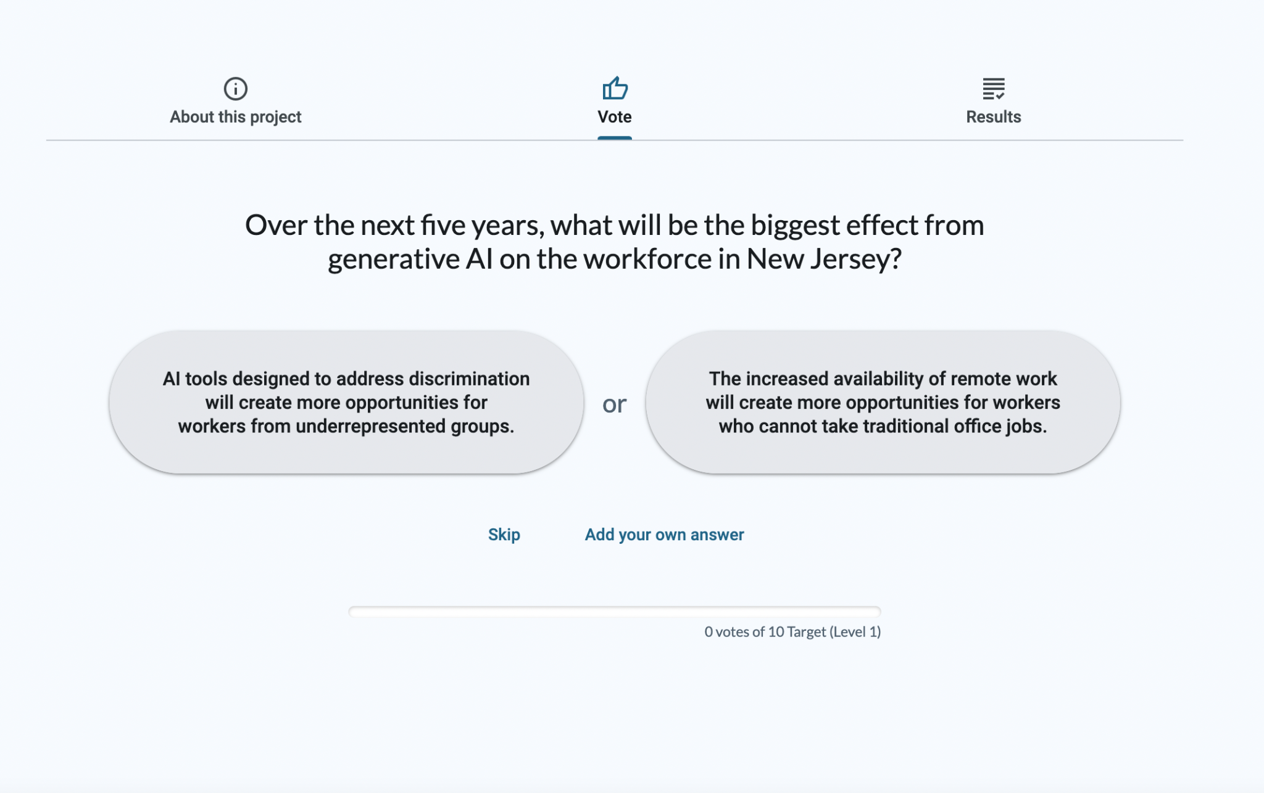
Over 3 weeks in August, 2,200 individuals submitted nearly 68,000 responses.
The engagement was available in both English and Spanish.
Based on the public’s responses, the tool created a rank-ordered list showing the most-selected and least-selected answer choices in real time. The top five responses:
- Laws protecting privacy rights will struggle to keep pace with the capabilities of AI surveillance.
- Workers will feel less secure in their jobs, believing that AI could replace them at any time.
- Older workers, who face challenges adapting to new technologies, will experience greater unemployment or underemployment.
- Workers displaced by AI will face financial struggles.
AI will take over entry-level tasks, leaving fewer opportunities for workers with minimal education, training, or experience.
To view the full list, click here and navigate to the “Results” tab.

A.2 Appendix B: “Your Future of AI” Survey
The 29-question “Your Future of AI” survey was conducted online in English using a non-probability sample. The findings represent the opinions of respondents based on self-reported data and are not generalizable to a larger population.
The survey was distributed via email to 64,000 public-sector workers via the NJ Direct mailing list, and participation was voluntary. The survey received 5,158 responses. The survey launched on May 31 and closed on June 20, 2024.
The survey was drafted by the John J. Heldrich Center for Workforce Development at Rutgers, The State University of New Jersey, in collaboration with New Jersey’s Office of Innovation. It was administered by the New Jersey Civil Service Commission Center for Learning and Improving Performance (CLIP).
To view the full list of survey questions, click here. For an analysis of the results, click here.

A.3 Appendix C: Using AI to Conduct Policy Research
The Working Group deployed a custom application to explore the problems at hand, as well as potential policy solutions regarding the impact of GenAI on New Jersey’s workforce and economy. The application, Policy Synth, is an AI toolkit that uses LLMs to conduct large-scale, automated web research with the goal of creating evidence-based policy recommendations systematically. The toolkit first generated a list of 20 problem areas based on a search of more than 1,000 online sources. Policy Synth then generated two sets of solutions:
- Solutions to the problem areas identified through the online search (1,451 ideas across 20 problem areas)
- Solutions to the highest-priority problem areas identified by workers through public engagement (1,101 ideas across 15 problem areas)
The Working Group then prioritized the top five solutions for eight priority problem areas covering both searches:
- Problem Area 1: Economic Disparity
- Problem Area 2: Reduction in Overall Labor Demand
- Problem Area 3: AI-driven Occupational Shifts
- Problem Area 4: Worker Displacement
- Problem Area 5: Lack of Transparency and Accountability in AI Systems
- Problem Area 6: Impacts on Mental Health
- Problem Area 7: Impacts on Older Workers
Problem Area 8: Privacy and Surveillance Challenges
This prioritization resulted in a list of 40 solutions for consideration. From there, the Working Group combined and further prioritized the results to produce the five recommendations described above.

A.4 Appendix D: AI in Higher Education Landscape Analysis
In Spring 2024, the Office of the Secretary of Higher Education (OSHE) conducted an AI landscape analysis at institutions of higher education (IHEs) across New Jersey. This analysis used public data on academic program offerings and completions, as well as an AI Inventory Questionnaire developed specifically to collect data not already available on the topic. The questionnaire questions/items were split into four major thematic areas: academic programs related to AI that are currently offered or in development; AI research and development activity and output; research and other partnerships with AI companies; and institutional approaches to AI on campus.
The results are based on 43 (38 complete) institutional responses to OSHE’s AI Inventory Questionnaire, administered in April/June 2024. This represents about 48 percent of all IHEs in the State of New Jersey. The majority (51 percent) of respondents were public institutions (12 county colleges and 10 senior public); seven private for-profit institutions; 10 independent public-mission institutions; and four religious institutions.

A.5 Appendix E: Findings from OSHE Survey
A.5.1 Curricula
Over one-third of academic programs related to AI currently offered and in development are programs that are or will be minors or tracks, which is not surprising given the relative newness of GenAI and its link to established disciplines like computer science, mathematics, linguistics, information systems, and engineering. The survey results suggest that there are almost as many programs at varying stages of program development (119) as those currently being offered (148), demonstrating the growing and developmental nature of AI academic program initiatives.
Institutions also indicated providing several non-degree offerings on AI tools and their use including non-credit courses, workshops for faculty, students, and staff, and professional development workshops and webinars.
A.5.2 Research and Innovation
Current exploration in improving education is already well underway. AI research and development is a burgeoning area where colleges and universities are ramping up their investments. According to the OSHE AI Inventory survey, 10 institutions invested over $14 million in AI research and development in FY 2022–23, with the largest source of grant funds coming from the federal government. Responses indicate that New Jersey Research Universities have more than 85 patents issued or pending related to AI, suggesting that these institutions are leading the way in developing AI tools and researching their use. Eight institutions have direct research partnerships with top AI companies including Amazon, Google, Microsoft, Apple, IBM, and Meta. Some additional research partnerships are with key state-based firms in the biotech, pharmaceutical, and medical/health industries such as NEC, AstraZeneca, and BioMap, in addition to companies in the education space such as Educational Testing Services (ETS). Twelve New Jersey institutions provide support for start-up entrepreneurship and 13 have or are planning AI research hubs, centers, or office space, like NJIT’s Center for AI Research.
A.5.3 Direct Usage of GenAI
As AI tools like ChatGPT become more common and integrated into all aspects of life, institutions of higher education need to be aware of, adapt to, and help their faculty and students navigate the ethical and proper use of these tools. More than half (58 percent) of responding institutions in the OSHE survey stated that they currently have an AI Task Force on campus. The survey explored how institutions would use AI tools and asked them to place where they fell on an AI maturity scale. Eight percent of institutions feel as though they are optimized, having a strategic approach to leveraging AI to enhance their mission and operations; 37 percent rate themselves as proactive (the institution has multiple groups working on different plans for AI but not generally coordinated/integrated); most (45 percent) indicate that there are reactive/individual efforts underway but that they are limited and specific; and 11 percent respond that there are no plans or work underway. These responses are expected to shift as AI becomes more integrated into daily operations.

A.6 Appendix F: Survey on Public Perspectives of AI
A.6.1 Background
To gauge public opinion on AI technologies, New Jersey in partnership with Rutgers University conducted a survey of New Jersey residents. This survey is one of the first statewide surveys to focus specifically on individual attitudes toward AI using a representative sample. The survey explored public perspectives about interactions with AI, perceptions of AI’s impact on the workplace, and its potential implications for education. Respondents also shared their views on AI's effects on data security, mental health, and transparency, along with their level of trust in AI systems to act fairly and without bias.
These results will help contextualize the Task Force recommendations by providing insight into public opinion and expectations regarding AI's potential and challenges. These perspectives are essential for delivering equitable initiatives that meet the diverse needs of our State. The following section outlines these findings.
A.6.2 Survey Design and Sample
To develop a survey of New Jersey residents that captures diverse perspectives on AI, the Equity Working Group first conducted a systematic review of existing public opinion studies from 2018 to early 2024, employing the PRISMA methodology for structured evaluation. This review was designed to identify critical knowledge gaps and areas of public concern, particularly regarding AI’s societal impacts, while also offering a comprehensive understanding of the broader issues surrounding development and governance. The review identified 55 relevant studies and a total of 1,088 survey items published during this period. The group, then, refined this list by categorizing the items into relevant themes, eliminating duplicates, and ensuring that the final selection addressed the most pressing issues identified in the analysis. Ultimately, the list focused on a set of items that provide systematic and comprehensive insights into public attitudes toward AI.
The survey was distributed by the Eagleton Center for Public Interest Polling (ECPIP) at Rutgers University. ECPIP's respondents were selected using a probability-based polling method from a statewide representative panel of New Jersey adults, allowing the results to be generalized to the broader New Jersey adult population. Care was also given to ensure adequate representation of Black or African American residents and Hispanic or Latino residents in the sample. Such representation is important because members of these communities have historically encountered significant barriers to technological access and employment in technology-driven industries. Each of these groups accounted for 20% of the respondents, while the remaining 60% represented other race-ethnicity groups.
The survey was distributed using a dual-mode survey approach that employs both online and telephone methods (covering cell phones and landlines) through ECPIP’s panel. This dual-mode design ensured that we reached individuals who may not be familiar with or have access to digital technology or are often omitted in the polling efforts. To further enhance inclusivity, the questionnaire was offered in both English and Spanish, based on the respondent's language preference.
Data collection took place from September 20 to 30, 2024, gathering a total of 1,307 responses. Most responses (94.8%) were collected online, with the remaining 5.2% gathered via telephone interviews. Among the respondents, 23.6% were Black or African American, 18.8% were Hispanic or Latino, 46.4% were White, 8.9% were Asian, and 2.1% were from other race-ethnicity groups (with 0.3% unreported). Black or African American and Hispanic or Latino groups are sufficiently represented in the sample to accommodate more representative views of these communities. Gender distribution was 56.8% female, 42.8% male, and 0.5% identified as another gender.
Regarding education, 5.1% had less than a high school diploma, 17.5% had a high school diploma, 26.3% had some college education, and 51% held a college degree or higher. As for annual income, 28.8% reported earning less than $50,000, 25.9% earned between $50.000 and $100,000, 17.7% earned between $100,000 and $150,000, and 21.1% earned $150,000 or more (with 6.5% not disclosing their income).
A.6.3 Results
The following section presents key findings from the survey, which explored public attitudes on various aspects of AI, including: the importance of human interaction, impacts on job markets, potential benefits in education, factors influencing tool adoption, trust in ethical decision-making capabilities, and concerns about discrimination. The results are discussed both in the aggregate and by racial and ethnic groups to highlight potential disparities in perspectives. Stratifying by these groups allows us to understand how different communities experience and respond to AI, ensuring that diverse viewpoints are adequately represented.
A.6.3.1 AI Use
We begin by examining how frequently New Jersey residents use or interact with artificial intelligence (AI) in their daily lives. Respondents rated their frequency of AI usage, with options ranging from "several times a day" to "never." Understanding the prevalence of AI integration in individuals' routines is important because this information helps contextualize their perceptions and attitudes toward these technologies.
As the results demonstrate, in aggregate, 35.5% of respondents interact with AI infrequently. Meanwhile, 21.3% do so several times a week, 12.4% several times a day, and 9.6% about once a day. 20.9% of respondents never interact with AI.
When stratifying the results by race and ethnicity (Exhibit A.6.3.1-1), Asian respondents report the most frequent interactions, while White, Black, and Hispanic or Latino respondents use AI less often. Specifically, 23.3% of Asian respondents interact with AI several times a day, and 12.9% do so about once a day. In contrast, only 10.8% of White, 10.4% of Black, and 14.2% of Hispanic or Latino respondents use AI several times daily. Additionally, a significant portion of White (23.7%), Black (22.1%), and Hispanic or Latino (18.3%) respondents report never using AI. These trends suggest that Asian respondents may be more comfortable or reliant on AI in daily life, while other groups demonstrate a more cautious or limited engagement with these technologies.

Exhibit A.6.3.1-1: AI Usage by Race

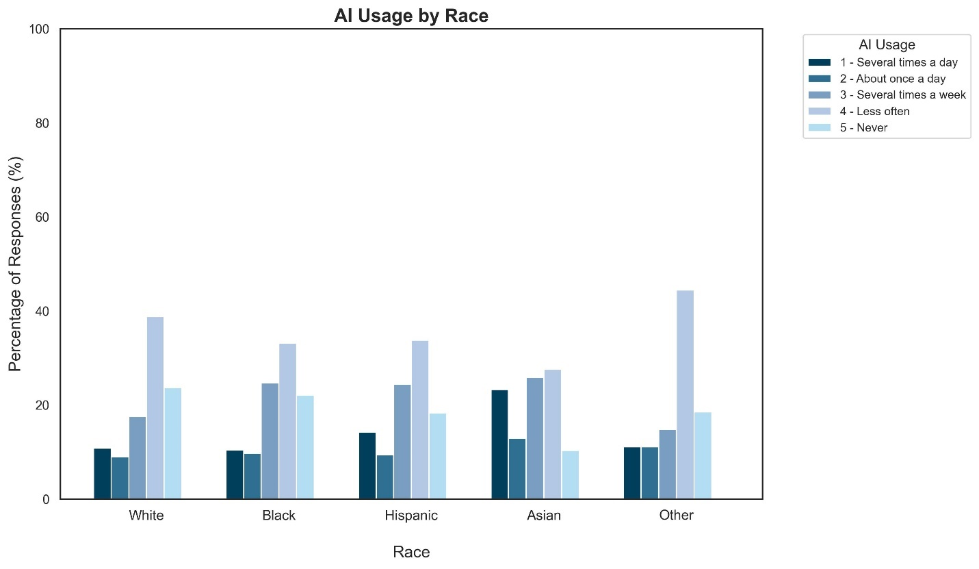
A.6.3.2 Determinants of AI Tool Adoption
Building on the insights from AI usage, we assessed the factors that influence New Jersey residents' decisions to adopt new tools. Respondents rated the importance of factors, including data security, equitable treatment of users, and transparency in decision-making. These determinants highlight the critical factors that shape AI tool adoption.
The results show that data security is the most important factor for respondents, with over 80% of respondents ranking it as extremely or very important. Specifically, 90% of White respondents, 89.6% of Asian respondents, 83.4% of Black respondents, and 84.5% of Hispanic or Latino respondents consider data security extremely or very important.
Equitable treatment is also a major concern, with over 60% of all respondents rating it as extremely or very important. Black and Asian respondents place slightly higher importance on equitable treatment compared to Hispanic or Latino and White respondents. For example, 66.7% of Black respondents and 65.2% of Asian respondents consider equitable treatment extremely or very important, while 62.3% of Hispanic or Latino respondents and 60.8% of White respondents do the same.
Transparency in decision-making is another key factor, with over 70% of respondents rating it as extremely or very important. While there is little variation across racial groups, Asian respondents were slightly more moderate in the importance they placed on transparency when deciding whether to use an AI tool or not. Specifically, 41.8% of White respondents, 39.4% of Black respondents, and 41.4% of Hispanic or Latino respondents consider transparent and understandable decision-making extremely important, while 37% of Asian respondents do the same.
Overall, these findings demonstrate that New Jersey residents prioritize data security, equitable treatment, and transparency when considering AI tool adoption. While there are some variations across racial groups, these factors are consistently important to a significant majority of respondents.

Exhibit A.6.3.2-1: Importance of Transparency for AI Adoption by Race

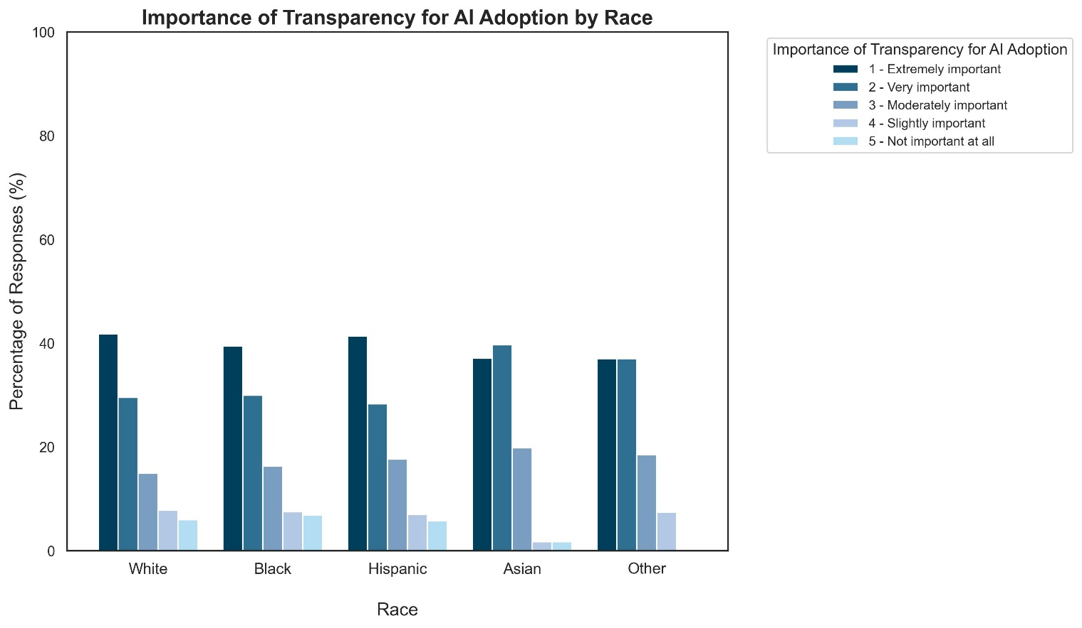

Exhibit A.6.3.2-2: Importance of Equitable Treatment for AI Adoption by Race

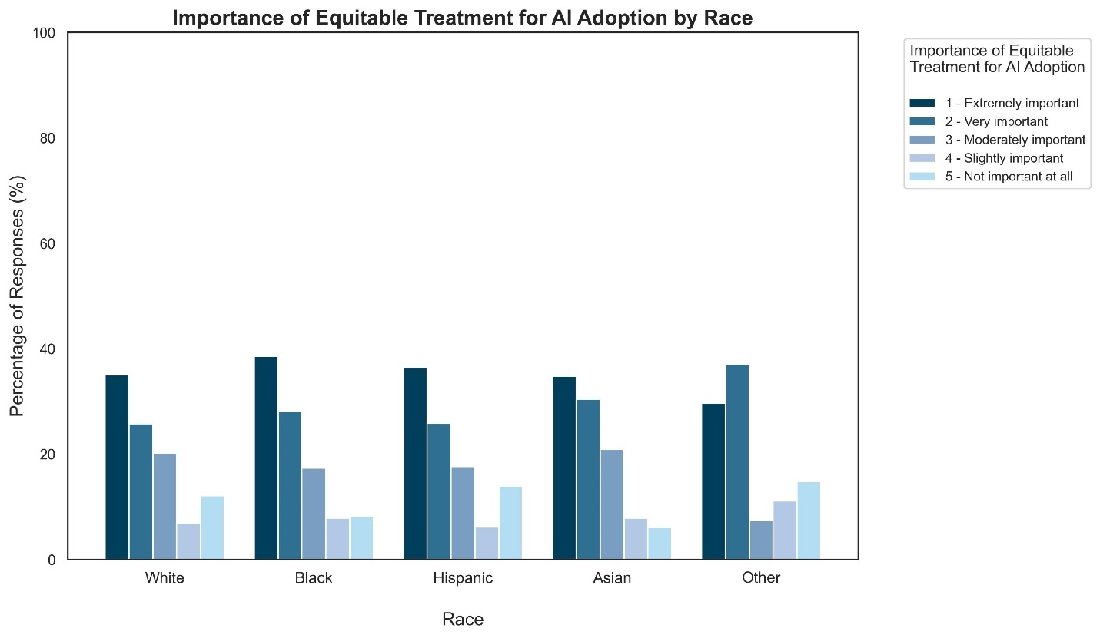

Exhibit A.6.3.2-3: Importance of Data Security for AI Adoption by Race

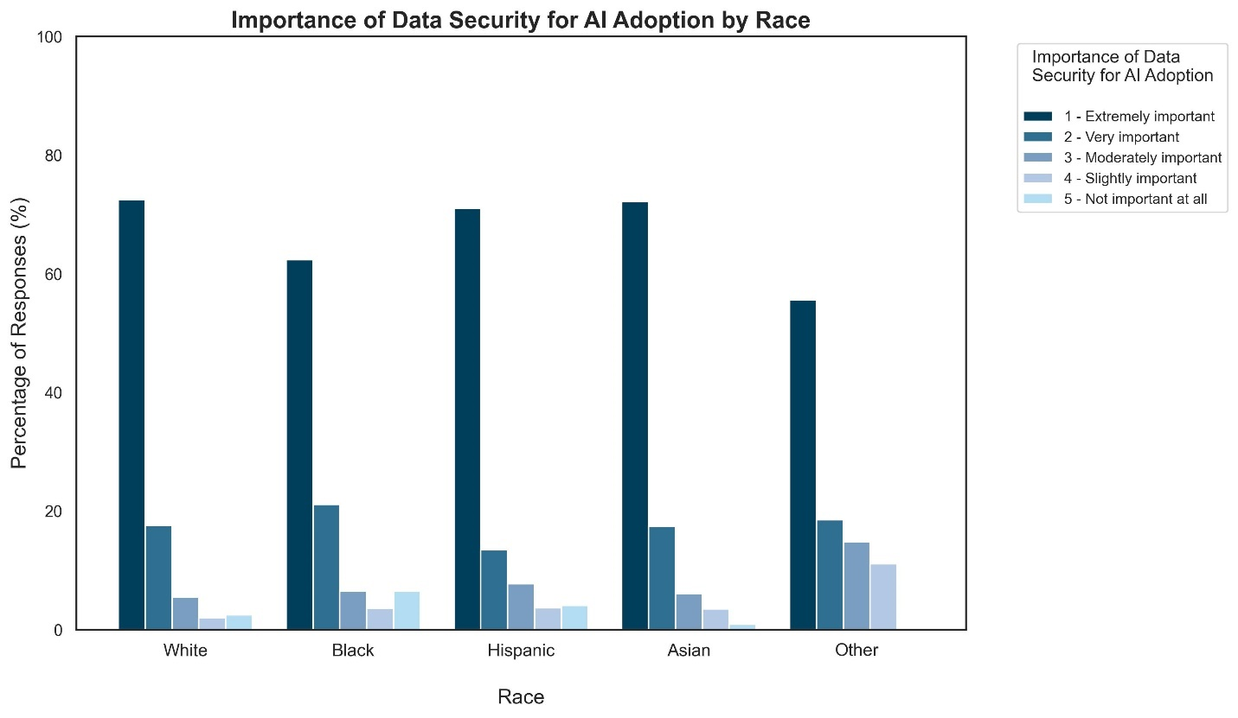
A.6.3.3 Public Trust in AI-Generated Information
An additional consideration when attempting to explain attitudes toward AI use and adoption is the level of trust individuals have in AI-generated information. Here, we explore New Jersey residents' trust in AI systems to provide reliable information, with responses ranging from "a great deal" to "none at all."
In aggregate, 8.2% of respondents express a great deal of trust in AI's reliability, and 29.3% report a fair amount of trust. However, a substantial portion of the population remains skeptical, with 29.3% expressing limited trust and 6.7% reporting no trust at all. This trend suggests that while some residents are open to trusting AI, a significant portion remains cautious, reflecting broader societal concerns about the accuracy and transparency of AI systems.
When stratified by race and ethnicity, Exhibit A.6.3.3-1 reveals that distrust in AI systems is notably higher among White and Hispanic or Latino respondents, with 40.2% of White and 39.4% of Hispanic or Latino respondents expressing little to no trust in AI. In comparison, only 26.7% of Black respondents and 31% of Asian respondents report similarly low levels of trust. These findings suggest that White and Hispanic or Latino individuals may be more skeptical of AI's reliability, though distrust remains significant across all groups.

Exhibit A.6.3.3-1: Public Trust in AI-Generated Information by Race

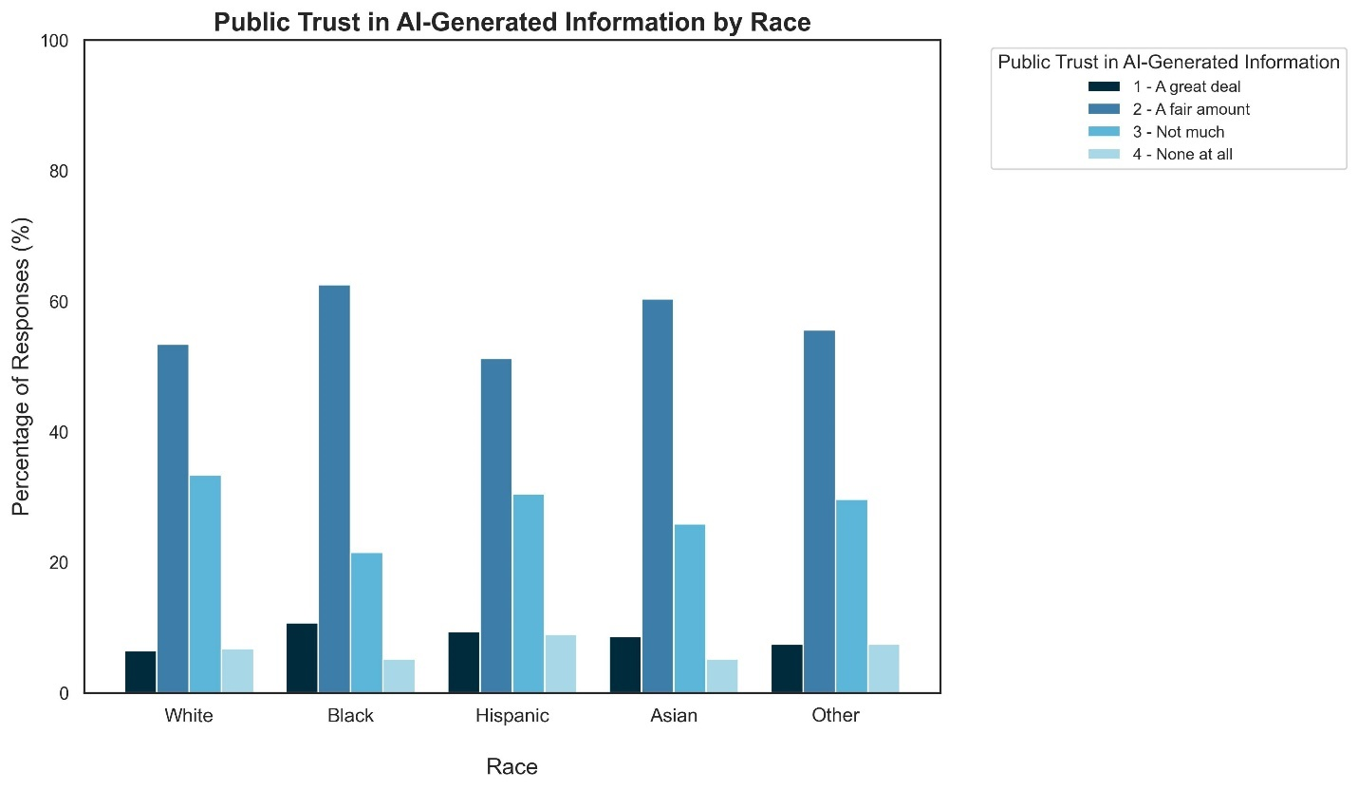

A.6.3.4 Preferences for Human Agency in an AI-Driven World
The group also examined the importance of maintaining options for human interaction in an increasingly automated environment. The Working Group explores the extent to which New Jersey residents believe it is important to ensure options for human interaction as AI technologies become more widely used.
As the results demonstrate, in aggregate, 70.2% of respondents think it is very important to ensure an option to allow individuals to interact with humans instead of AI. This is followed by 21.3% who say it is somewhat important, 5.4% who say it is not very important, and 2.4% who say it is not important at all.
Stratifying the results by race and ethnicity, Exhibit A.6.3.4-1 shows that while a significant majority of White (73.6%), Black or African American (68.4%), and Hispanic or Latino (72.4%) respondents consider having an option for human interaction to be very important, only 53.4% of Asian respondents share this view. This suggests that Asian participants may be somewhat more comfortable relying on AI compared to the other racial and ethnic groups surveyed.

Exhibit A.6.3.4-1: Preferences for Human Agency in an AI-Driven World by Race

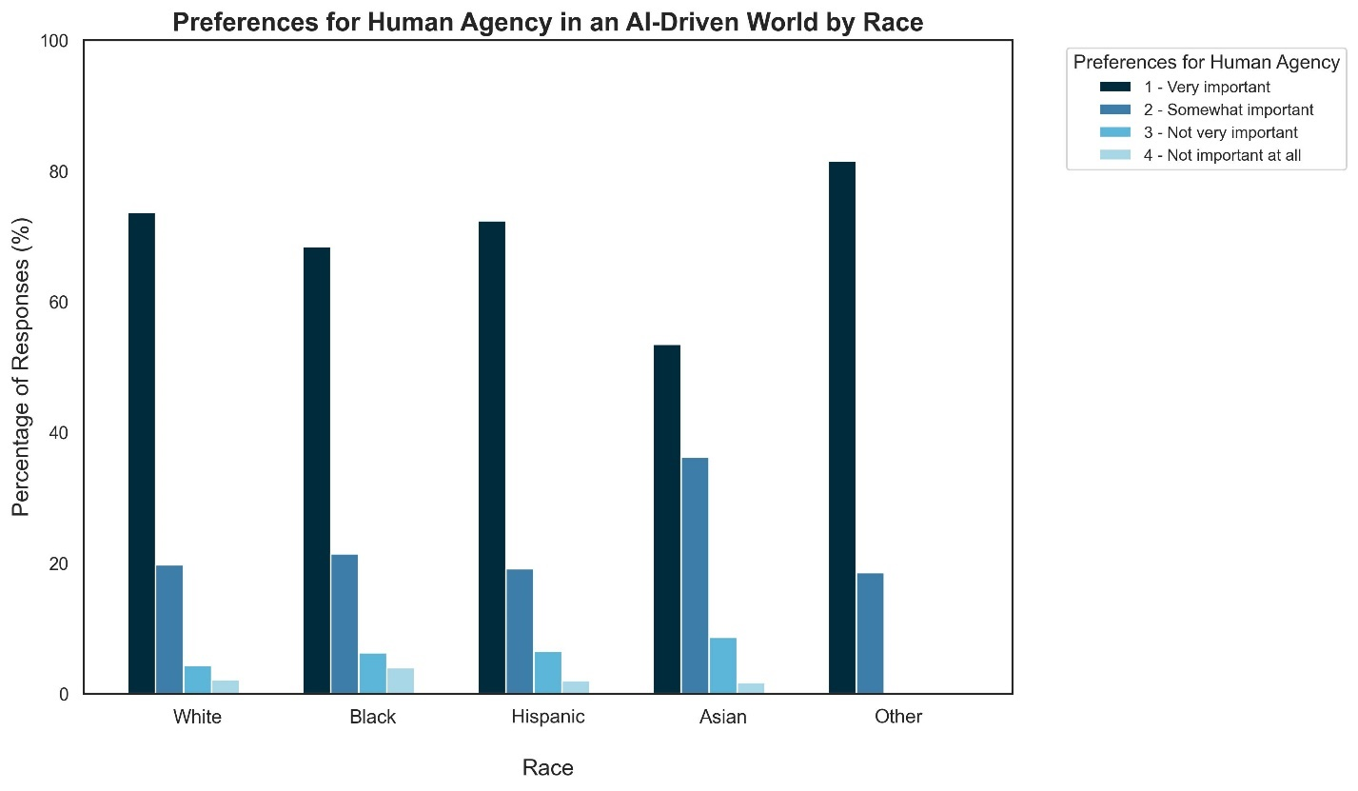

A.6.3.5 Perceptions of AI's Impact on Employment
The integration of AI into daily life also raises questions about its impact on employment. We assess New Jersey residents' perceptions regarding AI's influence on job availability. Respondents were asked whether they believed AI would increase, decrease, or have no impact on the number of jobs available. These responses provide insight into public expectations and anxieties regarding AI's role in shaping the future of work.
The results demonstrate that, in aggregate, 63.6% respond that AI will eliminate more jobs than it creates, while 14.2% say AI creates more jobs than it eliminates. Meanwhile, 21.3% anticipate no impact on the number of jobs available. Stratifying these results by race and ethnicity, as can be seen from Exhibit A.6.3.5-1 below, reveals distinct differences in outlook among various racial groups.
Most respondents across all racial groups express concerns about AI's impact on job availability, with 65.5% of Black respondents, 64.8% of White respondents, 62.2% of Hispanic respondents, and 58% of Asian respondents fearing job reductions. Optimism about AI's potential to create jobs remains low across the board; only 18.8% of Asian respondents, 16.7% of Hispanic respondents, and 16.3% of Black respondents foresee job creation because of AI. Notably, White respondents are the most pessimistic, with just 11.8% believing that AI will contribute to job growth. Furthermore, a significant portion of respondents expect AI to have little to no impact on employment: 21.1% of White and Hispanic respondents, 23.2% of Asian respondents, and 17.9% of Black respondents share this view.

Exhibit A.6.3.5-1: Perceptions of AI’s Impact on Employment by Race

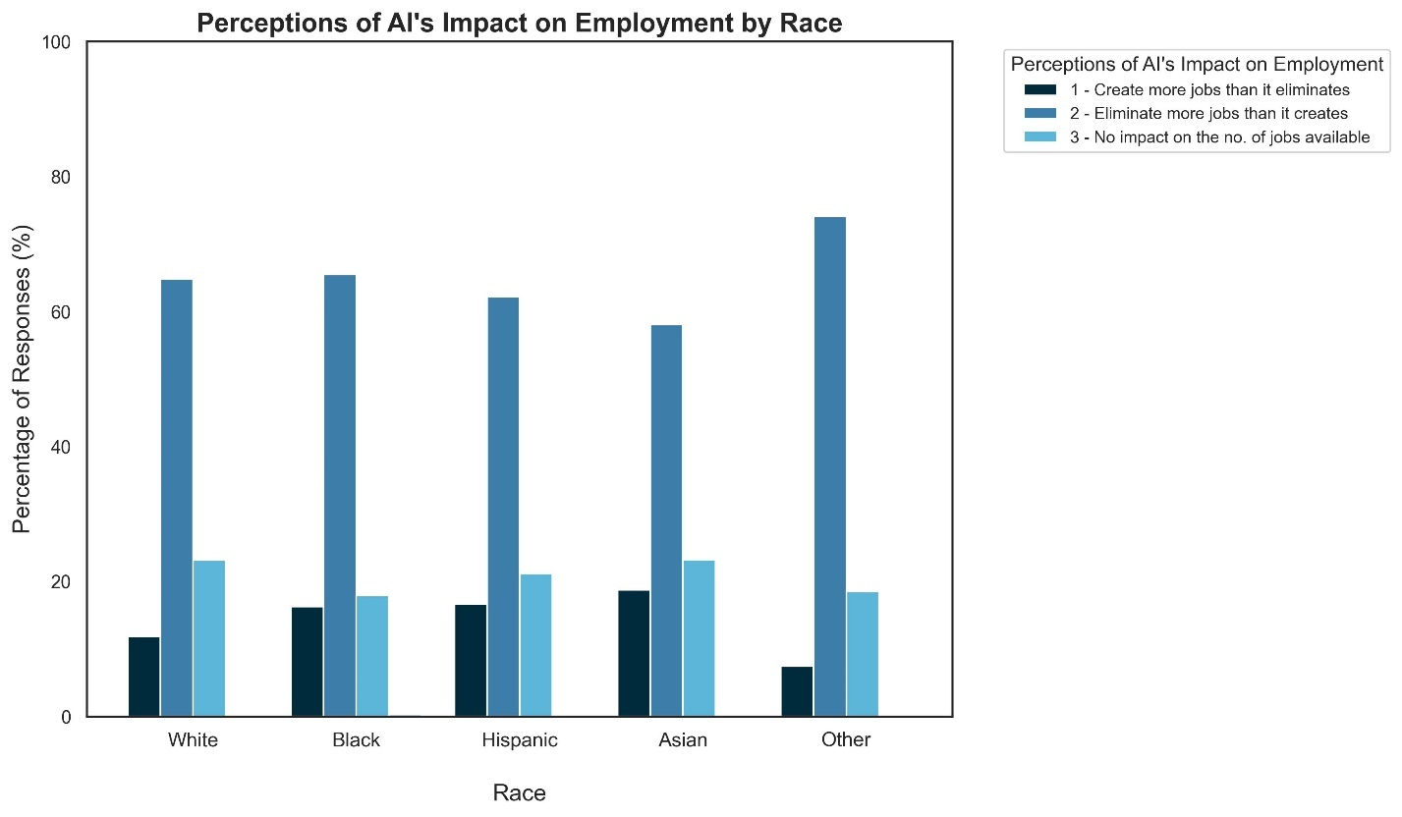

A.6.3.6 Perceived Benefits of AI for Education
The survey also explored views on the potential benefits of AI in education over the next five years. Respondents identified which uses of AI they believe would be most beneficial including improving access to higher education for underrepresented groups such as women, people of color, and individuals with disabilities, reducing disparities in educational outcomes, and enhancing learning experiences for students. These responses highlight public perceptions of AI’s potential to address equity challenges within the education system.
The results reveal mixed attitudes regarding AI's impact on education. Overall, 36.2% of respondents believe AI will help more than hurt in improving access to higher education for underrepresented groups, while 20.9% anticipate it will hurt more. Notably, 42.2% feel that AI makes no difference, indicating a significant degree of uncertainty. Asian respondents are the most optimistic, with 53.0% believing that AI will help improve access to higher education, followed by Black respondents at 39.8%. White respondents are more likely to see AI as having little effect, with 49.2% indicating that AI will make no difference. Hispanic respondents display a balanced view, with 37.1% expecting AI to help and 38.8% feeling it will have no impact. Regarding concerns over potential harm, Black respondents (24.3%) and Hispanic respondents (24.1%) show higher levels of apprehension, while Asian respondents (15.7%) and White respondents (18.7%) are less likely to view AI as detrimental.
Respondents are balanced on reducing disparities in educational outcomes: 29.9% think AI will help more than hurt, while 29.2% believe the opposite. Meanwhile, 40.1% expect no impact from AI, reflecting a lack of consensus on its potential benefits. Black respondents are the most optimistic, with 37.5% believing AI will help reduce disparities. White respondents predominantly believe AI will not significantly affect educational disparities, with 44.0% holding this view. Hispanic respondents are more cautious, with 36.6% saying AI will make no difference, 28.0% expecting it to help, and a notable 35.4% expressing concern that AI may hurt educational equity. Asian respondents reflect a relatively balanced perspective, with 33.6% believing AI will help, 42.2% seeing no impact, and 24.1% concerned about potential harm.
When it comes to enhancing students' learning experiences, the outlook is positive, with 50.3% of respondents believing AI will help more than hurt. However, 29.5% expect it to hurt more, and 19.6% assert that it will make no difference, highlighting a cautious optimism among respondents. Black and Asian respondents are the most optimistic, with 57.1% and 55.2%, respectively, believing AI will improve learning experiences. White respondents are more cautious, with 47.9% seeing AI as beneficial but 30.2% concerned it may harm learning. Hispanic respondents are similarly mixed, with 49.8% expecting positive impacts but 33.1% fearing negative effects.

Exhibit A.6.3.6-1: Perceived Benefits of AI for Access to Higher Education by Race

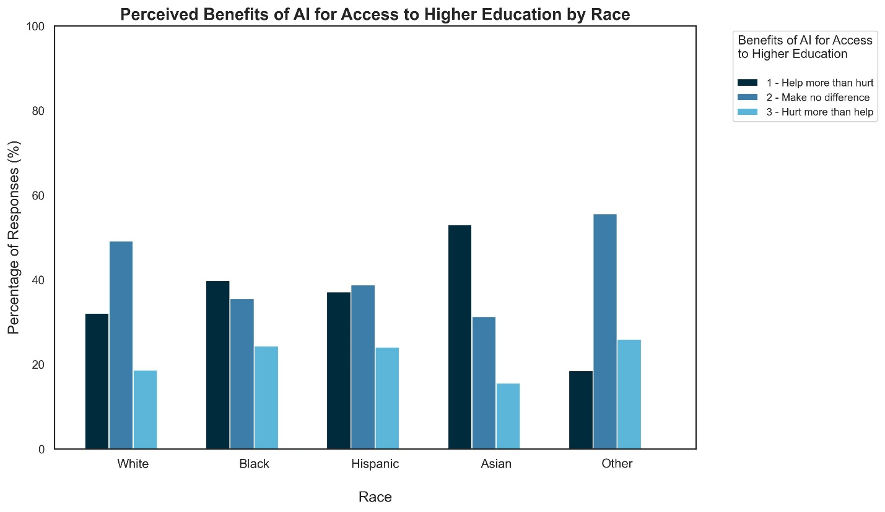

Exhibit A.6.3.6-2: Perceived Benefits of AI for Disparities in Education Outcomes by Race

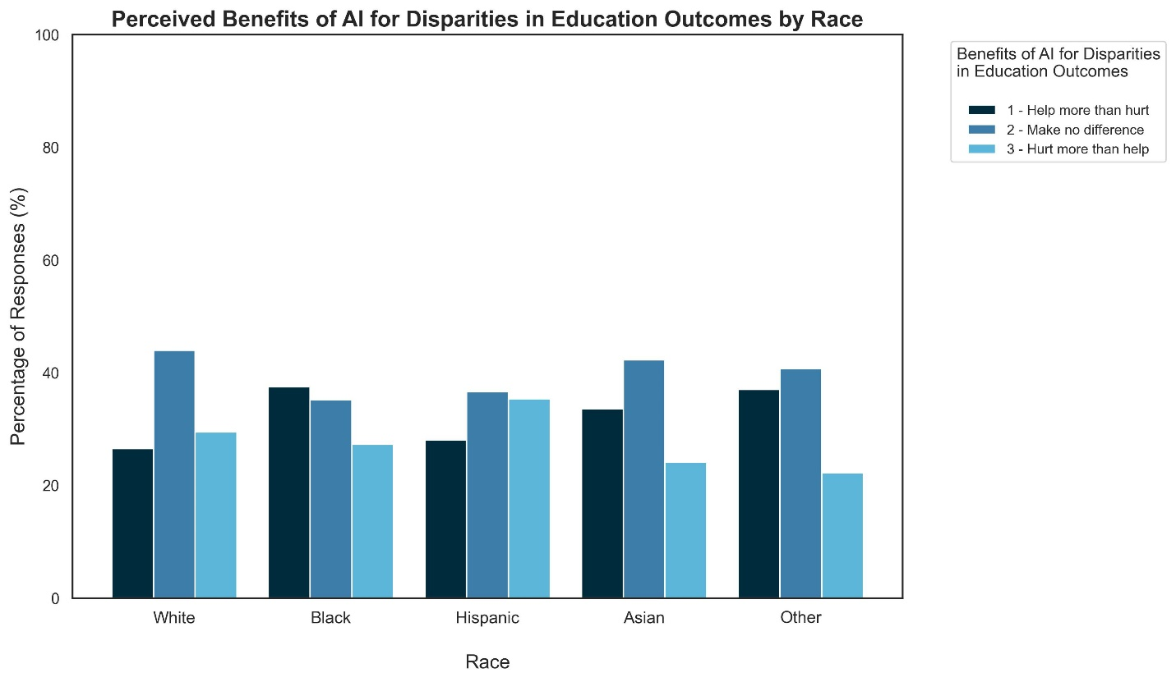

Exhibit A.6.3.6-3: Perceived Benefits of AI for Enhancing Learning Experiences by Race

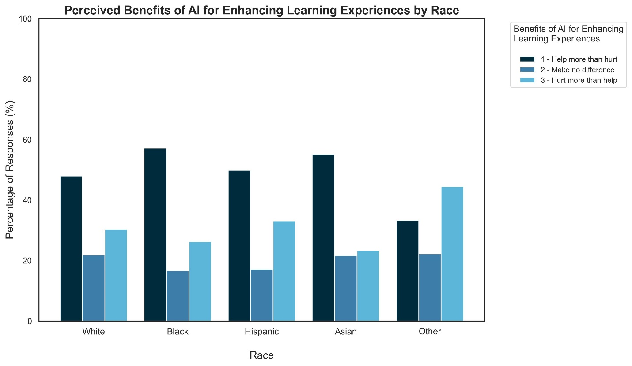

A.6.3.7 Trust in AI for Ethical Decision-Making
As AI becomes more integrated in the economy, understanding the level of trust in AI systems to make ethical and unbiased decisions is crucial. Here, the survey examines confidence in AI's ability to act fairly, with responses ranging from "a great deal" to "none at all." These insights gauge public confidence in AI's ethical decision-making and its perceived alignment with societal values.
The data reveals a range of trust levels across racial groups regarding AI’s capacity to make ethical decisions. Overall, a predominant sentiment of limited trust is evident, with significant proportions within each group indicating only moderate or minimal confidence in AI's ethical decision-making capabilities. In aggregate, 42.9% of respondents do not trust AI systems to make ethical and unbiased decisions, and 17.7% do not trust them at all. However, 34% have a fair amount of trust and 4.6% have a great deal of trust.
As can be seen from Exhibit A.6.3.7-1 below, White respondents show significant skepticism toward AI in ethical matters, with 47.5% expressing low trust, 19.8% indicating no trust, 31.0% showing a fair amount of trust, and only 1.7% reporting a great deal of trust. Black respondents show a more varied trust distribution in AI, with 40.5% expressing a moderate amount of trust, 39.2% indicating low trust, 14.1% having no trust, and 6.2% demonstrating a high level of trust in AI's ethical decision-making. Like White respondents, Hispanics exhibit limited trust in AI for ethical decisions, with 40.2% indicating low trust, 34.4% expressing fair trust, 18.0% having no trust, and only 7.4% reporting a high level of trust. Asian respondents are comparatively more optimistic about AI's ethical decision-making, with 37.9% expressing fair trust and 9.5% indicating a great deal of trust, though 36.2% show limited trust and 16.4% report no trust, reflecting a mix of caution and optimism.

Exhibit A.6.3.7-1: Trust in AI for Ethical Decision-Making by Race

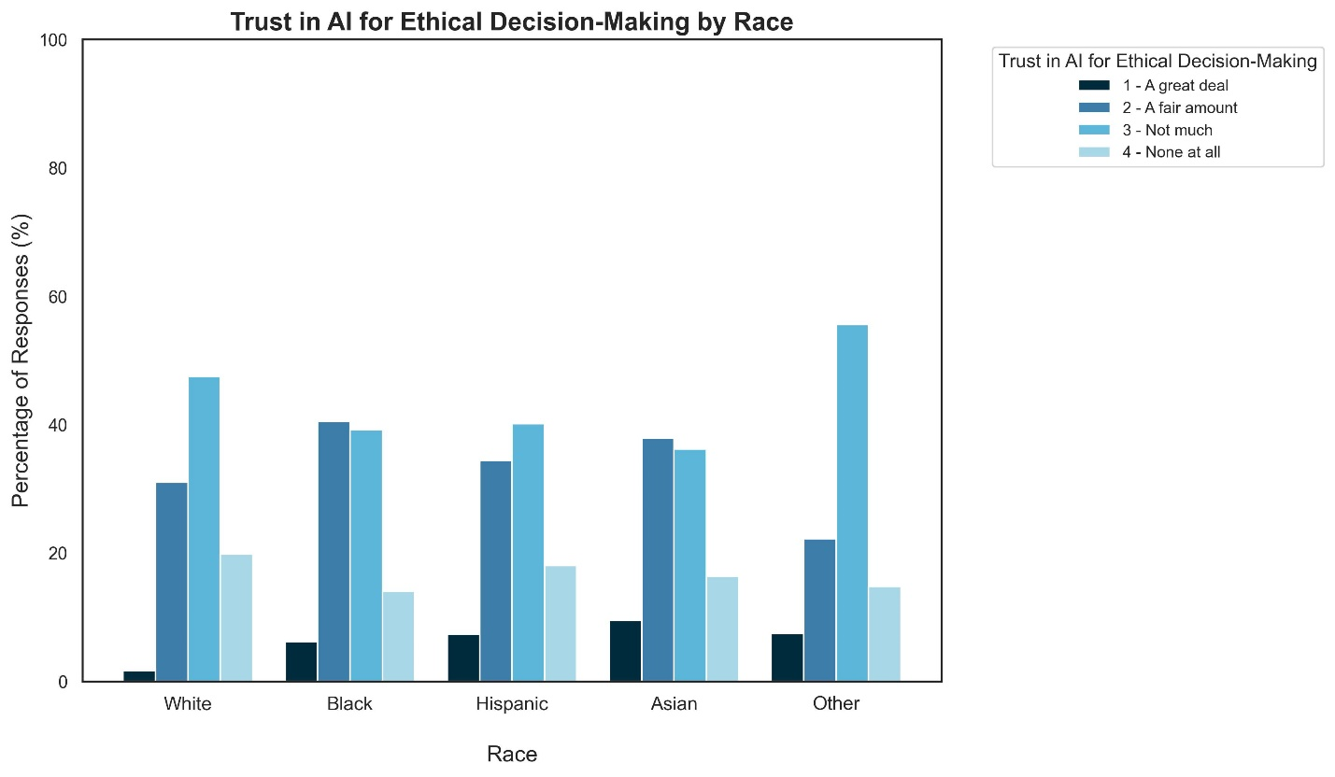

A.6.3.8 AI and Discrimination
Finally, the survey investigates residents' concerns about the potential for AI adoption to lead to personal discrimination in the next five years. Respondents expressed their level of concern, ranging from "not concerned at all" to "extremely concerned." This data sheds light on public sentiment regarding AI technologies on equity and fairness within society.
The results reveal varying levels of apprehension across racial groups regarding the potential for discrimination stemming from AI integration. In aggregate, 34.9% respond that they are not too concerned about discrimination against themselves, 16.2% are not at all concerned, 31.7% are somewhat concerned, and 16.8% are very concerned. Exhibit A.6.3.8-1 below highlights differences in how race and ethnicity groups perceive the risks associated with AI’s impact on fairness and equity.
Black respondents exhibit the highest level of concern, with 28.3% very concerned and 32.6% somewhat concerned about discrimination stemming from AI. In contrast, White respondents display more varied views, with 37.8% indicating they are not too concerned and only 10.6% reporting they are very concerned. Hispanic respondents show a more balanced outlook, with 33.9% somewhat concerned and 19.2% very concerned, while 13.9% express no concern at all. Asian respondents hold a moderate stance, with 38.8% not too concerned, 32.8% somewhat concerned, and a smaller proportion, 14.7%, very concerned, indicating relatively lower levels of apprehension within this group.

Exhibit A.6.3.8-1: Concerns About Discrimination Due to AI Adoption by Race

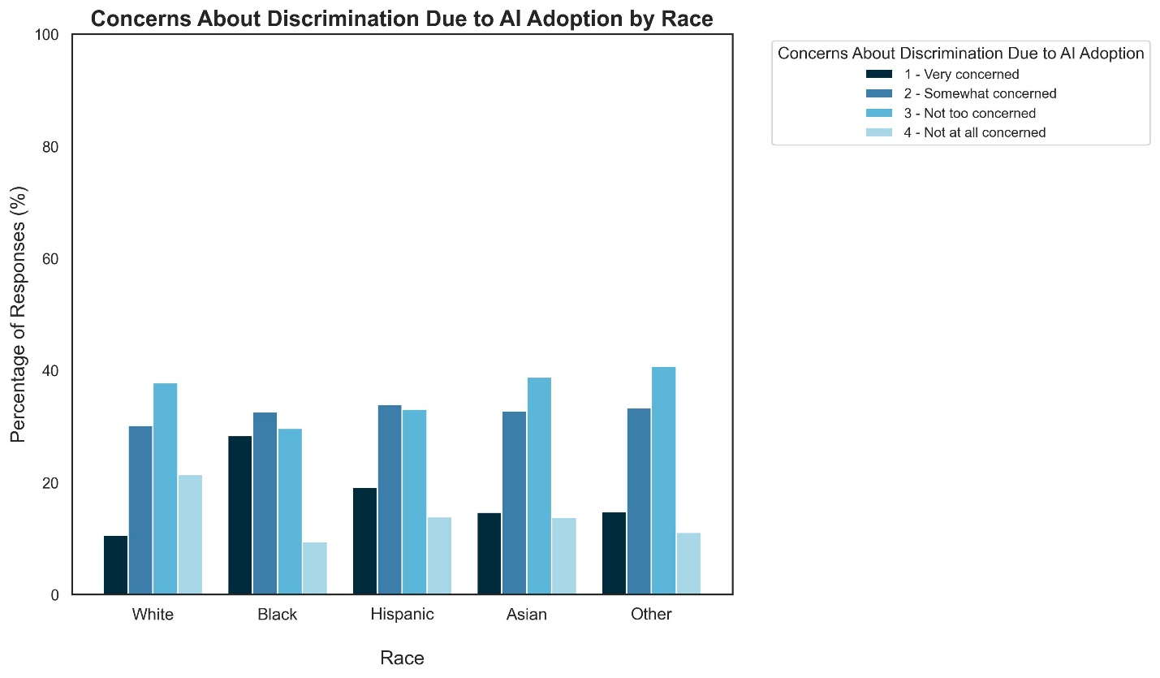
A.6.4 Summary
This survey of New Jersey residents reveals nuanced perspectives on public attitudes towards AI, offering insights into often subtle yet substantive differences across racial and ethnic groups. These findings are informative for policymakers as they consider implementing AI-related recommendations and strive for equitable AI integration. Overall, the data reveals a thoughtful and engaged approach to AI adoption among New Jersey residents, indicating a population ready to embrace AI's potential benefits while mindful of its challenges.
While current AI usage remains limited, New Jersey residents recognize its potential to impact various sectors, particularly in education and the workforce. However, residents show a balanced perspective, acknowledging both the promises and challenges of AI adoption. Across demographic groups, there is also a shared emphasis on the importance of data security and ethical considerations, reflecting a populace that values responsible AI development.
At the same time, varying levels of trust and concerns about AI-driven discrimination across the different ethnic and racial groups surveyed highlight a need to involve diverse communities in shaping AI policies and technologies to contribute to equitable and fair use, development and governance that work to the benefit of all New Jersey residents.
Overall, these findings paint a picture of a state ready to embrace the benefits of AI while remaining mindful of potential pitfalls. This thoughtful stance positions New Jersey well for developing equitable, transparent, and effective AI policies that could serve as a model for responsible AI integration. The survey results offer important insights for New Jersey policymakers, suggesting that AI initiatives that prioritize security, fairness, and maintain a balance between automation and human interaction are likely to find support among residents.

Glossary of Terms
- AI Boot Camps: Intensive training programs, often offered online or through community centers, that teach AI concepts and tools to students and professionals over a short period, typically focusing on practical skills for the job market
- AI Hackathons: Events where students and developers collaborate to design and build AI-driven solutions over a short period of time, fostering innovation and hands-on experience with AI technologies
- AI Inventory: A survey conducted by the New Jersey Office of the Secretary of Higher Education (NJOSHE) to collect data on AI-related academic programs, research, and partnerships at public and private institutions across the state
- AI Literacy: The knowledge and skills required to understand and use AI technologies effectively, including awareness of their capabilities, limitations, and ethical implications
- AI Maturity Scale: A metric used by organizations to assess their level of integration and strategic use of AI technologies, ranging from basic awareness to full optimization of AI capabilities in operations and decision-making
- AI Workforce Transition Program: A proposed initiative by the NJDOL to expand upon existing NJDOL programs to provide financial support, reskilling opportunities, and social services to workers affected by AI
- AI-Powered Predictive Models: Systems that analyze data patterns to make forecasts about future behavior, such as student performance, economic trends, or resource needs, enabling proactive decision-making
- Adversarial AI: A type of AI threat where malicious actors manipulate AI systems, often to cause harm, such as by creating deepfakes or launching cyberattacks
- Algorithmic Fairness: The principle that AI systems should make decisions without discrimination or bias, ensuring that all users are treated equitably, regardless of their background
- Analytical AI: Earlier AI systems (before GenAI) that focused on data analysis, pattern recognition, and decision-making using existing data, without generating new content like text, images, or audio.
- Angel Match Program: A financial initiative by the New Jersey Economic Development Authority (NJEDA) that matches the investments made by angel investors, providing additional capital to early-stage startups in the AI and technology sectors
- Angel Tax Credit: A financial incentive provided to individual investors, known as angel investors, who provide capital to early-stage companies. This credit reduces their tax liability, making it more attractive to invest in startups, particularly in the AI sector
- Applicant Tracking Systems (ATS): Software used by employers to screen resumes and job applications based on keywords and qualifications, often influenced by AI-driven resume optimization tools
- Artificial Intelligence (AI): A field of technology that enables machines to perform tasks typically requiring human intelligence, such as facial recognition, data analysis, and decision-making
- Association Bias: A form of bias where unconscious judgments are made based on a stereotype or automatic associations
- Automation Bias: A form of bias where there is a tendency to favor automated systems for tasks such as decision making
- Bias in AI: A risk where AI models, trained on biased data, may produce discriminatory or unbalanced outputs
- Black Box: A system whose internal processes are opaque or not easily understood, making it difficult to explain how inputs are transformed into outputs, as is often the case with complex models like GenAI
- Children’s Online Privacy Protection Act (COPPA): A law that protects the privacy of children under 13 online, requiring organizations to safeguard children’s data when using AI-powered platforms in education
- Capability Overhang: Refers to hidden capacity or capabilities of AI that go beyond its intended purpose or training
- Chatbot: An AI-powered tool that simulates human conversation, often used to provide customer service or assist with various queries and tasks
- Cloud Service Providers: Companies that offer cloud-based solutions for data storage, processing, and software applications, often supporting AI systems that require significant computational resources
- Confirmation Bias: A form of bias where support for a specific point of view is sought out and conflicting information is minimized; the act of confirming one’s preexisting beliefs
- Conversational Privacy: An expectation that a private conversation will not be recorded, shared, or listened to by unauthorized parties
- Cybersecurity: Measures and practices put in place to protect AI systems and the data they handle from malicious attacks, such as data theft or adversarial AI threats
- Data Ingestion: Feeding in multiple sources of data to storage (e.g., database) or processing system for future analysis
- Data Poisoning: A type of cyberattack where an AI system’s training data are intentionally corrupted to produce inaccurate or harmful outputs
- Data for Opportunity in Occupational Reskilling Solutions (DOORS): A program by the nonprofit Research Improving People’s Lives (RIPL) that provides funding and technical assistance to state governments to modernize workforce programs with AI-driven career services
- Data Scraping: The extraction of large amounts of data from digital sources (e.g., websites) using code or formal data access methods
- Data Security: Protection of digital information from unauthorized access, theft, or corruption via methods such as encryption
- Deepfake: AI-generated synthetic media, typically videos or images, that convincingly mimic real individuals; often used maliciously to deceive or mislead
- Deep Learning Algorithms: A subset of machine learning that use neural networks with multiple layers to automatically learn and extract complex patterns from large amounts of data, often applied in areas like image recognition, natural language processing, and AI
- Digital Divide: The gap between individuals or communities that have access to digital technologies (such as AI and the internet) and those who do not, often along socioeconomic or geographic lines
- Digital Literacy: The ability to effectively find, evaluate, use, and create information through digital technologies. It includes skills such as navigating the internet, using software, and understanding digital communication tools
- Dilutive Capital: Money a company receives from giving up some ownership or shares
- Disparate Impact: Practices or policies that appear neutral but may unintentionally produce unequal outcomes
- Disparate Treatment: A situation when individuals are treated differently or unfairly based on characteristics like race, gender, or age, resulting in intentional discrimination.
- Equity in AI: The fair and inclusive deployment of AI technologies to ensure that all groups, especially historically underserved communities, benefit from AI advancements without exacerbating existing inequalities
- Escalation Path: A structured process that outlines the steps and criteria for advancing unresolved issues to higher levels of authority or expertise, ensuring timely and appropriate resolution in complex or critical situations
- Explainability: The ability of an AI system to provide understandable reasons for its decisions or outputs, helping users interpret and trust the system’s functioning
- Explainable Model Inference: A feature of AI models that allows users to understand how the model arrived at a particular decision or output, enhancing transparency and trust
- Family Educational Rights and Privacy Act (FERPA): A federal law that protects the privacy of student education records, ensuring that AI tools used in educational settings comply with data privacy regulations
- Fine-Tuning: The process of adapting a pre-trained AI model to perform specific tasks more effectively by further training it on specialized data
- Foundation Model: A large, pre-trained AI model that can be adapted or fine-tuned for specific tasks. The text discusses the need for New Jersey to procure high-quality foundation models for government use
- Generative AI (GenAI): A type of artificial intelligence that creates new content, such as text, images, and videos, based on simple user inputs or prompts
- Greenwashing: Providing an over-exaggerated perception of environmentally friendly and sustainable practices
- Guardrails: Guidelines for measures to prevent certain actions from straying across a set of rules/principles
- Hallucination (AI): A situation where an AI model generates incorrect or nonsensical information, despite appearing plausible, due to limitations in its understanding or data
- Human-in-the-loop (HITL): A process where human oversight is integrated into AI workflows, particularly to review and ensure the accuracy of AI-generated outputs in critical decision-making processes
- Hyperscalers: Large companies that provide scalable cloud computing services, typically operating massive data centers and offering platforms for AI infrastructure, storage, and processing
- Impactful Bias: A type of bias in AI that directly influences decision-making and results in harmful consequences, such as discrimination in hiring or loan approvals
- Implicit Bias: A form of bias where an individual has unconscious internal bias toward certain topics that skew their thought processes
- InnovateUS: A nonprofit organization that collaborates with the public and private sectors to provide AI training and skill development to workers and students, helping them adapt to technological advancements
- Innovation Evergreen Fund: A fund from which NJEDA draws to make contributions to an Evergreen special purpose vehicle that invests alongside a venture capital main fund, and support innovation-driven businesses in New Jersey
- Job Transition Accounts: Publicly funded accounts designed to help low-income and displaced workers by covering the costs of reskilling or retraining, particularly for transitioning into AI-augmented jobs or careers less affected by AI
- Meaningful Bias: Bias that has a significant, tangible impact or influence on decisions, outcomes, or perceptions
- Minority Serving Institution (MSI): A higher education institution in the U.S. that is specifically recognized for serving a significant percentage of minority students from historically underrepresented communities. Per the U.S. Department of Interior’s Office of Diversity, Inclusion, and Civil Rights, MSIs are defined as Historically Black Colleges and Universities (HBCUs), Tribal Colleges and Universities, Hispanic-Serving Institutions, and Asian American and Pacific Islander Serving Institutions (AAPISIs)
- Model Inversion: A privacy risk in AI where a model can be exploited to recreate sensitive data that it was trained on
- Multi-modal Phishing: A type of phishing attack that combines multiple channels e.g., text, email, or calls to trick individuals into compromising private information
- My Career NJ: A State-run platform offering personalized career advice and training recommendations to New Jersey residents, powered by AI to help users find high-demand jobs and upskilling opportunities
- Natural Language: Human language that GenAI models can understand and use to interpret prompts and generate meaningful responses or content in a way that mimics conversation
- NJ Big Data Alliance (NJBDA): A cooperative of New Jersey institutions focused on advancing research and development in big data analytics, machine learning, and AI, often engaging with universities and industry partners
- NJ Career Navigator: An AI-powered platform that provides personalized career recommendations and training opportunities to New Jersey residents, helping them navigate job transitions and upskill for high-growth industries
- NJ Training Explorer: A search engine within My Career NJ that helps users find training programs based on various criteria, such as cost, location, language of instruction, and format, tailored to individual career goals
- National Science Foundation (NSF): A U.S. government agency that supports research and education in all fields of science and engineering, including AI, through grants and initiatives like the National Applied Artificial Intelligence Consortium (NAAIC)
- National Applied Artificial Intelligence Consortium (NAAIC): An NSF-funded initiative that develops technician-level AI courses and certification programs at two-year institutions to prepare students for AI-related careers
- Natural Language: The language used by humans for daily communication as opposed to computer languages
- Non-Dilutive Capital: Money a company receives while retaining ownership/shares such as grants, loans, or tax incentives
- Non-impactful Bias: Information bias or bias present in AI models or data that does not have a direct effect on decision-making and thus may not cause immediate harm
- Policy Synth: An AI toolkit used by New Jersey’s AI Task Force Working Group to conduct large-scale automated research and generate evidence-based policy recommendations related to the impact of GenAI on the workforce
- Predictive Analytics: The use of AI to analyze data and predict future outcomes, such as identifying students at risk of dropping out based on academic performance, attendance, and engagement
- Principles of Least Privileged (POLP): A cybersecurity concept where users, applications, or systems are given the minimum level of access necessary to perform their tasks.
- Privacy: The protection of personal data, which can be at risk due to improper handling by AI models, leading to data leaks or unauthorized access
- Public-Private Partnerships (PPPs): Collaborations between government entities and private companies to achieve public policy goals, such as workforce development or AI education, by pooling resources and expertise
- Sandbox Environment: A secure and controlled environment used to test and experiment with AI technologies without exposing sensitive data or systems to risk
- Shadow AI: Artificial intelligence that is developed or used without the knowledge, oversight, or permission of an organization that may lead to security and compliance risks
- Sustainability: The environmental impact of AI, particularly the energy consumption and resource use associated with training and deploying AI models, and the efforts to mitigate these effects
- Tech Apprenticeships: Practical training programs that combine on-the-job experience with classroom learning, focusing on technology and AI-related skills to prepare individuals for careers in the AI and tech sectors
- Tech Stack: A combination of different technologies (e.g., tools, programming languages, frameworks) of front-end or back-end development components
- Test-and-Learn Approach: An iterative process for decision-making where small experiments are conducted to test hypotheses and ideas
- Toxic Content: Harmful or offensive content that can be generated by AI models if not properly monitored, including disinformation or instructions that could lead to dangerous outcomes
- Training Data: A dataset used to train a machine learning model with examples of the “correct” data that a user wants the model to predict so that the model can learn patterns, relationships, and behaviors
- Upskilling: The process of acquiring additional skills or improving current ones to remain competitive in the labor market, especially in light of new technologies like AI
- Workforce Innovation and Opportunity Act (WIOA): A U.S. federal law aimed at helping job seekers access employment, education, training, and support services to succeed in the labor market, including programs like Individual Training Accounts for reskilling
- Zero-Trust Architecture: A principle by which entities employ security safeguards – putting in as many safeguards to ensure those accessing the systems or sub-systems are who they say they are

Reference Materials, Research, Publications, and Articles Used
- Arkansas JobLink (2022, December 8). ReSkill Arkansas - Information Technology. https://www.arjoblink.arkansas.gov/jobs/2959319
- Autor, D., Chine, C., Salomons, A., & Seegmiller, B. (2024). New Frontiers: The Origins and Content of New Work, 1940–2018. The Quarterly Journal of Economics, 139(3). https://doi.org/10.1093/qje/qjae008
- Bajowala, R., & Goker, A. (2024, April 1). Utah enacts first AI-focused consumer protection legislation in U.S. Greenberg Traurig LLP. https://www.gtlaw.com/en/insights/2024/4/utah-enacts-first-ai-focused-consumer-protection-legislation-in-us
- Bajwa, J., Munir, U., Nori, A., & Williams, B. (2021). Artificial intelligence in healthcare: transforming the practice of medicine. Future healthcare journal, 8(2), e188–e194. https://doi.org/10.7861/fhj.2021-0095
- Bamberger, S., Clark, N., Ramachandran, S., & Sokolova, V. (2023, July 6). How generative AI is already transforming customer service. Boston Consulting Group. https://www.bcg.com/publications/2023/how-generative-ai-transforms-customer-service
- Borowiec D, Harper R, and Garraghan P (2021) IT Now: The Environmental Consequence of Deep Learning. BCS. https://www.bcs.org/articles-opinion-and-research/the-environmental-consequence-of-deep-learning/
- Boston Consulting Group (2022): Infrastructure and energy Demand of GenAI; & Advisory/Strategic engagement with State of NJ, 2024
- Boston Consulting Group. (2024). 2024 Digital government survey: Trust imperative 4.0. https://www.bcg.com/publications/2024/digital-government-survey
- Boston Consulting Group (2024): GenAI: The Trust Multiplier for Government, 2024 Global Report. https://www.bcg.com/publications/2024/trust-imperative-4-0-genai-the-trust-multiplier-for-government
- California Department of Human Resources. (n.d.). Diversity, equity, and inclusion toolkit. https://www.calhr.ca.gov/state-hr-professionals/Pages/Diversity-Equity-and-Inclusion-Toolkit.aspx
- California Legislature. (2019). AB 602: Political Reform Act of 1974: Digital political advertisements: Disclosure. LegiScan. https://legiscan.com/CA/text/AB602/id/2055866
- Candelon, F., Krayer, L., Rajendran, S., & Zuluaga Martinez, D. (2023, September 21). How People Can Create—and Destroy—Value with Generative AI. BCG. https://www.bcg.com/publications/2023/how-people-create-and-destroy-value-with-gen-ai
- Candelon, F., Evans, P., Zhukov, L., & Zuluaga Martinez, D. (2024, February 2). How your company could be tomorrow’s surprise GenAI leader. Fortune. https://fortune.com/2024/02/02/ai-genai-corporate-power-dynamics-leadership-bcg/
- Chatterjee, M. (2024, May 26). Nonconsensual AI porn is hated on the left and right. Can Congress act on it? Politico. https://www.politico.com/news/2024/05/26/ai-deepfake-porn-congress-00158713
- Choose New Jersey (2024, May 10). Choose New Jersey Expands Reach in Q1 with Inaugural Mission to the United Arab Emirates and AI Marketing Campaign in California. https://www.choosenj.com/news/choose-new-jersey-expands-reach-in-q1
- Chuang, T. (2024, April 25). Colorado bill to regulate generative artificial intelligence clears its first hurdle at the Capitol. The Colorado Sun. https://coloradosun.com/2024/04/25/colorado-generative-ai-artificial-intelligence-senate/
- Connecticut Innovations. (2023, January 26). Connecticut Innovations launches $50 million Future Fund. https://ctinnovations.com/news/connecticut-innovations-launches-50-million-future-fund/
- Council of the Great City Schools (October 2023). K-12 Gen AI Readiness Checklist. https://www.cgcs.org/cms/lib/DC00001581/Centricity/Domain/417/K-12%20Generative%20AI%20Readiness%20Checklist%20October%202023%20v1.1%202.pdf
- Cui, Z., Demirer, M., Jaffe, S., Musolff, L., Peng, S., & Salz, T. (2024, September 5). The Effects of Generative AI on High Skilled Work: Evidence from Three Field Experiments with Software Developers. SSRN. http://dx.doi.org/10.2139/ssrn.4945566
- Cybersecurity & Infrastructure Security Agency. (2024). Risk in Focus: Generative AI and the 2024 Election Cycle. https://www.cisa.gov/resources-tools/resources/risk-focus-generative-ai-and-2024-election-cycle
- David, G. (2024, September 16). How NYC Became an AI Industry Hot Spot. The City. https://www.thecity.nyc/2024/09/16/artificial-intelligence-industry-new-yorkhow-nyc-became-an-ai-industry-hot-spot/
- Davis+Gilbert staff (2024, September 25). California Passes New Legislation Prohibiting Unauthorized AI Replicas. Davis+Gilbert Law. https://www.dglaw.com/california-passes-new-legislation-prohibiting-unauthorized-ai-replicas
- Dell’Acqua, F., McFowland, E., Mollick, E., Lifshitz-Assaf, H., Kellogg, K., Rajendran, S., Krayer, L., Candelon, F., & Lakhani, K. (2023). Navigating the Jagged Technological Frontier: Field Experimental Evidence of the Effects of AI on Knowledge Worker Productivity and Quality. https://papers.ssrn.com/sol3/papers.cfm?abstract_id=4573321
- DeSanty, T. M., CPA (2013, May 1). Sec. 1202: Small Business Stock Capital Gains Exclusion. The Tax Adviser.
- https://www.thetaxadviser.com/issues/2013/may/clinic-may2013-story-07.html
- Ember, S. (2024, June 17). Can A.I. Answer the Needs of Smaller Businesses? Some Push to Find Out. The New York Times. https://www.nytimes.com/2024/06/17/business/economy/artificial-intelligence-small-business.html
- Enhancv. (n.d.). Enhancv homepage. http://enhancv.com
- Falk, S., van Wynsberghe, A. Challenging AI for Sustainability: what ought it mean?. AI Ethics (2023). https://doi.org/10.1007/s43681-023-00323-3
- Felten, E., Raj, M., & Seamans, R. (2021). Occupational, industry, and geographic exposure to artificial intelligence: A novel dataset and its potential uses. Strategic Management Journal. https://doi.org/10.1002/smj.3286
- Felten, E., Raj, M., & Seamans, R. (2023). How Will Language Modelers Like ChatGPT Affect Occupations and Industries? SSRN. http://dx.doi.org/10.2139/ssrn.4375268
- Florida Senate. (2024). CS/HB 919: Artificial Intelligence Use in Political Advertising. The Florida Senate. https://flsenate.gov/Session/Bill/2024/919
- Franklin Organization (n.d.). Guide to New Jersey Colleges & Universities. Best Adult Colleges & Careers Guide. https://www.franklin.edu/colleges-near/new-jersey
- Freeman, R. B., Ganguli, I., & Handel, M. J. (2020). Within-occupation changes dominate changes in what workers do: A shift-share decomposition, 2005–2015. AEA Papers and Proceedings, 110, 394–399. https://doi.org/10.1257/pandp.20201005
- Garces, S. (2023, May 18). City of Boston Interim Guidelines for Using Generative AI. City of Boston. https://www.boston.gov/sites/default/files/file/2023/05/Guidelines-for-Using-Generative-AI-2023.pdf
- Georgia State University (n.d.). Student Success Programs. GPS Advising. https://success.gsu.edu/initiatives/gps-advising/
- Get Schooled. (n.d.). Get Schooled homepage. Getschooled.com
- Glasscock, A. H. (2023, December 12). NASCIO Your AI Blueprint: 12 Key Considerations as States Develop Their Artificial Intelligence Roadmaps. https://www.nascio.org/resource-center/resources/your-ai-blueprint-12-key-considerations-as-states-develop-their-artificial-intelligence-roadmaps
- Globe Newswire. (2024, September 17). NJIT devotes over $10 million in new funds for push in artificial intelligence. Globe Newswire. https://www.globenewswire.com/news-release/2024/09/17/2947627/0/en/NJIT-Devotes-Over-10-Million-in-New-Funds-for-Push-in-Artificial-Intelligence.html
- Goldman Sachs. (2024, June 25). GenAI: Too much spend, too little benefit? Goldman Sachs. https://www.goldmansachs.com/images/migrated/insights/pages/gs-research/gen-ai--too-much-spend%2C-too-little-benefit-/TOM_AI%202.0_ForRedaction.pdf
- Gómez, J. (2024, May 13). Newark Public Schools considers new AI tutor chatbot for districtwide use after pilot testing. Chalkbeat Newark. https://www.chalkbeat.org/newark/2024/05/13/artificial-intelligence-khanmigo-chatbot-tutor-pilot-testing-districtwide-expansion/
- Gómez, J. (2024, May 28). Newark considers AI tutor chatbot for districtwide use. eSchool News. https://www.eschoolnews.com/digital-learning/2024/05/28/newark-ai-tutor-chatbot-districtwide-use/
- Google staff. (2023). Google Cloud: The public sector guide to getting started with GenAI. https://services.google.com/fh/files/misc/publicsectorgenai_digitalebook.pdf
- Gradescope. (n.d.). Deliver and Grade Your Assessments Anywhere. https://www.gradescope.com/
- Hanifan, G., & Timmermans, K. (2018, August 10). New Supply Chain Jobs Are Emerging as AI Takes Hold. Harvard Business Review. https://hbr.org/2018/08/new-supply-chain-jobs-are-emerging-as-ai-takes-hold
- Healey, J. (2024, March 7). Beverly Hills school district expels 8th graders involved in fake nude scandal. Los Angeles Times. https://www.latimes.com/california/story/2024-03-07/beverly-hills-school-district-expels-8th-graders-involved-in-fake-nude-scandal
- Interview Buddy. (n.d.). Interview Buddy homepage. https://interviewbuddy.net/
- Jobscan. (n.d.). Jobscan homepage. http://jobscan.co
- Khan Academy. (n.d.). Maximize your score with free Official Digital SAT® Prep. https://www.khanacademy.org/digital-sat
- Khan Academy (n.d.). Meet Khanmigo: Khan Academy's AI-powered teaching assistant & tutor. https://www.khanmigo.ai/
- Kochnar, R. (2023, July 26). Which U.S. Workers Are More Exposed to AI on Their Jobs? Pew Research Center. https://www.pewresearch.org/social-trends/2023/07/26/which-u-s-workers-are-more-exposed-to-ai-on-their-jobs/
- Levi, S. et. Al. (2024, April 5). Utah becomes first state to enact AI-centric consumer protection law. Skadden, Arps, Slate, Meagher & Flom LLP. https://www.skadden.com/insights/publications/2024/04/utah-becomes-first-state
- Louisiana Legislature. (2023). Act 440: Criminalizes the nonconsensual disclosure of private images. Louisiana State Legislature. https://legis.la.gov/legis/ViewDocument.aspx?d=1333325
- Magoosh. (n.d.). More than 10 Million Students Have Said Hello to Stress-Free Studying. https://magoosh.com/
- Mainstay. (n.d.). Success Coaching: Human Centered, AI Enhanced. https://mainstay.com/
- Massachusetts Technology Collaborative. (2024). Massachusetts Technology Collaborative. https://masstech.org/
- McDaniel, P. (2024, March 5). New AI Policy in Holmdel Schools Puts District ‘Ahead of the Curve.’ Patch. https://patch.com/new-jersey/holmdel-hazlet/new-ai-policy-holmdel-schools-puts-district-ahead-curve
- McKinsey Digital. (2023). The economic potential of generative AI: The next productivity frontier. McKinsey & Company. https://www.mckinsey.com/capabilities/mckinsey-digital/our-insights/the-economic-potential-of-generative-ai-the-next-productivity-frontier#introduction
- Minnesota Legislature. (2023). Chapter 58 - S.F. No. 2909: Omnibus Elections Act. Office of the Revisor of Statutes. https://www.revisor.mn.gov/laws/2023/0/58/
- New Jersey Big Data Alliance. (n.d.). New Jersey Big Data Alliance. https://njbda.org/
- New Jersey Institute of Technology. (2024, September 17). NJIT devotes over $10 million in new funds for push in artificial intelligence. GlobeNewswire.
- NJ Pathways. (n.d.). Technology & innovation collaborative. NJ Pathways. https://njpathways.org/collaboratives/#technology
- New Mexico Legislature. (2024). House Bill 182: An Act relating to elections; amending and enacting sections of the Campaign Reporting Act. https://www.nmlegis.gov/Sessions/24%20Regular/bills/house/HB0182.HTML
- New York Legislature. (2023). § 52-b: Private right of action for unlawful dissemination or publication of an intimate image. New York Consolidated Laws, Civil Rights Law. Justia US Law. https://law.justia.com/codes/new-york/cvr/article-5/52-b/
- Nguyễn, T. (2024, September 29). California governor signs bills to protect children from AI deepfake nudes. APNews.com. https://apnews.com/article/ai-deepfakes-children-abuse-7dcf5c566e2a297567f1e148ac2074a4
- Noveck, B. S. (2024, April 11). New Jersey is turning to AI to improve the job search process. Fast Company. https://www.fastcompany.com/91090516/new-jersey-ai-to-improve-job-search
- NYC Mayor’s Office of the Chief Technology Officer (2021, October 13). AI Strategy: The New York City Artificial Intelligence Strategy. https://www.nyc.gov/assets/cto/downloads/ai-strategy/nyc_ai_strategy.pdf
- Office of the Governor of California. (2024, September 17). Governor Newsom signs bills to combat deepfake election content. https://www.gov.ca.gov/2024/09/17/governor-newsom-signs-bills-to-combat-deepfake-election-content/
- Office of the Governor of California. (2023, September 6). Governor Newsom Signs Executive Order to Prepare California for the Progress of Artificial Intelligence. https://www.gov.ca.gov/2023/09/06/governor-newsom-signs-executive-order-to-prepare-california-for-the-progress-of-artificial-intelligence/
- Office of the Governor of California (2024, September 29). Governor Newsom announces new initiatives to advance safe and responsible AI, protect Californians. https://www.gov.ca.gov/2024/09/29/governor-newsom-announces-new-initiatives-to-advance-safe-and-responsible-ai-protect-californians
- Officer of Governor Katy Hochul. (2024, April 22). Governor Hochul launches Empire AI consortium to make New York a global leader in artificial intelligence. https://www.governor.ny.gov/news/governor-hochul-launches-empire-ai-consortium-make-new-york-global-leader-artificial
- Office of Senator Martin Heinrich. (2024, July 26). Heinrich advances legislation to address nonconsensual, sexually explicit deepfakes. U.S. Senate. https://www.heinrich.senate.gov/newsroom/press-releases/heinrich-advances-legislation-to-address-nonconsensual-sexually-explicit-deepfakes
- Ooi, K. B., Tan, G. W. H., Al-Emran, M., Al-Sharafi, M. A., Capatina, A., Chakraborty, A., … Wong, L. W. (2023). The potential of generative artificial intelligence across disciplines: Perspectives and future directions. Journal of Computer Information Systems, 1–32. https://doi.org/10.1080/08874417.2023.2261010
- Orrell, B., & Veldran, D. (2024). The age of uncertainty—and opportunity: Work in the age of AI. American Enterprise Institute. http://www.jstor.org/stable/resrep58084
- Patent Docs. (n.d.). Patent legislation. Patent Docs. https://www.patentdocs.org/patent_legislation/
- Pennsylvania Department of Community and Economic Development. (2023, February 24). Digital equity stakeholder engagement plan. https://dced.pa.gov/download/digital-equity-stakeholder-engagement-plan-plan/
- Perdomo Klukosky, F., & Kohel, M. D. (2024, June 14). The ELVIS Act: New law addresses the impact of AI on the music industry. American Bar Association. https://www.americanbar.org/groups/litigation/resources/newsletters/intellectual-property/elvis-act-new-law-addresses-impact-ai-music-industry/
- PowerSchool. (n.d.). How to Boost Your Students’ On-Time Graduation Rates. https://www.powerschool.com/blog/how-to-boost-your-students-on-time-graduation-rates/
- Psychiatrist.com Staff. (2023, June 5). NEDA suspends AI chatbot for giving harmful eating disorder advice. Psychiatrist.com. https://www.psychiatrist.com/news/neda-suspends-ai-chatbot-for-giving-harmful-eating-disorder-advice/
- PublicLawLibrary.org. (2024, September 25). California enacts groundbreaking legislation to combat AI-generated sexual exploitation and deepfakes. https://publiclawlibrary.org/california-enacts-groundbreaking-legislation-to-combat-ai-generated-sexual-exploitation-and-deepfakes/
- Quinlan, K. (2024, January 9). Pennsylvania buys enterprise ChatGPT licenses through unique pilot with OpenAI. StateScoop. https://statescoop.com/pennsylvania-openai-chatgpt-pilot-program-2024/
- Quizlet. (n.d.). Meet Q-Chat: Your AI tutor. https://quizlet.com/qchat-personal-ai-tutor
- Rainie, L., Funk, C., Anderson, M., & Tyson, A. (2022, March 17). AI and Human Enhancement: Americans’ Openness Is Tempered by a Range of Concerns. Pew Research Center. https://www.pewresearch.org/internet/2022/03/17/ai-and-human-enhancement-americans-openness-is-tempered-by-a-range-of-concerns/
- Ramos, L., Mullen, A., Yan, B., & Zhang, T. (2023, November 22). Gartner: Innovation Insight: Multimodal AI Explained. https://www.gartner.com/en/documents/4959431
- Resume.io. (n.d.). Online resume builder. http://resume.io
- Rezi. (n.d.). Rezi homepage. http://rezi.ai
- Schwartz, R., Dodge, J., Smith, N. A., & Etzioni, O. (2020). Green AI. Communications of the ACM, 63(12), 54–63. https://doi.org/10.1145/3381831
- Selenko, E., Bankins, S., Shoss, M., Warburton, J., & Restubog, S. L. D. (2022). Artificial intelligence and the future of work: A functional-identity perspective. Current Directions in Psychological Science, 31(3), 272–279. https://doi.org/10.1177/09637214221091823
- Shine, I. (2023, September 23). We often hear that AI will take our jobs. But what jobs will it create? World Economic Forum. https://www.weforum.org/agenda/2023/09/jobs-ai-will-create/
- Singer, N. (2024, April 8). Teen Girls Confront an Epidemic of Deepfake Nudes in Schools. New York Times. https://www.nytimes.com/2024/04/08/technology/
deepfake-ai-nudes-westfield-high-school.html
- Starace, J. & Van Horn, C. (2024). U.S. Workers Assess the Impacts of Artificial Intelligence on Jobs: Topline Survey Results. WorkTrends. https://heldrich.rutgers.edu/sites/default/files/2024-02/Work_Trends_February_2024.pdf
- Strubell, E., Ganesh, A., & McCallum, A. (2019). Energy and policy considerations for deep learning in NLP. In Proceedings of the 57th Annual Meeting of the Association for Computational Linguistics (pp. 3645–3650). Association for Computational Linguistics. https://aclanthology.org/P19-1355.pdf
- Tattersfield, K. (2024, July 24). How Predictive Analytics Can Boost Student Success Rates. Full Fabric. https://www.fullfabric.com/articles/how-predictive-analytics-can-boost-student-success-rates
- Tennessee Office of the Governor. (2024, March 21). Photos: Gov. Lee signs ELVIS Act into law. https://www.tn.gov/governor/news/2024/3/21/photos--gov--lee-signs-elvis-act-into-law.html
- Texas Legislature. (2019). Senate Bill No. 751: Relating to the creation of a criminal offense for fabricating a deceptive video with intent to influence the outcome of an election. Texas Legislature Online. https://capitol.texas.gov/tlodocs/86R/billtext/pdf/SB00751F.pdf
- The AI Summit New York. (n.d.). Frequently Asked Questions: The AI Summit. The AI Summit New York. https://newyork.theaisummit.com/about/frequently-asked-questions
- The New Jersey Department of Education. (2024). Adjusted cohort graduation rate (ACGR). https://www.nj.gov/education/schoolperformance/grad/ACGR.shtml
- The New Jersey Economic Development Authority (n.d.). Angel Investor Tax Credit Program. NJEDA.gov. from https://www.njeda.gov/angeltaxcredit/
- The New Jersey Economic Development Authority (n.d.). The New Jersey Innovation Evergreen Fund. NJEDA.gov. https://www.njeda.gov/evergreen/
- The New Jersey Economic Development Authority. (2022, December 20). NJEDA to receive $255M in federal funds to support New Jersey’s small business community. https://www.njeda.gov/njeda-to-receive-255m-in-federal-funds-to-support-new-jerseys-small-business-community/
- The New Jersey Economic Development Authority (2024, July 25). Governor Murphy Signs Legislation to Spur Investment in New Jersey’s AI Sector. NJEDA.gov. https://www.njeda.gov/governor-murphy-signs-legislation-to-spur-investment-in-new-jerseys-ai-sector
- The New Jersey Office of Innovation. (2024). AI assistant impact report. https://innovation.nj.gov/impact-report/2024/ai-assistant/#:~:text=New%20Jersey%20is%20one%20of%20the%20first%20States%20in%20the
- The White House. (2021). Executive order on transforming federal customer experience and service delivery to rebuild trust in government. https://www.whitehouse.gov/briefing-room/presidential-actions/2021/12/13/executive-order-on-transforming-federal-customer-experience-and-service-delivery-to-rebuild-trust-in-government/
- The White House. (2023, October 30). Executive Order on the Safe, Secure, and Trustworthy Development and Use of Artificial Intelligence. WhiteHouse.gov. https://www.whitehouse.gov/briefing-room/presidential-actions/2023/10/30/executive-order-on-the-safe-secure-and-trustworthy-development-and-use-of-artificial-intelligence/
- U.S. Department of the Interior. (n.d.). Minority Serving Institutions Program. https://www.doi.gov/pmb/eeo/doi-minority-serving-institutions-program
- U.S. National Science Foundation (2024, August 2). NSF invests $2.8M to strengthen technical AI education at two-year institutions. https://new.nsf.gov/news/nsf-invests-28m-strengthen-technical-ai-education
- U.S. Patent and Trademark Office. (n.d.). Public views on patent subject matter eligibility: Summary of stakeholder input and next steps. https://www.uspto.gov/sites/default/files/documents/USPTO-SubjectMatterEligibility-PublicViews.pdf
- Utah State Legislature. (2024). Artificial Intelligence Amendments. https://le.utah.gov/~2024/bills/sbillint/SB0149.htm
- Verdecchia, R., Sallou, J., & Cruz, L. (2023). A systematic review of Green AI. WIREs Data Mining and Knowledge Discovery, 13(4). https://doi.org/10.1002/widm.1507
- Virginia Legislature. (2019). HB 2678: Unlawful dissemination or sale of images of another; penalty. LegiScan. https://legiscan.com/VA/text/HB2678/id/1971540
- Washington Office of Superintendent of Public Instruction (n.d.). Career Connect Washington. https://ospi.k12.wa.us/student-success/career-technical-education-cte/cte-resources-essentials/career-connect-washington
- Washington State Legislature. (n.d.). Chapter 42.62 RCW: Legislative Ethics Act. https://app.leg.wa.gov/RCW/default.aspx?cite=42.62&full=true
- Yeretsian, S. (2024, April 2). California right of publicity laws in light of Tennessee’s ELVIS Act. Lewis Brisbois Bisgaard & Smith LLP. https://lewisbrisbois.com/newsroom/legal-alerts/california-right-of-publicity-laws-in-light-of-tennessees-elvis-act
- YouScience. (n.d.). YouScience homepage. https://www.youscience.com/
- Zety. (n.d.). Zety: Resume builder, cover letter builder, and career resources. Zety. http://zety.com
- Zhou, S., Xu, F. F., Zhu, H., Zhou, X., Lo, R., Sridhar, A., Cheng, X., Ou, T., Bisk, Y., Fried, D., Alon, U., & Neubig, G. (2023). WebArena: A realistic web environment for building autonomous agents. ArXiv. https://arxiv.org/abs/2307.13854

Generative AI (“GenAI”) is defined as a type of artificial intelligence that creates new content, such as text, images, and videos, based on simple user inputs or prompts
Starace, J. & Van Horn, C. (2024). U.S. Workers Assess the Impacts of Artificial Intelligence on Jobs: Topline Survey Results. WorkTrends. https://heldrich.rutgers.edu/sites/default/files/2024-02/Work_Trends_February_2024.pdf.
Personalized recommendations will be recommendations only, not guarantees of employment of job offers.
Given GenAI’s multi-lingual capabilities, the technology can also be used to translate materials for English as a Second Language (ESL) students and their parents or guardians. Because GenAI tools are largely trained on datasets collected from the Internet, in which standard U.S. English predominates, special care and human oversight must be taken when deploying these tools to serve communities that speak other languages or dialects to confirm that the output of the tools adequately serves their needs and does not perpetuate real-world biases.
New Jersey Office of Innovation. (2024). AI assistant impact report. https://innovation.nj.gov/impact-report/2024/ai-assistant/#:~:text=New%20Jersey%20is%20one%20of%20the%20first%20States%20in%20the
Bamberger, S., Clark, N., Ramachandran, S., & Sokolova, V. (2023, July 6). How generative AI is already transforming customer service. Boston Consulting Group. https://www.bcg.com/publications/2023/how-generative-ai-transforms-customer-service
Psychiatrist.com Staff. (2023, June 5). NEDA suspends AI chatbot for giving harmful eating disorder advice. Psychiatrist.com. https://www.psychiatrist.com/news/neda-suspends-ai-chatbot-for-giving-harmful-eating-disorder-advice/
Defined as the process of using a training algorithm and training data to teach a machine learning model how to make predictions or perform a task.
Goldman Sachs. (2024, June 25). GenAI: Too much spend, too little benefit? Goldman Sachs. https://www.goldmansachs.com/images/migrated/insights/pages/gs-research/gen-ai--too-much-spend%2C-too-little-benefit-/TOM_AI%202.0_ForRedaction.pdf
Office of the Governor of California. (2024, September 17). Governor Newsom signs bills to combat deepfake election content. https://www.gov.ca.gov/2024/09/17/governor-newsom-signs-bills-to-combat-deepfake-election-content/
Texas Legislature. (2019). Senate Bill No. 751: Relating to the creation of a criminal offense for fabricating a deceptive video with intent to influence the outcome of an election. Texas Legislature Online. https://capitol.texas.gov/tlodocs/86R/billtext/html/SB00751S.htm
Idaho State Legislature. (2024). House Bill 407: Freedom from AI-Rigged (FAIR) Elections Act. Idaho Legislature. https://legislature.idaho.gov/sessioninfo/2024/legislation/H0407/
Florida Senate. (2024). CS/HB 919: Artificial Intelligence Use in Political Advertising. The Florida Senate. https://flsenate.gov/Session/Bill/2024/919
New Mexico Legislature. (2024). House Bill 182: An Act relating to elections; amending and enacting sections of the Campaign Reporting Act. https://www.nmlegis.gov/Sessions/24%20Regular/bills/house/HB0182.HTML
Minnesota Legislature. (2023). H.F. No. 1370 - 93rd Legislature (2023-2024). https://www.revisor.mn.gov/bills/text.php?number=HF1370&type=bill&version=3&session_year=2023&session_number=0
Washington State Legislature. (n.d.). Chapter 42.62 RCW, Electioneering Communications – Use of Synthetic Media. https://app.leg.wa.gov/RCW/default.aspx?cite=42.62&full=true
Johnson, A. (2023, November 3). Call for action at Westfield High School after AI used to make fake pornographic images of girls. ABC7 New York. https://abc7ny.com/nj-westfield-high-school-artificial-intelligence-pornographic-images/14009286/
Healey, J. (2024, March 7). Beverly Hills school district expels 8th graders involved in fake nude scandal. Los Angeles Times. https://www.latimes.com/california/story/2024-03-07/beverly-hills-school-district-expels-8th-graders-involved-in-fake-nude-scandal
Singer, N. (2024, April 8). Teen Girls Confront an Epidemic of Deepfake Nudes in Schools. New York Times. https://www.nytimes.com/2024/04/08/technology/deepfake-ai-nudes-westfield-high-school.html
California Legislature. (2019). AB 602: Political Reform Act of 1974: Digital political advertisements: Disclosure. LegiScan. https://legiscan.com/CA/text/AB602/id/2055866
Texas Legislature. (2019). Senate Bill No. 751: Relating to the creation of a criminal offense for fabricating a deceptive video with intent to influence the outcome of an election. Texas Legislature Online. https://capitol.texas.gov/tlodocs/86R/billtext/pdf/SB00751F.pdf
Virginia Legislature. (2019). HB 2678: Unlawful dissemination or sale of images of another; penalty. LegiScan. https://legiscan.com/VA/text/HB2678/id/1971540
New York Legislature. (2023). § 52-b: Private right of action for unlawful dissemination or publication of an intimate image. New York Consolidated Laws, Civil Rights Law. Justia US Law. https://law.justia.com/codes/new-york/cvr/article-5/52-b/
Louisiana Legislature. (2023). Act No. 457, §73.13. Unlawful Deepfakes. Louisiana State Legislature. https://legis.la.gov/legis/ViewDocument.aspx?d=1333325
Office of Senator Martin Heinrich. (2024, July 26). Heinrich advances legislation to address nonconsensual, sexually explicit deepfakes. U.S. Senate. https://www.heinrich.senate.gov/newsroom/press-releases/heinrich-advances-legislation-to-address-nonconsensual-sexually-explicit-deepfakes
PublicLawLibrary.org. (2024, September 25). California enacts groundbreaking legislation to combat AI-generated sexual exploitation and deepfakes. https://publiclawlibrary.org/california-enacts-groundbreaking-legislation-to-combat-ai-generated-sexual-exploitation-and-deepfakes/
Chatterjee, M. (2024, May 26). Nonconsensual AI porn is hated on the left and right. Can Congress act on it? Politico. https://www.politico.com/news/2024/05/26/ai-deepfake-porn-congress-00158713
Utah State Legislature. (2024). Artificial Intelligence Amendments. https://le.utah.gov/~2024/bills/sbillint/SB0149.htm
Bajowala, R., & Goker, A. (2024, April 1). Utah enacts first AI-focused consumer protection legislation in U.S. Greenberg Traurig LLP. https://www.gtlaw.com/en/insights/2024/4/utah-enacts-first-ai-focused-consumer-protection-legislation-in-us
Levi, S. et. Al. (2024, April 5). Utah becomes first state to enact AI-centric consumer protection law. Skadden, Arps, Slate, Meagher & Flom LLP. https://www.skadden.com/insights/publications/2024/04/utah-becomes-first-state
Chuang, T. (2024, April 25). Colorado bill to regulate generative artificial intelligence clears its first hurdle at the Capitol. The Colorado Sun. https://coloradosun.com/2024/04/25/colorado-generative-ai-artificial-intelligence-senate/
Colorado Senate Bill 24-205 (https://leg.colorado.gov/sites/default/files/2024a_205_signed.pdf).
New York State Senate, Assembly Bill A9315A (https://www.nysenate.gov/legislation/‌‌bills/‌2023/‌‌A9315/‌amendment/‌A)
Illinois General Assembly, HB 3773 (https://www.ilga.gov/legislation/‌BillStatus.asp?DocNum=3773&GAID=17‌&DocTypeID=HB&SessionID=112&GA=103)
Connecticut Senate Bill 2023-1103 (https://www.cga.ct.gov/asp/cgabillstatus/cgabillstatus.asp?selBillType=Bill&bill_num=SB01103&which_year=2023).
Boston Consulting Group. (2023). The trust imperative: 4 - Generative AI: The trust multiplier. https://web-assets.bcg.com/2e/7f/3ad092a547d5b09d8a155d69f0d6/trust-imperative-4-genai-the-trust-multiplier.pdf
Tech Stack: A combination of different technologies (e.g., tools, programming languages, frameworks) of front-end or back-end development components
Felten, E., Raj, M., & Seamans, R. (2023). How Will Language Modelers Like ChatGPT Affect Occupations and Industries? SSRN. http://dx.doi.org/10.2139/ssrn.4375268
Autor, D., Chine, C., Salomons, A., & Seegmiller, B. (2024). New Frontiers: The Origins and Content of New Work, 1940–2018. The Quarterly Journal of Economics, 139(3). https://doi.org/10.1093/qje/qjae008
Shine, I. (2023, September 23). We often hear that AI will take our jobs. But what jobs will it create? World Economic Forum. https://www.weforum.org/agenda/2023/09/jobs-ai-will-create/
Bajwa, J., Munir, U., Nori, A., & Williams, B. (2021). Artificial intelligence in healthcare: transforming the practice of medicine. Future healthcare journal, 8(2), e188–e194. https://doi.org/10.7861/fhj.2021-0095
Hanifan, G., & Timmermans, K. (2018, August 10). New Supply Chain Jobs Are Emerging as AI Takes Hold. Harvard Business Review. https://hbr.org/2018/08/new-supply-chain-jobs-are-emerging-as-ai-takes-hold
Cui, Z., Demirer, M., Jaffe, S., Musolff, L., Peng, S., & Salz, T. (2024, September 5). The Effects of Generative AI on High Skilled Work: Evidence from Three Field Experiments with Software Developers. SSRN. http://dx.doi.org/10.2139/ssrn.4945566
Starace, J. & Van Horn, C. (2024). U.S. Workers Assess the Impacts of Artificial Intelligence on Jobs: Topline Survey Results. WorkTrends. https://heldrich.rutgers.edu/sites/default/files/2024-02/Work_Trends_February_2024.pdf
Rainie, L., Funk, C., Anderson, M., & Tyson, A. (2022, March 17). AI and Human Enhancement: Americans’ Openness Is Tempered by a Range of Concerns. Pew Research Center. https://www.pewresearch.org/internet/2022/03/17/ai-and-human-enhancement-americans-openness-is-tempered-by-a-range-of-concerns/
We leveraged Policy Synth, an open-source AI toolkit developed by the Citizens Foundation and the Governance Lab, to conduct extensive research on A’'s economic impact. Overseen by labor economists on the Task Force, the tool performed thousands of web searches and extracted key insights from hundreds of white papers. AI then assisted in crafting concise, clear statements suitable for public engagement, which were subsequently translated into Spanish. The resulting set of statements reflected a balanced perspective, with approximately 60 percent highlighting potential negative impacts of AI on workers, while 40 percent focused on positive outcomes.
The top five responses: - Laws protecting privacy rights will struggle to keep pace with the capabilities of AI surveillance. - Workers will feel less secure in their jobs, believing that AI could replace them at any time. - Older workers, who face challenges adapting to new technologies, will experience greater unemployment or underemployment - Workers displaced by AI will face financial struggles. - AI will take over entry-level tasks, leaving fewer opportunities for workers with minimal education, training, or experience.
The White House. (2023, October 30). Executive Order on the Safe, Secure, and Trustworthy Development and Use of Artificial Intelligence. WhiteHouse.gov. https://www.whitehouse.gov/briefing-room/presidential-actions/2023/10/30/executive-order-on-the-safe-secure-and-trustworthy-development-and-use-of-artificial-intelligence/
Noveck, B. S. (2024, April 11). New Jersey is turning to AI to improve the job search process. Fast Company. https://www.fastcompany.com/91090516/new-jersey-ai-to-improve-job-search
Garces, S. (2023, May 18). City of Boston Interim Guidelines for Using Generative AI. City of Boston. https://www.boston.gov/sites/default/files/file/2023/05/Guidelines-for-Using-Generative-AI-2023.pdf
Quinlan, K. (2024, January 9). Pennsylvania buys enterprise ChatGPT licenses through unique pilot with OpenAI. StateScoop. https://statescoop.com/pennsylvania-openai-chatgpt-pilot-program-2024/
U.S. National Science Foundation (2024, August 2). NSF invests $2.8M to strengthen technical AI education at two-year institutions. https://new.nsf.gov/news/nsf-invests-28m-strengthen-technical-ai-education
Washington Office of Superintendent of Public Instruction (n.d.). Career Connect Washington. https://ospi.k12.wa.us/student-success/career-technical-education-cte/cte-resources-essentials/career-connect-washington
Arkansas JobLink (2022, December 8). ReSkill Arkansas - Information Technology. https://www.arjoblink.arkansas.gov/jobs/2959319
Ember, S. (2024, June 17). Can A.I. Answer the Needs of Smaller Businesses? Some Push to Find Out. The New York Times. https://www.nytimes.com/2024/06/17/business/economy/artificial-intelligence-small-business.html
New Jersey Department of Education. (2024). Adjusted cohort graduation rate (ACGR). https://www.nj.gov/education/schoolperformance/grad/ACGR.shtml
U.S. Department of Education, National Center for Education Statistics. (2022). The condition of education 2022 (NCES 2022-144). https://nces.ed.gov/pubs2022/2022144.pdf
The mention of specific companies in this chapter is for illustrative purposes only and serves to highlight current activities in this field. The State of New Jersey does not endorse or recommend any particular product or service.
Gómez, J. (2024, May 28). Newark considers AI tutor chatbot for districtwide use. eSchool News. https://www.eschoolnews.com/digital-learning/2024/05/28/newark-ai-tutor-chatbot-districtwide-use/
McDaniel, P. (2024, March 5). New AI Policy in Holmdel Schools Puts District ‘Ahead of the Curve.’ Patch. https://patch.com/new-jersey/holmdel-hazlet/new-ai-policy-holmdel-schools-puts-district-ahead-curve
Khan Academy (n.d.). Meet Khanmigo: Khan Academy's AI-powered teaching assistant & tutor. https://www.khanmigo.ai/
Gómez |, J. (2024, May 13). Newark Public Schools considers new AI tutor chatbot for districtwide use after pilot testing. Chalkbeat Newark. https://www.chalkbeat.org/newark/2024/05/13/artificial-intelligence-khanmigo-chatbot-tutor-pilot-testing-districtwide-expansion/
(n.d.). Meet Q-Chat: Your AI tutor. Quizlet. https://quizlet.com/qchat-personal-ai-tutor
(n.d.). More than 10 Million Students Have Said Hello to Stress-Free Studying. Magoosh. https://magoosh.com/
(n.d.). Maximize your score with free Official Digital SAT® Prep. Khan Academy. https://www.khanacademy.org/digital-sat
(n.d.). Deliver and Grade Your Assessments Anywhere. Gradescope. https://www.gradescope.com/
(n.d.). YouScience homepage. YouScience. https://www.youscience.com/
(n.d.). Get Schooled homepage. Get Schooled. Getschooled.com Georgia State University (n.d.). Student Success Programs. GPS Advising. https://success.gsu.edu/initiatives/gps-advising/
(n.d.). Success Coaching: Human Centered, AI Enhanced. Mainstay. https://mainstay.com/
Georgia State University (n.d.). Student Success Programs. GPS Advising. https://success.gsu.edu/initiatives/gps-advising/
Tattersfield, K. (2024, July 24). How Predictive Analytics Can Boost Student Success Rates. Full Fabric. https://www.fullfabric.com/articles/how-predictive-analytics-can-boost-student-success-rates
(n.d.). How to Boost Your Students’ On-Time Graduation Rates. PowerSchool. https://www.powerschool.com/blog/how-to-boost-your-students-on-time-graduation-rates/
(n.d.). Interview Buddy homepage. Interview Buddy. https://interviewbuddy.net/
(n.d.). Online Resume Builder. Resume.io. http://resume.io
(n.d.). Zety homepage. Zety. http://zety.com
(n.d.).Rezi homepage. Rezi. http://rezi.ai
(n.d.).Enhancv homepage. http://Enhancv. Enhancv.com
(n.d.).Jobscan homepage. http://Jobscan. jobscan.co
New Jersey Institute of Technology. (2024, September 17). NJIT devotes over $10 million in new funds for push in artificial intelligence. GlobeNewswire. https://www.globenewswire.com/news-release/2024/09/17/2947627/0/en/NJIT-Devotes-Over-10-Million-in-New-Funds-for-Push-in-Artificial-Intelligence.html
New Jersey Economic Development Authority. (2022, December 20). NJEDA to receive $255M in federal funds to support New Jersey’s small business community. https://www.njeda.gov/njeda-to-receive-255m-in-federal-funds-to-support-new-jerseys-small-business-community/
Schools should determine whether parents and guardians will be given the opportunity to “opt out” of student AI use in school settings given potential for processing of student information.
See Appendix E for OSHE survey description and details
U.S. Department of the Interior. (n.d.). Minority Serving Institutions Program. https://www.doi.gov/pmb/eeo/doi-minority-serving-institutions-program
PRISMA stands for Preferred Reporting Items for Systematic Reviews and Meta-Analyses
The survey was distributed by Eagleton Center for Public Interest Polling (ECPIP), a statewide public polling center at Rutgers University.
Ooi, K. B., Tan, G. W. H., Al-Emran, M., Al-Sharafi, M. A., Capatina, A., Chakraborty, A., … Wong, L. W. (2023). The potential of generative artificial intelligence across disciplines: Perspectives and future directions. Journal of Computer Information Systems, 1–32. https://doi.org/10.1080/08874417.2023.2261010
Orrell, B., & Veldran, D. (2024). The age of uncertainty—and opportunity: Work in the age of AI. American Enterprise Institute. http://www.jstor.org/stable/resrep58084
Franklin Organization (n.d.). Guide to New Jersey Colleges & Universities. Best Adult Colleges & Careers Guide. https://www.franklin.edu/colleges-near/new-jersey
NJ Pathways. (n.d.). Technology & innovation collaborative. NJ Pathways. https://njpathways.org/collaboratives/#technology
New Jersey Big Data Alliance. (n.d.). New Jersey Big Data Alliance. https://njbda.org/
U.S. Department of the Interior. (n.d.). Minority Serving Institutions Program. https://www.doi.gov/pmb/eeo/doi-minority-serving-institutions-program

