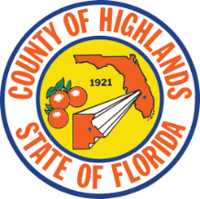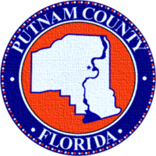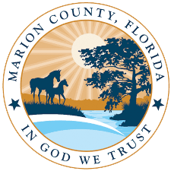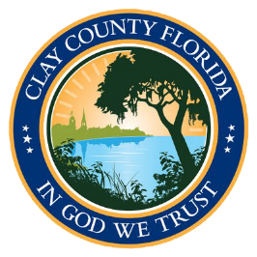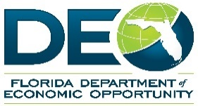

**Business Damage Assessment Survey**

[**FloridaDisaster.biz**](http://www.FloridaDisaster.biz/BusinessDamageAssessments)

The Business Damage Assessment Survey gathers information from businesses affected by the severe weather event in Central and Northeast Florida and shares the results with various local, state, and federal agencies to implement appropriate disaster relief programs. To complete the Business Damage Assessment Survey online, visit: [www.FloridaDisaster.biz/BusinessDamageAssessments](http://www.FloridaDisaster.biz/BusinessDamageAssessments).

**Individual Assistance Resources**

**Community Services Block Grant (CSBG) and Low-Income Home Energy Assistance Program (LIHEAP) CSBG services may include, but are not limited to: Emergency Health, Food, Housing, Debris Removal, Repair of Electrical and Gas Lines, etc. LIHEAP services include, but are not limited to: home heating and cooling costs.**

**Clay and Putnam Counties**

**Northeast Florida Community Action Agency**

**4070 Boulevard Center Dr., 4500 Bldg., Suite 200| Jacksonville, FL 32207|** **[www.NFCAA.net](http://www.NFCAA.net) | PH: 904-398-7472**

CSBG and LIHEAP assistance for eligible income-qualified individuals and families in **Clay and Putnam counties** is availablethrough the Northeast Florida Community Action Agency. For additional eligibility criteria and to apply online, visit [www.NFCAA.net](http://www.NFCAA.net).

**Highlands County**

**Agricultural and Labor Program, Inc.   
300 Lynchburg Rd. | Lake Alfred, FL 33850 |** [**www.ALPI.org**](http://www.ALPI.org) **|** **PH: 863-956-3491**

CSBG and LIHEAP assistance for eligible income-qualified individuals and families in **Highlands County** is available through the Agricultural and Labor Program, Inc. For additional eligibility criteria and to apply online, visit [www.ALPI.org](http://www.ALPI.org).

**Marion County**

**Central Florida Community Action Agency  
411 North Main St., Suite 210| Gainesville, FL 32601 |** **[www.CFCAA.org](http://www.CFCAA.org) | PH:** **352-373-7667**

CSBG and LIHEAP assistance for eligible income-qualified individuals and families in **Marion County** is available through the Central Florida Community Action Agency. For additional eligibility criteria and to apply online, visit [www.CFCAA.org](http://www.CFCAA.org).

**Central and Northeast Florida Severe Weather**

**Recovery Resources**