August 2022
Hot Deals and Discounts from NEA Member Benefits



NEA Discount Marketplace—Exclusive Offers for Members

The NEA Discount Marketplace, powered by Rakuten, enables members to earn Cash Back when they shop and save on brand-name merchandise from over 3,500 top retailers and online stores.* Check out the following member-exclusive deals in August 2022 at neamb.com/marketplace:

Dell Refresh your tech! Shop more than just laptops and PCs: get must-have electronics & accessories like monitors, audio, gaming gear and more. Free, next-day delivery on select items.

Adidas Get suited up for fall with training shoes, clothing and gear—whether you’re in the classroom or on the court, the trail, the track or the mat! Join ADICLUB for free and get 15% off your next purchase.

JC Penney Find deep discounts on clothing, shoes, window and home décor, and bedding. Check out summer and holiday sales and clearance. Get fast and free curbside or in-store pickup.

Sephora Sephora’s your source for everything beauty—including cosmetics, skincare, fragrance, nail color, body lotions and haircare. All orders ship for free!

Petco Save on pet food, habitats, toys, and medicines, as well as grooming, training and veterinary services. Get free shipping on orders of $35 or more.

*If you don’t find what you’re looking for in the exclusive member deals above, simply search for your favorite retailer by entering the store name in the search box on the NEA Discount Marketplace page!

* * * * *

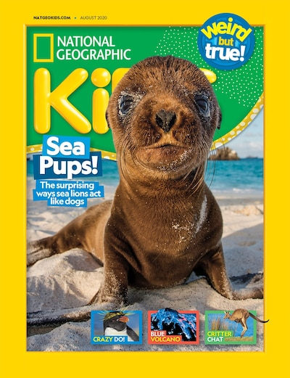

Educational Magazines for Kids (and You!)

The NEA Magazine Service offers access to over 800 titles in most every area of interest, with many geared toward young and school-age readers. Find selections for home and classroom at up to 85% off newsstand prices! Browse available subscriptions and place your order at www.neamb.com/magazine.

* * * * *

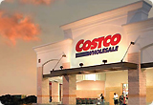


Get a $30 Costco Shop Card with a New Costco Membership
From school supplies, storage solutions, and electronics, to health & beauty items and lunchbox favorites, you’ll find everything you need for a fresh start to the new school year. NEA members obtaining a new Costco membership will receive a $30 Costco Shop Card!
It’s easy to join Costco: go online to www.neamb.com/costco, sign into your account or register, and click “Join Now” to purchase your Costco Membership Activation Certificate. You will receive an email confirmation that includes your certificate, which you can then redeem at any Costco location to start saving!

* * * * *



Find Labor Day Deals with the NEA Auto Buying Program

If you’re in the market for a new or used car, the NEA Auto Buying Program through TrueCar is the first place you should look! NEA members and their families enjoy preferred pricing year-round, save an average of $3,125 off MSRP on new cars, plus get these other benefits:

- Used Car Discounts—Save hundreds off the list price.*
- See What Others Paid—See what others have paid for the same car so you know when you’re getting a good or a great price.
- Upfront Pricing—See pricing, price rankings, and lock in Guaranteed Savings on the car you want before you even leave home.
- Enjoy a Hassle-Free Experience—Bring in your Price Certificate to a Certified Dealer or show it on your mobile phone.
NEA members also receive TrueCar Buyer’s Bonus Benefits at no additional cost, including Auto Repair Reimbursement and Auto Deductible Reimbursement – benefits that could be worth up to $2,000 (available in most states).

Visit the NEA Auto Buying Program today to see how much you can save! Go to: www.neamb.com/buyacar

*Discounts not available on all cars or in all states.

# # #

