Winter WINEland 2023 Social Media Toolkit
Below are some helpful hints on what to post when using Facebook, Twitter, or Instagram, followed by posts that can be used on all platforms.
Hashtag #WINEland2023 / #winterwineland2023 for the event.
Event Page URL: https://www.wineroad.com/events/winter-wineland/
Shortened event page URL: http://bit.ly/2KDul4m
Event Ticket Page URL: https://www.eventbrite.com/e/winter-wineland-2023-sonoma-county-30th-anniversary-tickets-461361283017
Dropbox Link to photo/video assets: https://www.dropbox.com/sh/gb92g7cguepzjb5/AABIvlnhMZbXxZVeZufKqZFBa?dl=0
Facebook Tips:
Please share/add our Winter WINEland event that is already created on Facebook and found here. Share to your timeline and add text such as: “Tickets are now on sale for Winter WINEland….”
You can also add our event to your page by going to the event on our page, clicking on the “three dots” on the top of the event and choosing “Add to Page.” See graphic for how to share and add below. It’s generally better to share our event versus creating your own so that those that are interested click on our event and therefore can be retargeted with sponsored posts later.
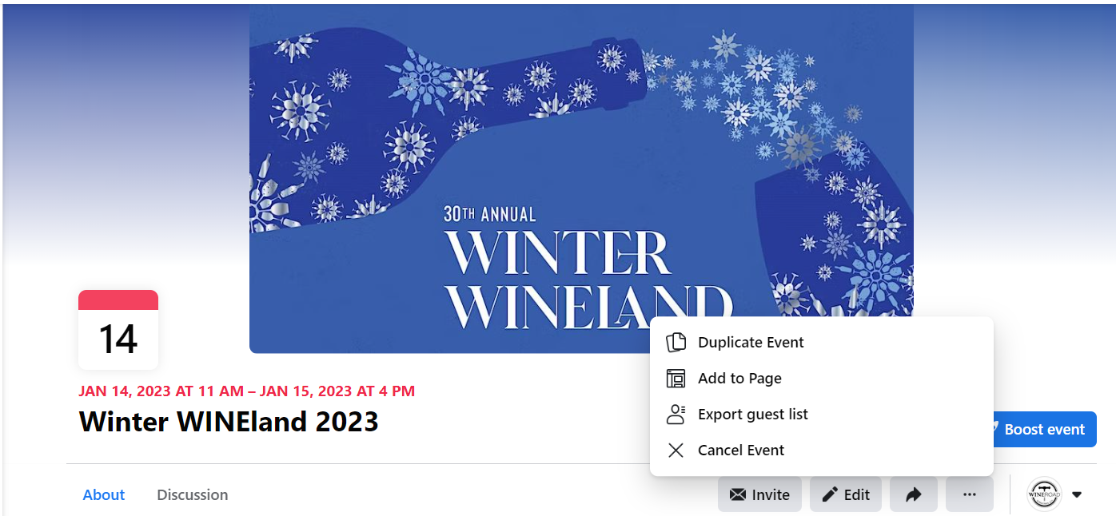
Twitter Tips:
- If you tag @TheWineRoad in your tweets so we are notified, we’ll retweet you!
- We recommend using a photo in all tweets as it improves engagement.
- Use our event artwork or a photo of your own.
- Please note that the character limit on Twitter is 280 characters.
- Hashtags: Generally, use 2-3 per post (pick from this list): #WINEland2023 #yourwineryname #sipsonoma (and others)

Tik Tok: We are now on Tik Tok @thewineroad, so be sure to follow us and share our Winter WINEland videos if your winery is there too!
Instagram Tips:
- If you tag @thewineroad on Instagram, we’ll like your photo and engage with you – we might repost your photo on our page or story.
- REELs: Instagram began favoring REELs this year. Therefore, we do suggest creating your own or using the one we’ve created in the assets folder. It doesn’t have music, so you can add the music that best suits your brand / vibe.
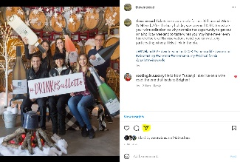
- If you choose to post our Winter WINEland artwork on Instagram, we suggest you only do it once. If you post about the event, we recommend posting photos of previous Winter WINEland, wines you’ll be pouring, your winery, etc.
- Don’t forget about Instagram stories! You can simply press the “arrow” icon under our Instagram posts and share our WFA posts directly to your story and add your own text (see highlight). Or use one of our photos to post to your stories.
- Use our hashtags, plus your hashtags - the ones we’ve used are just suggestions, but by no means a complete list for Instagram. Instagram allows up to 30 hashtags in your posts – use as many as you feel most comfortable with (average is about 11).
- Hashtag suggestions for a post (choose from this list): #wineroadlife #wineroad #sipsonoma #yourwineryname #WINEland2023 #winterwineland2023 #yourvalley #sonomacountywine #wineevents #winetasting #YourCity or #YourVisitorCenterHashtag #winetravel #vineyards #scenic #fun #friends #gowinetasting #vino #winter #winetourism #winetime #foodandwine #foodwinetravel #winesofinstagram

Social Media Post Ideas:
As the event approaches, consider posting several times with varying themes. Be creative and post your own or use ours (edit as needed):
- Tickets are now on sale for our 30th annual Winter WINEland, the perfect winter escape…restock your wine cellar, join a few clubs, and take the opportunity to taste wines you’ve never heard of before. http://bit.ly/2KDul4m
- Wine Road’s Winter WINEland is January 14th and 15th. Get your tickets now! http://bit.ly/2KDul4m
- Winter WINEland tickets are officially on sale! Get them today so you don't forget in all the upcoming holiday mayhem. http://bit.ly/2KDul4m
- A ticket to Winter WINEland gives you access to over 70 wineries across 3 valleys, including us! Get your tickets now: http://bit.ly/2KDul4m
- Share your Winter WINEland adventures on Instagram, tagging your photos with #winterwineland2023 and #wineroadlife and #yourwineryname. We love seeing your photos!
- It’s all about the wine! Winter WINEland is a great opportunity to restock your wine cellar, try new wines and maybe even join a wine club or two. Get your tickets now: http://bit.ly/2KDul4m (Use our event photo, or a photo of your wine).
- Put a pair of Winter WINEland tickets in your favorite wine lover's stocking this Christmas: http://bit.ly/2KDul4m
- Baby it’s cold outside, but that shouldn’t stop you from enjoying this year’s Winter WINEland! Get your tickets today. http://bit.ly/2KDul4m
- If you love wine & winter in Sonoma County's Wine Country, then you’ll love Winter WINEland. Get your tickets and make us one of your stops! http://bit.ly/2KDul4m
- Make us one of your Winter WINEland stops! We’ll be pouring our (yourwine) and (describe). Tickets here: http://bit.ly/2KDul4m
- Come see what Sonoma County is famous for -- beautiful winter scenery, stunning vineyards and world-class wineries. A Winter WINEland ticket gives you access to all of it! http://bit.ly/2KDul4m (picture of your winery, outdoor preferable).
- Winter is a unique time of year along the Wine Road, when our vineyards are sleeping, but our views are still stunning. See for yourself during Winter WINEland, January 14 – 15th. http://bit.ly/2KDul4m
- Good friends + Good Wine + Good Times = Winter WINEland! Tickets are still available: http://bit.ly/2KDul4m
- Picture yourself along the Wine Road this January at this year’s Winter WINEland, where it's all about the wines. Just one more week to get your advance tickets – no tickets will be sold at the door. http://bit.ly/2KDul4m
- Advance ticket sales for Winter WINEland end on Monday, January 9th at 7pm. Don’t miss out. No tickets will be sold at the door: http://bit.ly/2KDul4m

