
2026 Dr. Martin Luther King, Jr.
Writing Contest

“A Look to the Future”

Dr. Martin Luther King, Jr. was an activist committed to peace, justice, and equality. As a visionary leader of the civil rights movement, King fought for racial and economic justice for the oppressed. His driving forces were nonviolence, love, the importance of family and self-respect.

This year’s theme is “A Look to the Future” from Dr. King’s 1957 “A Look to the Future” address.
“In order to look to the future, it is often necessary to get a clear picture of the past.”

Students can reflect on these words and how they relate to themselves or others in their families, schools, neighborhoods or the world.

Eligibility/Categories
The writing contest is open to greater Milwaukee students in grades K-12.

All entries must be submitted to the MTEA office or the Librarian at any Milwaukee County Public Library by 5pm on Friday, November 13, 2026. Entries submitted after 5pm will not be considered for prizes. Entries that do not stay within word limitations (listed below) for their grade level will be disqualified. Teachers should include a cover sheet listing the names of students who have submitted an entry. Please submit an entry for each student who participated.
There are seven grade level categories:
- K-1: group project only (no individual essays), reflecting children’s work and ideas
- Grades 2-3: individual entries, maximum length 250 words
- Grades 4-5: individual entries, maximum length 350 words
- Grade 6: individual entries, maximum length 400 words
- Grades 7-8: individual entries, maximum length 450 words
- Grades 9-10: individual entries, maximum length 500 words
- Grades 11-12: individual entries, maximum length 550 words

The following information must be included on the back of each entry: Student’s name, grade, parent/guardian phone number and email address, teacher name, school name and school phone number.

Note on AI: Any entries found to be plagiarized or created partially or in full using AI or other sources will be disqualified.

Judging
The entries will be judged on a point system, with the following criteria considered:
- Entries must address the theme.
- Entries should relate the student’s personal ideas, work and experiences to the topic and show an understanding of Dr. King’s ideals.
- Entries must not be a biographical sketch of Dr. King.
- Entries will be judged on the basis of clearly expressed, creative ideas and ability level. In judging entries, emphasis will be placed on clarity, creativity, and originality. Correct usage of basic grammar and writing skills will also be considered.

Entries should show an understanding of the historical context of Dr. King’s words and actions, see the relevance of these words and actions in their world today, and become familiar with Dr. King’s life and values. (We recommend utilizing the resources of MPS school libraries and the Milwaukee County Public Libraries.)

Prizes/Recognition
First, second, and third place writing contest winners will receive an engraved plaque and a prize valued up to $100. Winning students will be presented on stage, January 18, 2027, at the Marcus Performing Arts Center’s Dr. Martin Luther King, Jr. City-wide Celebration.

Questions/Concerns
If you have any questions or concerns, please contact Donelle Johnson, Contest Coordinator, at 414-445-5635 or donellejohnson@aol.com.

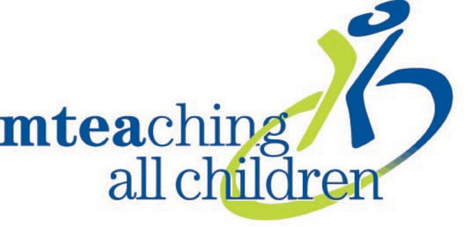
Milwaukee Teachers’ Education Association
5130 West Vliet Street, Milwaukee, WI 53208 Phone: 414-259-1990 Fax: 414-259-7801
www.mtea.org Milwaukee Teachers’ Education Association

