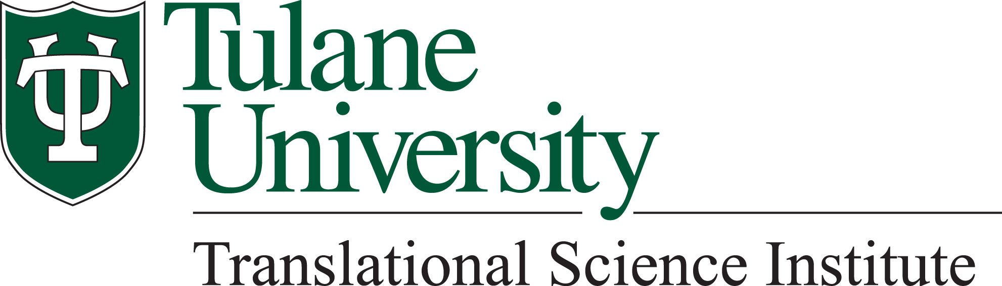

Translational Science Grand Rounds

**Understanding the molecular mechanisms of heart failure: opportunities and challenges**

Presented by

**Bing Yu, PhD, FAHA**

Associate Professor

JLH Foundation Chair in Transplant Prevention

Department of Epidemiology and Human Genetics Center

School of Public Health, University of Texas Health Science Center at Houston

Dr. Yu is a molecular epidemiologist and her research focuses on discovering novel biomarkers and underlying biological pathways of cardiopulmonary disease using cutting-edge omics technologies, including whole genome sequencing, proteomics and metabolomics. Dr. Yu has been leading multiple omics projects in large consortia including the Cohorts for Heart and Aging Research in Genomic Epidemiology (CHARGE) consortium, the Trans-Omics for Precision Medicine (TOPMed) Program and the COnsortium of METabolomics Studies (COMETS). Her work on integrating omics for cardiovascular disease has been sponsored by the National Heart, Lung, and Blood Institute and American Heart Association.

**Monday, December 5, 2022 at 12:00 PM**

**Tidewater Room 1210**

Lunch will be served at 12 PM

For additional information, please contact Blake Bathel at

988-0679 or bbathel@tulane.edu