MIDDLE FRENCH IMMERSION PROGRAM

INFORMATION PACKAGE

2022-2023

PARENTS/CAREGIVERS OF CHILDREN IN GRADE 3

You have a choice to make about French programming for your child. You have the opportunity to apply to the Middle French Immersion program which begins in Grade 4.

Grade 3 is the ONLY time your child may apply to begin the Middle French Immersion program.

WHAT IS THE MIDDLE FRENCH IMMERSION PROGRAM?
The Middle French Immersion program is designed for students who do not speak French at home.

GRADES | DESCRIPTION OF THE PROGRAM
GRADES 4 - 5 | 100% of the day taught in French - All subjects  (with the exception of a PREP providing subject that may be delivered in English if required)
GRADES 6 - 8 | 75 % of the day taught in French (French Literacy, Math, Social Studies, The Arts)  25% of the day taught in English (English Literacy and Science)  (with the exception of a PREP providing subject that may be delivered in English if required)
GRADES 9 - 12 | Students continue in the French Immersion program at designated secondary schools. Students who successfully complete a minimum of 10 credits in French at the secondary school level are eligible for a Certificate of Bilingual Studies in French within the TDSB.

Information about the Middle French Immersion Program is available in multiple languages.

www.tdsb.on.ca/Elementary-School/School-Choices/French-Programs/French-as-a-Second-Language-FSL-Programs/Middle-French-Immersion

Please note: This program replaces the Junior Extended French program as the Grade 4 entry program in TDSB.

WHO IS FRENCH IMMERSION FOR?
✓ The program is designed for families who speak a language other than French at home.
✓ All students are capable of learning another language so students of all learning styles and language backgrounds are welcomed and supported in the program.
✓ French Immersion programs are suited to all families who are interested in the opportunity to develop proficiency in French.

THE APPLICATION PROCESS
STEPS OF THE PROCESS | DESCRIPTION OF THE PROCESS
HOW TO APPLY | - The application process is done entirely online. All communication will be sent via the email address provided online at the time of application. Please check this email regularly including junk mail.  - For information on the Application process or how to find your associated Middle French Immersion school for your area, please visit the French Programs website below and/or access the Frequently Asked Questions under Application Process – left menu bar: www.tdsb.on.ca/Elementary-School/School-Choices/French-Programs  - You will need your child’s date of birth and OEN (Ontario Education Number). The OEN is a 9-digit number found on any report card from the TDSB.  - For non-TDSB students, please select the “Non-TDSB Student” option and follow the steps to generate an identification number. You must then return to the PARS site and follow the application procedure with this number.  - Please select Middle French Immersion from the drop-down menu and complete  - the application process.  NOTE: Families with an older sibling currently enrolled in a French program and who will be in attendance the following year are still required to complete an online application for the new student. Please select the “sibling option” within the online application.
WHERE TO APPLY | - Please visit the Middle French Immersion Online Application page.  www.tdsb.on.ca/Elementary-School/School-Choices/French-Programs/Application-Process/PARS
WHEN TO APPLY | - When your child is in Grade 3 and not currently in a French program  Applications open: January 3, 2022  Deadline: January 28, 2022
WHAT HAPPENS NEXT? | - An offer of placement in Middle French Immersion is guaranteed to all eligible on-time applicants, however placement in a particular school is NOT guaranteed.  - On-time applicants will be offered a placement online via the email address provided at the time of application. Parents/Caregivers MUST take action to accept this placement by the deadline requested when offered a placement in order to reserve a spot in the program.  - Offers of placement will be ongoing through the weeks and months following the close of the application period. Please check email regularly (including junk mail) and follow all instructions found therein.
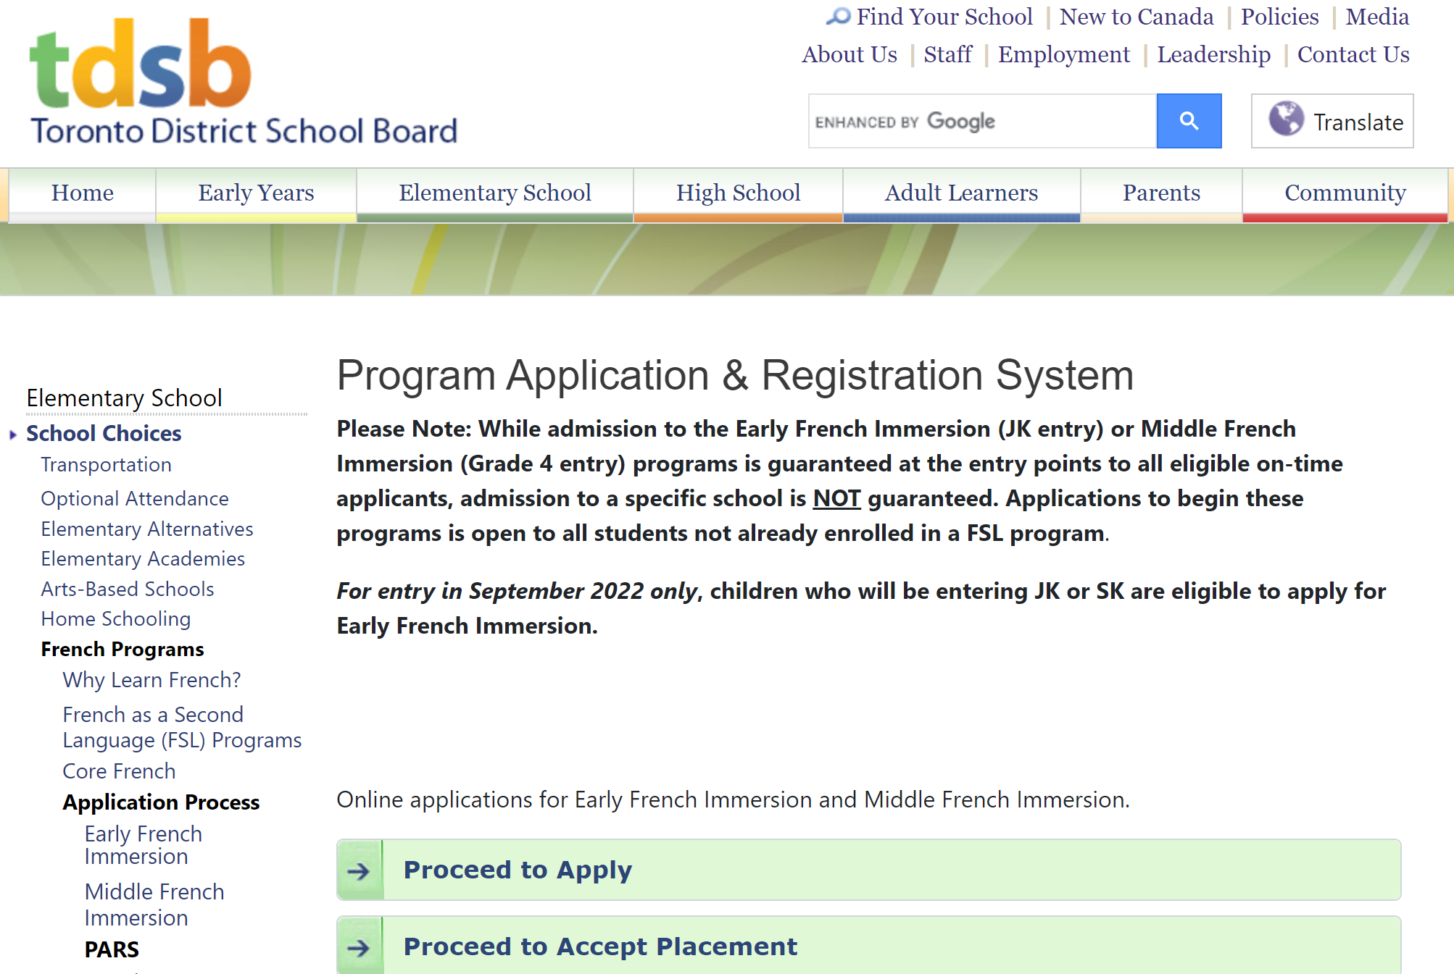

CENTRAL PARENTS/CAREGIVERS INFORMATION WEBINARS
DATES, TIME & LINK TO WEBINARS | ALTERNATE WAYS TO PARTICIPATE
January 6, 2022 – 10 am  CLICK HERE TO JOIN THE WEBINAR ON JANUARY 6 | Webinar ID: 957 9470 9338  Phone one-tap: Canada: +6473744685,,95794709338# or +16475580588,,95794709338#  Dial: Canada : +1 647 374 4685 or +1 647 558 0588
January 13, 2022 – 1 pm  CLICK HERE TO JOIN THE WEBINAR ON JANUARY 13 | Webinar ID: 965 0951 9491  Phone one-tap: Canada: +6475580588,,96509519491# or +16473744685,,96509519491#  Dial: Canada:+1 647 558 0588 or +1 647 374 4685
January 17, 2022 – 7 pm  CLICK HERE TO JOIN THE WEBINAR ON JANUARY 17 | Webinar ID: 998 7090 8992  Phone one-tap: Canada: +16473744685,,99870908992# or +16475580588,,99870908992#  Dial: Canada: +1 647 374 4685 or +1 647 558 0588
Families can request interpretation services for this event in advance, by completing this online form before December 17, 2021.

For more information, please visit the Information Session page on our website.
www.tdsb.on.ca/Elementary-School/School-Choices/French-Programs/Information-Sessions

VIDEO INFORMATION ON THE APPLICATION PROCESS
At any time, parents/caregivers can visit our website to view a video that provides a great deal of information about our French programs as well as the application and placement process for the Middle French Immersion programs.

www.tdsb.on.ca/Elementary-School/School-Choices/French-Programs/French-as-a-Second-Language-FSL-Programs

IMPORTANT NOTES
Applications for the Middle French Immersion program
are completed online for September 2022

IMPORTANT DATES:
Application process opens: January 3, 2022
Deadline for applications: January 28, 2022
- While every effort will be made to place students in the school identified as their area French Immersion school, this is not always possible. In cases where the number of applications in a given area is greater than the number of allotted program spaces in the school, students may be redirected to schools with available program space.
- Placements are made based on the child's primary home address of record prior to the application deadline. If the address changes between the application deadline and the fall of the Grade 4 year, there is no guarantee of placement in the new area.
- Applicants who have older siblings currently enrolled in a French program and who will be in attendance the following year have a priority placement in that school.
- Classes with fewer than 25 students may not open.
FIND US AT: www.tdsb.on.ca/French

