J. Richard Williams Sr, MD 1931 Lecture

Presented by

The Program in Medical Ethics and Human Values

Tulane University School of Medicine

“The Brave New World of Assisted Dying: Enlighted or Dystopian?”
This talk will overview the global sociocultural evolution of medically assisted dying and describe the clinical experience in Canada.
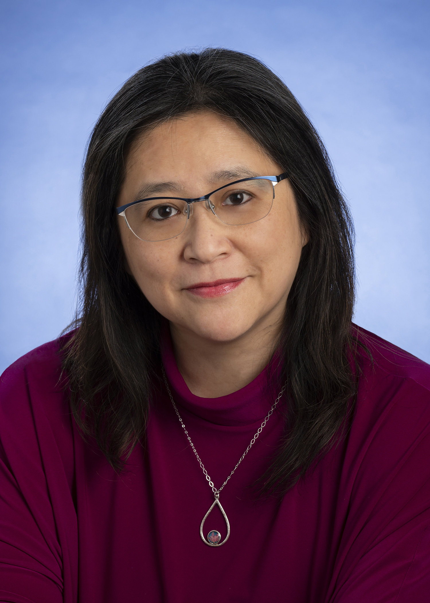

Madeline Li, MD PhD FRCP(C)
Madeline Li is a Clinician-Scientist at the University of Toronto and Head of the Psychosocial Oncology Program at the Princess Margaret Cancer Centre who has been actively involved in supporting the safe practice of assisted dying since its legalization in Canada.
Tuesday, April 25, 2023,
12:00 – 1:00 PM CT
A Zoom Presentation
Please Register in advance for this meeting:
https://tulanehipaa.zoom.us/meeting/register/tJ0udeGurDojG9bbBVKWetMzoGq7R7AiMqTq

After registering, you will receive a confirmation email containing information about joining the meeting.
Tulane school of Medicine
Tulane University School of Medicine is accredited by the Accreditation Council for Continuing Medical Education to sponsor continuing medical education for physicians. TUSOM designates this CME activity for 1 credit hour in Category 1 of the Physician’s Recognition Award of the American Medical Association.

