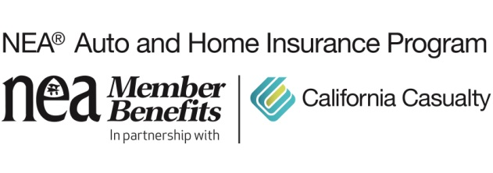
School Bus Safety Tips

School buses are one of the safest vehicles on the road. Students who ride the bus are actually 70x’s more likely to get to school safely than those who go to school by car. That’s because school buses are designed with your kids in mind. Every feature of a bus has a safety purpose—from its bright yellow exterior to its flashing lights and extendable stop sign arms.

Although school buses are considered the safest form of child transportation, the truth is that, even in the safest vehicle, accidents can and do happen. School transportation-related accidents cause, on average, 128 fatalities a year. That’s why it’s still important to educate your children on school bus safety practices.

School Bus Safety Tips for Parents
- Always wait at the bus stop with young children.
- Teach kids to stand at least 3 giant steps (6 ft) back from the curb, and never run around or play while waiting.
- Teach kids to wait for the bus to come to a complete stop, for the door to open, and for the driver to say it’s okay to board.
- Make your child aware of proper bus-riding behavior and the importance of not distracting the driver.
- Tell your children never to walk behind the bus.
- If your child has to walk in front of the bus, teach them to walk 5 giant steps (10 ft) in front of the bus, make contact with the bus driver so they can see them, and to look both ways twice before crossing.

It is also our job, as drivers, to help make school transportation continue to be as safe as it can be.

School Bus Safety Tips for Drivers
- Slow down when driving in neighborhoods and school zones.
- Stay alert and watch for children walking on cross streets and waiting at bus stops.
- Learn and obey school bus laws in your state:
  - Yellow Flashing Lights: the bus is preparing to stop. Drivers should slow down and prepare to stop, as well.
  - Red Flashing Lights & Stop Arm: the bus has stopped, and children are exiting. Drivers should come to a complete stop and not move until the bus has turned off its flashers and withdrawn the stop arm.
- Never tailgate a bus or ignore an extended stop arm.
- Make sure all children have exited the bus and are safely away from the road before proceeding.

Together we can help continue to keep buses and bus stops safe for our children. For more Safety Tips visit: mycalcas.com/resources

For more information on School Bus Safety visit:
https://bit.ly/2Jdj8YO
https://bit.ly/2JdlTsW

California Casualty has been serving the needs of educators since 1951 and is the only auto and home insurance company to earn the trust and endorsement of the National Education Association (NEA). Learn how to save on your insurance by getting a quote at www.neamb.com/autohome, or by calling 1.800.800.9410.

