LAMOND-RIGGS CITIZENS ASSOCIATION, INC. SCHOLARSHIP
GUIDELINES FOR APPLICANTS

2021
ABOUT THE LAMOND-RIGGS CITIZENS ASSOCIATION, INC.
The Lamond-Riggs Citizens Association, Inc. (LRCA or Association), organized on September 4, 1957, aims to promote the general welfare of the District of Columbia and to participate in common District of Columbia endeavors to effect civic improvements for the benefit of its inhabitants.

OBJECTIVE
LRCA works to further the general welfare of residents who reside within its boundaries (see LRCA boundary map on page 3). The objective of these scholarships is to provide post-secondary support to graduating high school seniors who have excelled academically and have contributed their talents to the improvement of the community. The scholarship recognizes the achievements of students living in the community and the impact that financial assistance can have on higher education study and completion.

AWARDS
LRCA will award three (3) Academic Excellence Scholarships to eligible high school graduating seniors residing within the LRCA boundaries, who will attend an accredited* two or four - year college or university. Scholarship awards will range from $250 to $1000.
*For a list of accredited colleges and universities, please visit www.ed.gov.

APPLICANT ELIGIBILITY
To be considered for any scholarship, the applicant must:
- be a permanent resident within the geographical boundaries of the LRCA (see map)
- be a college-bound graduating 2021 senior from a traditional public or public charter school in the District of Columbia
- plan to enter an accredited two or four-year university or college as a full-time freshman in the fall of the calendar year (2021) in which the application is made
- complete the application packet as prescribed by the instructions herein, and
- have a scholastic average of at least 2.5 on a 4.0 scale

APPLICATION PROCEDURES

To be considered for a scholarship, you must complete the application form available in fillable format online at http://lrcadc.org. A community service narrative and essay must be submitted along with the other required information for the application packet. Only typed applications and statements will be accepted. Handwritten applications will not be accepted. The complete application package may be submitted in one of two ways (choose only one method):

- Preferred Method:
Email your complete scholarship packet by April 30, 2021 to: info@lrcadc.org
with subject heading "LRCA 2021 Scholarship Application (Last Name, First Name)." Applications may be submitted in either Microsoft Word or PDF version.
OR
- Print and mail your complete application packet postmarked by
April 30, 2021 to:

The Lamond-Riggs Citizens Association, Inc.
P.O. Box 60272
Washington, DC 20039
Attn: Scholarship Committee
Your complete application packet must include the following:
    - Application
    - Official Transcript
    - Official SAT/ACT Scores
    - Two letters of recommendation from two of the following: principal, counselor, advisor, or teacher. The letter of recommendation must be on official letterhead attached to the form provided.
    - Student community service - Double spaced typed (12 pt font) paragraph on your involvement in community service. This paragraph must include the name of the organization, your immediate supervisor and a brief description of your responsibilities. If you completed community service with more than one organization, a paragraph must be completed for each organization with the required information listed above.
    - The Applicant’s Written Essay - 400 word Double-Spaced typed (12 pt. font) essay on one of the following topics:

- Why are you applying and should receive this LRCA Scholarship?

OR
- How do you plan to use your college education to make the world a better place?

All information will be kept in the strictest of confidence. Finalists may be required to participate in an in-person interview on a date to be announced.

*LRCA Boundaries: The organizational and jurisdictional area of this association shall be defined, bounded and limited as follows: starting from the Baltimore and Ohio Railroad tracks at Underwood Place to Kansas Avenue, Northeast; then northerly on Kansas Avenue, Northeast to Eastern Avenue, Northeast; then southerly on Eastern Avenue, Northeast to where it intersects Galloway Street, Northeast; then westerly along Galloway Street, Northeast until it meets the railroad tracks of the Baltimore and Ohio Rail; then northwesterly along such railroad tracks to where they reach Underwood Place, Northwest, extended; all within the District of Columbia.
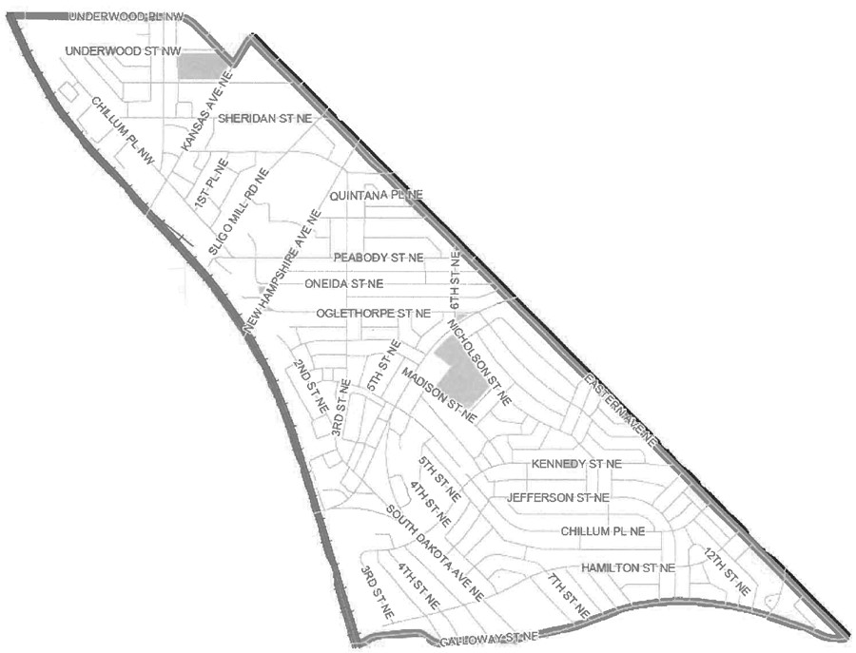

PERSONAL INFORMATION
Student’s Name (Last, First, Middle Initial) |  | Birth Date (mm/dd/yyyy)
Permanent Address
City | State |  | Zip Code
Home Telephone w/ Area Code |  | Mobile Number w/ Area Code
E-Mail Address
Name of Parent/Guardian
SCHOOL INFORMATION
Name of High School | City/State
School Counselor’s Name | Expected Graduation Date (Mo./Day/Year)
Cumulative GPA:
COLLEGE APPLICATIONS
List the Universities/Colleges to which you have applied and asterisk (*) any to which you have been accepted.
College/University | College/University
College/University | College/University
Intended Major/Area(s) of interest:

EXTRACURRICULAR ACTIVITIES
Please list the major extracurricular activities (school and community) that you have participated in during high school. Please be certain to highlight any leadership positions held. (If necessary, you may use a separate sheet of paper.)

Activities | 9th | 10th | 11 | 12th | Hours/Week | Position Held

COMMUNITY SERVICE
 | Grade 9 | Grade 10 | Grade 11 | Grade 12
Number of Community Hours Required
Number of Community Hours Completed
 |  |  |  |  | Grand Total:

CERTIFICATION
By the signature below, I affirm that all information provided herein is true and complete to the best of my knowledge, and that I reside in the boundaries of the Lamond Riggs Citizens Association. Misrepresentation or the submission of inaccurate or incomplete information will result in disqualification or forfeiture of any award.
Applicant Signature | Date
Parent/Guardian Signature | Date

TEACHER/COUNSELOR/PRINCIPAL LETTER OF

RECOMMENDATION
To the Recommending Official:
The student listed herein is applying for a scholarship from the Lamond Riggs Citizens Association, Inc. (LRCA). We would appreciate your candid assessment of the applicant’s academic performance, intellectual ability, maturity, oral and written communication skills, motivation and interpersonal skills.
In your letter of recommendation, please also include the length of your acquaintance with the applicant and a telephone number where you may be reached. If you are a teacher, please include the subject or courses taught, dates of instruction, and how well the applicant performed in the class. Your letter of recommendation should be submitted on official stationery and include your signature. Return your letter of recommendation to the applicant. The due date for the entire application packet is April 30, 2021.

APPLICATION PACKET CHECKLIST
Be sure to include the following:
_____ Application
_____ Essay
_____ Extra Curricular Activities
_____ Community Service Paper (Do not submit a résumé.)
_____ Two Letters of Recommendation
_____ Official Transcript
_____ SAT/ACT Scores
Please remember to proofread your application.
Deadline: April 30, 2021

